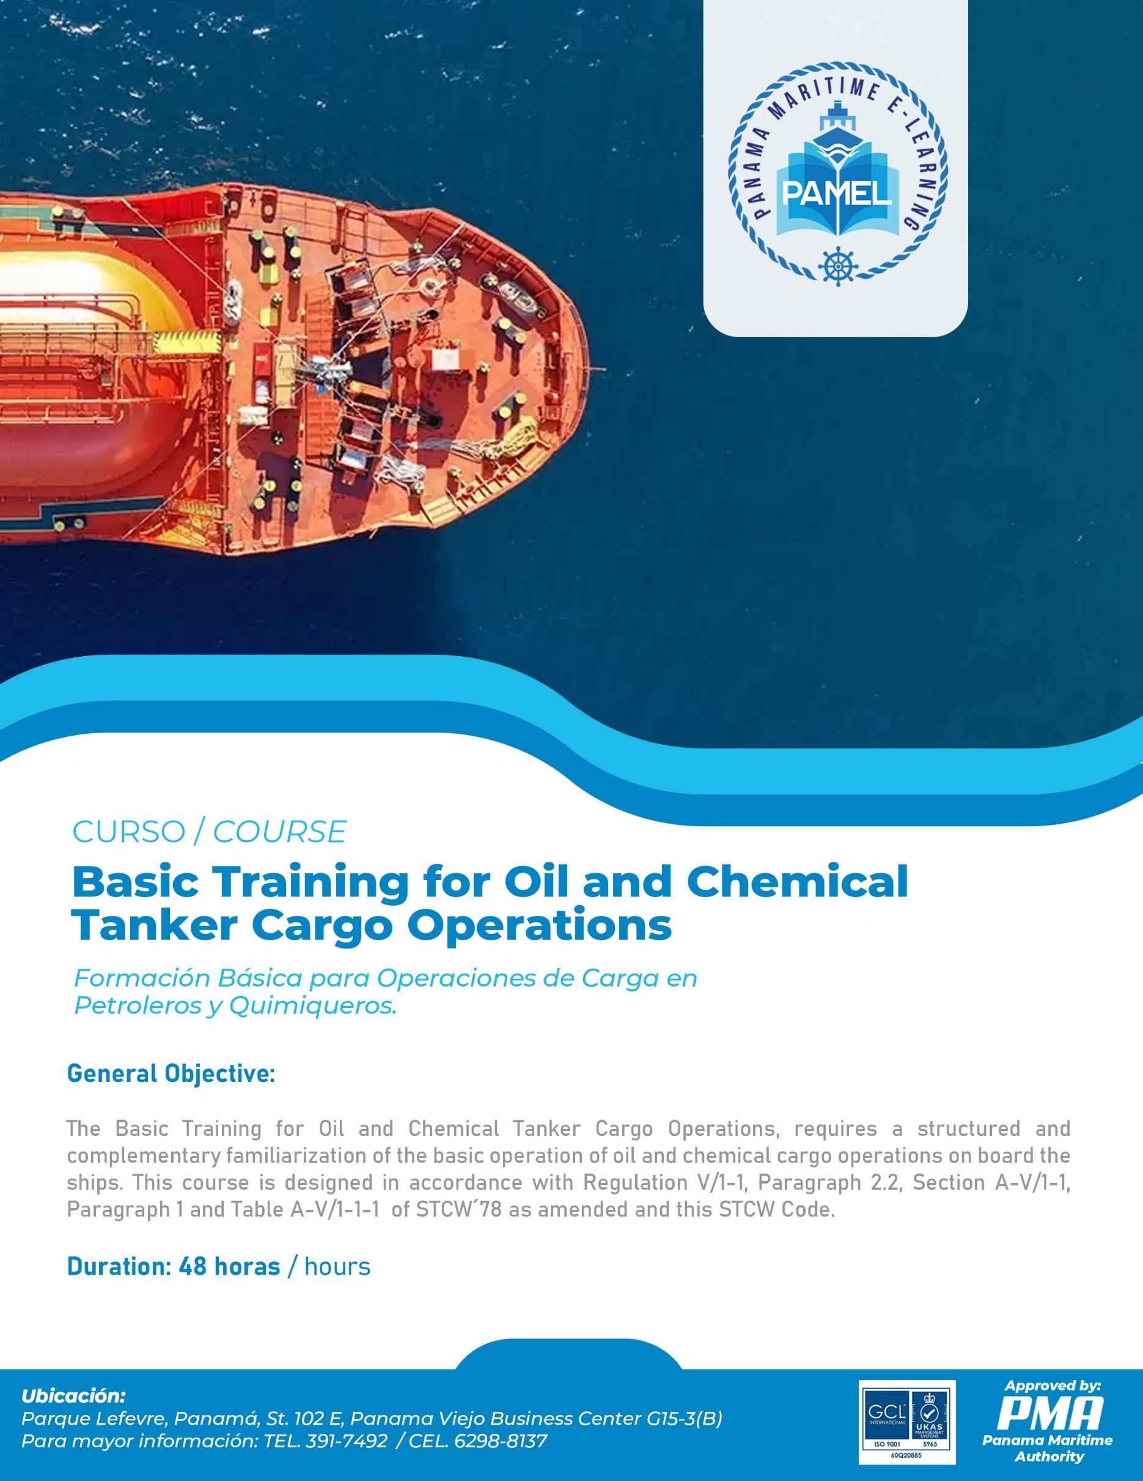

MANUAL OF THE TRAINING COURSE
BASIC TRAINING FOR OIL AND CHEMICAL TANKER CARGO OPERATIONS
Regulation V/1-1, paragraph 1, Section A-V/1-1, paragraph 1 and Table A-V/1-1-1 of The International Convention on Standards of Training Certification and Watchkeeping of Seafarers STCW 1978, as amended (Convention STCW´78, as amended) and the STCW Code.

This course provides mandatory minimum standards of competence the basic training for oil and chemical tanker cargo operations in accordance with the provisions of Section A-V/1-1, paragraph 1 and Table A-V/1-1-1 of the STCW Code.

COURSE OUTLINE

BASIC TRAINING FOR OIL AND CHEMICAL TANKER CARGO OPERATIONS

SUBJECT AREA |  | COURSE DURATION (TIME)
N° | Denomination | Theorical hours | Practical Hours (Simulators / workshops)
Knowledge, understanding and proficiency
1. | - Oil Ships
 | - Types of oil tankers | 0.25
 | - Types of chemical tankers | 0.25
 | - Basic knowledge for the general management of and oil and a chemical tanker. | 0.25
 | - Pumps and eductors
 | - Cargo system with heaters | 0.25
 | - Inert Gas System | 0.25
 | - Onboard System Measures | 0.50
2. | Chemical and Physical Properties of Oil
 | - Basic Physics | 2.0
 | - Basic Chemistry and Chemical elements | 1.5
 | 2.3 Physical and chemical properties of oil at the moment of being transported in bulk | 1.5
3. | Understanding of the safety culture onboard oil tankers and safety management | 2.0
4. | - Risks
 | - Health risks | 0.50
 | - Environmental Risks | 0.50
 | - Reactivity risks | 0.25
 | - Corrosion risks | 0.25
 | - Explosion and flammability risks | 0.50
 | - Electrostatic risks including the ignition sources. | 0.50
 | - Toxicity Risks | 0.25
 | 4.1.8 Leaks and vapor clouds | 0.25
 | - Risk control
 | 4.2.1 Inertization, water refill, desiccant agents and technical vigilance | 0.50
 | - Antistatic Measures | 0.50
 | - Ventilation. | 0.25
 | - Segregation cargo | 0.25
 | - Cargo Inhibition | 0.25
 | - Importance of cargo compatibility | 0.50
 | - Atmospheric Control | 0.50
 | - Gas Trial | 0.25
 | - Understanding of the information on the materials on safety sheets (MSDS) | 0.50 | 0.5
5. | 5.Safety
 | 5.1 Function and correct use of instruments to measure gas |  | 1.0
 | 5.2 Adequate use of safety instruments and protection devices among them:
 | 5.2.1 Autonomous breathing equipment and equipment for tanker evacuation | 0.50 | 0.50
 | 5.2.2 Protection dressing and equipment | 0.50
 | 5.2.3 Reanimation equipment | 0.50
 | 5.2.4 Search and scape equipment | 0.50
 | 5.3 Safe practices of work and procedures in accordance to the regulation and the guidelines of the industry and personal safety on board oil and chemical tankers.
 | 5.3.1 Precautions to be taken to enter in totally closed spaces. | 1.0
 | 5.3.2 Precautions to be taken before and during the work of “repair and maintenance” on dangerous areas. | 0.5
 | 5.3.3 Safety measures to work (hot and cold) | 1.5
 | 5.3.4 Safety precautions to work with electricity | 0.5
 | 5.4 First Aid regarding the informative sheets on material safety (MSDS) | 2.0
6. | 6.Safety against fires and firefighting operations
 | 6.1 Organization and measures to be adopted against fires onboard tankers. | 1.5
 | 6.2 Fire risks regarding cargo handling and transportation regarding harmful and potentially dangerous liquids in bulk. | 1.5
 | 6.3 Agents of firefighting used to extinguish hydrocarbon and chemical product fires. | 0.50
 | 6.4 Operations of fixed systems for foam-based firefighting. | 0.50 | 2.0
 | 6.5 Operation of portable foam-based fire extinguishers. | 0.25 | 1.0
 | 6.6 Operation of the fixed systems based on dry chemical agents. | 0.50 | 2.0
 | 6.7 Spill Containment regarding firefighting. | 0.25
7. | Cargo Operations
 | 7.1 For oil and chemical tankers | 0.25
 | 7.2 For an oil tanker
 | 7.2.1 Cargo information | 0.50
 | 7.2.2 Inert | 1.0
 | 7.2.3 Loading | 0.50
 | 7.2.4 Unloading | 0.50
 | 7.2.5 Tank cleansing | 1.0
 | 7.2.6 Clearing and gas free | 0.50
 | 7.3 For chemical tankers
 | 7.3.1 Cargo information | 0.50
 | 7.3.2 Loading | 1.0
 | 7.3.3 Unloading | 0.50
 | 7.3.4 Tank cleansing and gas free | 1.0
8. | Emergencies onboard oil and chemical tankers.
 | 8.1 Emergency procedures, including emergency shutdown | 0.5
 | 8.2 Organizational Structure | 0.25
 | 8.3 Alarms | 0.25
 | 8.4 Emergency procedures | 0.50
9. | 9.Prevention pollution caused by oil and chemical tankers
 | 9.1 Basic knowledge of the effects of pollution by oil and chemical tankers on humans and marine life. | 0.50
 | 9.2 Basic knowledge of basic procedures on board to prevent pollution. | 0.50
 | 9.3 Measures in case of spills  Measures to be taken in case of a spill, including the need of:  1. To transmit due information to the responsible people.  2. To contribute to implant the procedures on board meant to contain the spills. | 0.50
10. | Case study on spills and emergencies
 | 10.1 Fire and explosion during tank operations | 0.50
 | 10.2 Collapse of crewmembers during washing or cleaning operation on tankers. | 0.50
 | EXAM | 1.0 | 1.0
 | SUB TOTAL | 40.0 | 8.0
 | TOTAL | 48.0

COURSE TIMETABLE

Period | Day 1 | Day 2 | Day 3
1st Period | 1. Oil Ship (1.75 hr). | - Understanding of the safety culture onboard oil tankers and safety management. (1.0 hr).  - Risks (1.0 hr). | - Safety. (2.0 hr).
2nd Period | 2. Chemical and Physical Properties of Oil. (2.0 hr). | 4. Risks (2.0 hr). | 5. Safety. (2.0 hr).
3rd Period | 2. Chemical and Physical Properties of Oil. (2.0 hr). | 4. Risks (2.0 hr). | - Safety. (2.0 hr).
4th Period | - Chemical and Physical Properties of Oil. (1.0 hr).  - Understanding of the safety culture onboard oil tankers and safety management. (1.0 hr). | 4. Risks (2.0 hr). | 5. Safety. (2.0 hr).

Period | Day 4 | Day 5 | Day 6
1st Period | 5. Safety. (1.0 hr).  6. Safety against fires and firefighting operations. (1.0 hr). | 6. Safety against fires and firefighting operations. (2.0 hr). | 7. Cargo Operations (2. hr).
2nd Period | 6. Safety against fires and firefighting operations. (2.0 hr). | 6. Safety against fires and firefighting operations. (1.0 hr).  7. Cargo Operations (1.25 hr). | 8. Emergencies onboard oil and chemical tankers. (1.5 hr).  9. Prevention pollution caused by oil and chemical tankers. (0.5 hr).
3rd Period | - Safety against fires and firefighting operations. (2.0 hr). | 7. Cargo Operations (2.0 hr). | 9. Prevention pollution caused by oil and chemical tankers. (1. hr).  10. Case study on spills and emergencies (1.0 hr).
4th Period | 6. Safety against fires and firefighting operations. (2.0 hr). | 7. Cargo Operations (2.0 hr). | 11. Examination (2.0 hr).

Note: Please bear in mind that any timetable is subject to variation, depending on the general need of the trainees and local circumstances).

Oil Ships
An oil tanker, also known as a petroleum tanker, is a ship designed for the bulk transport of oil or its products. There are two basic types of oil tankers: crude tankers and product tankers. Crude tankers move large quantities of unrefined crude oil from its point of extraction to refineries. Product tankers, generally much smaller, are designed to move refined products from refineries to points near consuming markets.

Oil tankers are often classified by their size as well as their occupation. The size classes range from inland or coastal tankers of a few thousand metric tons of deadweight (DWT) to the mammoth ultra large crude carriers (ULCCs) of 550,000 DWT. Tankers move approximately 2.0 billion metric tons (2.2 billion short tons) of oil every year. Second only to pipelines in terms of efficiency, the average cost of transport of crude oil by tanker amounts to only US$5 to $8 per cubic meter ($0.02 to $0.03 per US gallon).
Some specialized types of oil tankers have evolved. One of these is the naval replenishment oiler, a tanker which can fuel a moving vessel. Combination ore-bulk-oil carriers and permanently moored floating storage units are two other variations on the standard oil tanker design. Oil tankers have been involved in a number of damaging and high-profile oil spills. As a result, they are subject to stringent design and operational regulations
The technology of oil transportation has evolved alongside the oil industry. Although use of oil reaches to prehistory, the first modern commercial exploitation dates back to James Young's manufacture of paraffin in 1850. In the early 1850s, oil began to be exported from Upper Burma, then a British colony. The oil was moved in earthenware vessels to the river bank where it was then poured into boat holds for transportation to Britain.
In the 1860s, the Pennsylvania oil fields became a major supplier of oil, and a center of innovation after Edwin Drake struck oil near Titusville, Pennsylvania. The first oil well in the United States was dug here in 1859, initially yielding around ten barrels per day. Within two years, the Titusville field was providing 3,000 barrels per day (480 m3/d).
The invention of oil refining led to the availability of kerosene as lamp oil, which has a smokeless combustion in contrast with the until then highly used whale oil. The lamp oil became known as Pennsylvania Kerosene. Due to overfishing, whale oil became rare and expensive. By this time, petroleum oil had already begun to supplant fish, whale, and vegetable oils for applications such as indoor and outdoor lighting, and transatlantic export had already begun.
Break-bulk boats and barges were originally used to transport Pennsylvania oil in 40-US-gallon (150 l) wooden barrels. But transport by barrel had several problems. The first problem was weight: the standard empty barrel weighed 64 pounds (29 kg), representing 20% of the total weight of a full barrel. Also barrels were leaky, and could only be carried one way. Finally, barrels were themselves expensive. For example, in the early years of the Russian oil industry, barrels accounted for half the cost of petroleum production.

Early design Oil Tankers

The movement of oil in bulk was attempted in many places and in many ways. Modern oil pipelines have existed since 1860. The first oil tankers were two sail-driven tankers that were built in 1863 on England's River Tyne.
In 1863, two sail-driven tankers were built on England's River Tyne. These were followed in 1873 by the first oil-tank steamer, Vaderland (Fatherland), which was built by Palmers Shipbuilding and Iron Company for Belgian owners. The vessel's use was curtailed by US and Belgian authorities citing safety concerns. By 1871, the Pennsylvania oil fields were making limited use of oil tank barges and cylindrical railroad tank-cars similar to those in use today.
The first ocean-going oil-tank steamer, the Vaderland, was designed and built by Palmers Shipbuilding and Iron Company of the United Kingdom for the American-Belgian Red Star Line in 1873, although the vessel's use was soon curtailed by the authorities citing safety concerns. By 1871, the Pennsylvania oil fields were making limited use of oil tank barges and cylindrical railroad tank-cars similar to those in use today.
Modern oil tankers
The modern oil tanker was developed in the period from 1877 to 1885. In 1876, Ludvig and Robert Nobel, brothers of Alfred Nobel, founded Branobel (short for Brothers Nobel) in Baku, Azerbaijan. It was, during the late 19th century, one of the largest oil companies in the world.
Ludvig was a pioneer in the development of early oil tankers. He first experimented with carrying oil in bulk on single-hulled barges. Turning his attention to self-propelled tankships, he faced a number of challenges. A primary concern was to keep the cargo and fumes well away from the engine room to avoid fires. Other challenges included allowing for the cargo to expand and contract due to temperature changes, and providing a method to ventilate the tanks.
The first successful oil tanker was Zoroaster, which carried its 246 metric tons (242 long tons) of kerosene cargo in two iron tanks joined by pipes. One tank was forward of the midships engine room and the other was aft. The ship also featured a set of 21 vertical watertight compartments for extra buoyancy. The ship had a length overall of 56 meters (184 ft), a beam of 8.2 meters (27 ft), and a draft of 2.7 meters (9 ft). Unlike later Nobel tankers, the Zoroaster design was built small enough to sail from Sweden to the Caspian by way of the Baltic Sea, Lake Ladoga, Lake Onega, the Rybinsk and Mariinsk Canals and the Volga River.

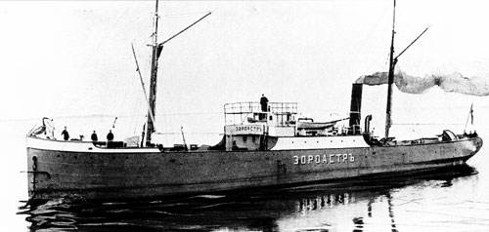
Zoroaster, the world's first tanker, delivered to the Nobel brothers in Baku, Azerbaijan.

In 1883, oil tanker design took a large step forward. Working for the Nobel Company, British engineer Colonel Henry F. Swan designed a set of three Nobel tankers. Instead of one or two large holds, Swan's design used several holds which spanned the width, or beam, of the ship. These holds were further subdivided into port and starboard sections by a longitudinal bulkhead. Earlier designs suffered from stability problems caused by the free surface effect, where oil sloshing from side to side could cause a ship to capsize. But this approach of dividing the ship's storage space into smaller tanks virtually eliminated free-surface problems. This approach, almost universal today, was first used by Swan in the Nobel tankers Blesk, Lumen, and Lux.
The supertanker era
Until 1956, tankers were designed to be able to navigate the Suez Canal. This size restriction became much less of a priority after the closing of the canal during the Suez Crisis of 1956. Forced to move oil around the Cape of Good Hope, ship-owners realized that bigger tankers were the key to more efficient transport. While a typical T2 tanker of the World War II era was 162 meters (532 ft) long and had a capacity of 16,500 DWT, the ultra-large crude carriers (ULCC) built in the 1970s were over 400 meters (1,300 ft) long and had a capacity of 500,000 DWT. Several factors encouraged this growth. Hostilities in the Middle East which interrupted traffic through the Suez Canal contributed, as did nationalization of Middle East oil refineries. Fierce competition among ship-owners also played a part. But apart from these considerations is a simple economic advantage: the larger an oil tanker is, the more cheaply it can move crude oil, and the better it can help meet growing demands for oil.
In 1955 the world's largest supertanker was 30,708 GRT and 47,500 LT DWT: SS Spyros Niarchos launched that year by Vickers Armstrongs Shipbuilders Ltd in England for Greek shipping magnate Stavros Niarchos.
In 1958 United States shipping magnate Daniel K. Ludwig broke the record of 100,000 long tons of heavy displacement. His Universe Apollo displaced 104,500 long tons, a 23% increase from the previous record-holder, Universe Leader which also belonged to Ludwig.
The world's largest supertanker was built in 1979 at the Oppama shipyard by Sumitomo Heavy Industries, Ltd., named Seawise Giant. This ship was built with a capacity of 564,763 DWT, a length overall of 458.45 meters (1,504.1 ft) and a draft of 24.611 meters (80.74 ft).[27] She had 46 tanks, 31,541 square meters (339,500 sq. ft) of deck, and at her full load draft, could not navigate the English Channel.
Seawise Giant was renamed Happy Giant in 1989, Jahre Viking in 1991, and Knock Nevis in 2004 (when she was converted into a permanently moored storage tanker). In 2009 she was sold for the last time, renamed Mont, and scrapped.
As of 2011, the world's two largest working supertankers are the TI-class supertankers TI Europe and TI Oceania. These ships were built in 2002 and 2003 as Hellespont Alhambra and Hellespont Tara for the Greek Hellespont Steamship Corporation. Hellespont sold these ships to Overseas Ship holding Group and Euronav in 2004. Each of the sister ships has a capacity of over 441,500 DWT, a length overall of 380.0 meters (1,246.7 ft) and a cargo capacity of 3,166,353 barrels (503,409,900 l). They were the first ULCCs to be double-hulled. To differentiate them from smaller ULCCs, these ships are sometimes given the V-Plus size designation.
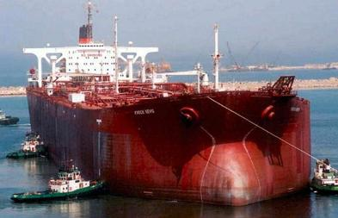
TT Knock Nevis, formerly Seawise Giant.

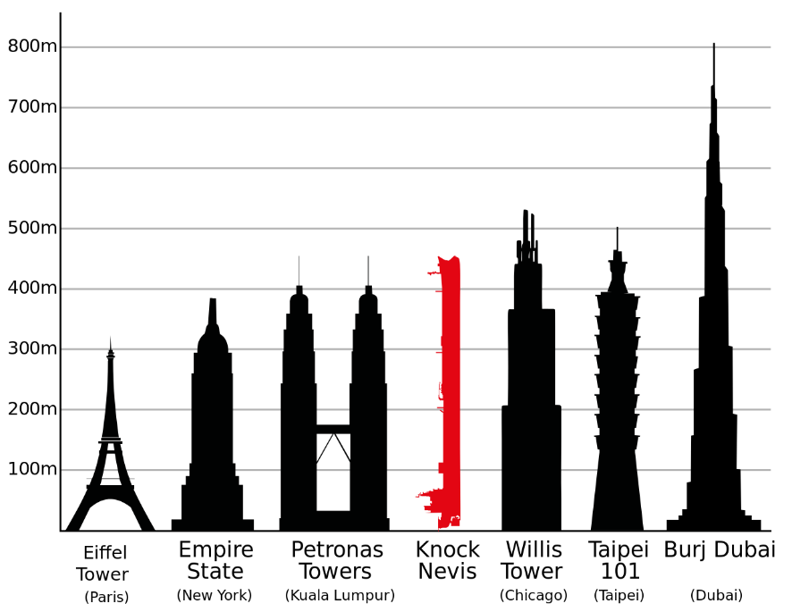
Knock Nevis, ex Seawise Giant rivaled some of the world's largest buildings in size

Types of Oil Tankers
Tankers however are not just restricted to one particular type or variety. There are many varied types of tankers that are used in the process of oceanic cargo transportation. This classification of tankers can be based on several factors. However, there are two categories in which shipping tankers can be classified:
- By Type/Purpose.
- By Size.

Classified of the Tankers on basis of Type/purpose
- Oil Tankers: as their name suggests carry oil and it’s by products. Oil tanker however, is a generic terminology and includes not only crude oil but also petrol, gasoline, kerosene and paraffin. Oil tankers are further sub-divided into two main types: product tankers and crude tankers:
- Product tankers are used to transport the above-mentioned petroleum based chemicals.
- Crude tankers are specifically used to transport crude oil from the excavation site to the crude oil refining industrial plant.

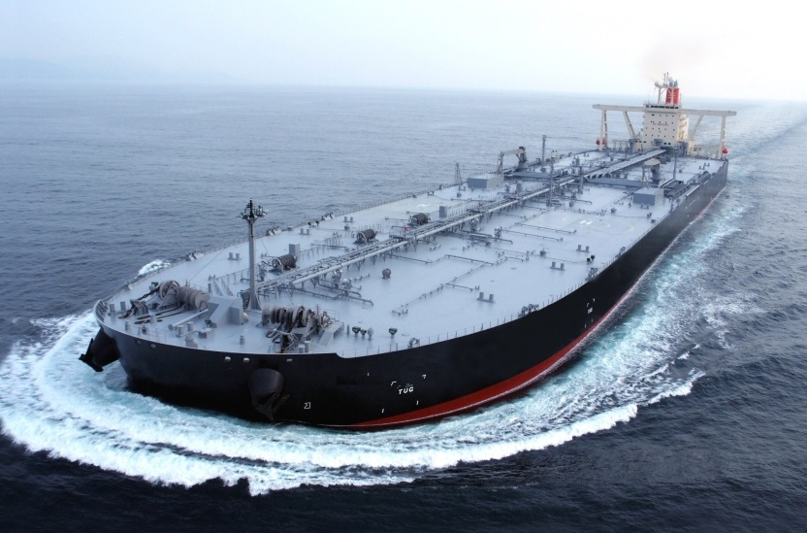

- LNG Carrier: are those tanker ships that are used to cargo LNG or Liquefied Natural Gas. These types of tankers require careful and delicate handling owing to the precariousness of the material they carry. Statistically speaking, there are around 193 LNG tankers that are currently under operation.

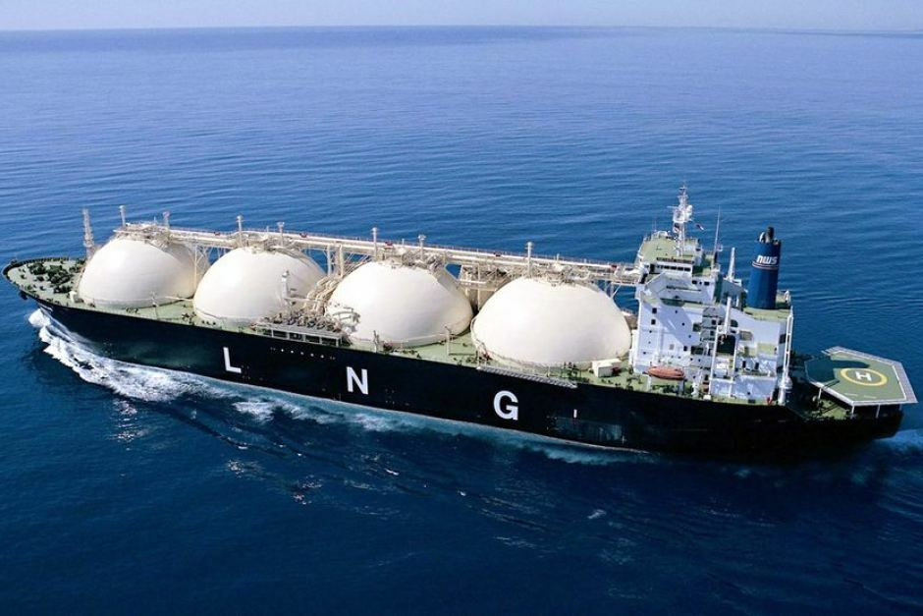

- Chemical Tankers: are those cargo tankers which transport chemicals in various forms. Chemical tankers are specifically designed in order to maintain the consistency of the chemicals they carry aboard them. These tanker ships are applied with coatings of certain substances that help in the easy identification of the chemicals that need to be transported.

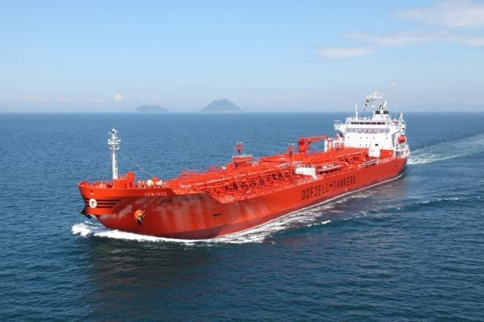
- Slurry Tankers: Slurry refers to all those materials that do not disperse or dissolve in water – otherwise regarded as waste materials. Slurry is used as a fertilizer and the slurry tankers help to haul slurry to areas where they can be put to productive use.

- Hydrogen Tankers: As the name suggests, hydrogen tankers are cargo tankers used for the shipping and transportation of liquefied hydrogen gas.

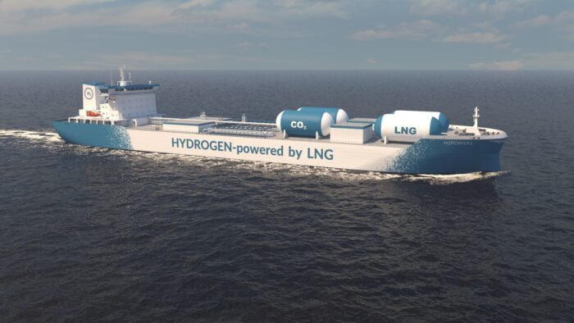

- Juice Tankers: Juice tankers or more specifically orange juice tankers which are used for the cargo carrying of orange juice in mass quantities. One of the biggest juice tankers is the Brazilian tanker Carlos Fischer. However, other fruit juices carriers are also available.

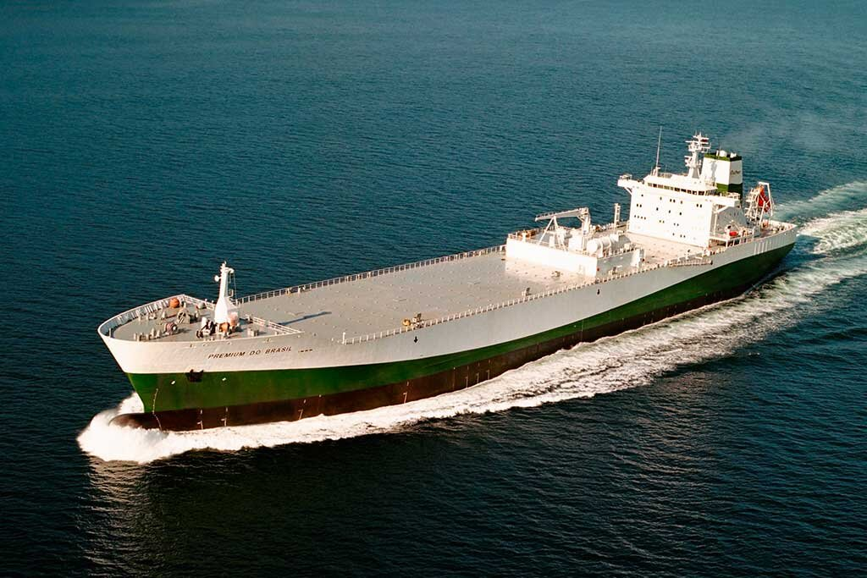
- Wine Tankers: Transporting wine has become quite simpler and feasible in contemporary times as sleek tankers have come up which are used specifically to carry wine to their intended destinations.

- ITB (Integrated Tug Barges): ITBs are prominently used in the eastern coast of the United States. These tankers are mainly tugs attached to barges leading to the formation of a single cargo carrying unit.

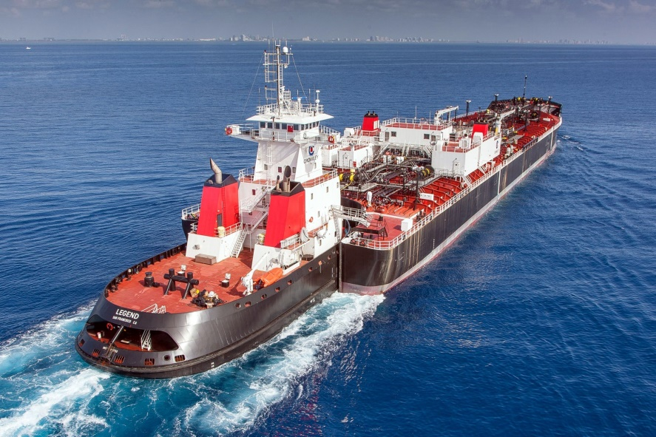

Classification of Tankers on the basis of Size
Some of the tankers shipping varieties in this category are as follows:
- VLCC: Known as Very Large Crude Carriers, these tankers have a cargo carrying capacitance of 2, 50,000 tons.

- ULCC: They are known as Ultra Large Crude Carriers and have a cargo hauling capacitance range up to 5, 00,000 tons. Know more about them here.

- Panamax: The classification of tankers that can pass through the Panama Canal is known as the Panamax. The cargo tankers which cannot be classified under this category owing to their size are known as the Post-Panamax tankers. Panamax specifications have been in effect since the opening of the canal in 1914. In 2009 the ACP published the New Panamax (Neopanamax) specification which came into effect when the canal's third set of locks, larger than the original two, opened on 26 June 2016. Ships that do not fall within the Panamax-sizes are called post-Panamax.

- Aframax: The Aframax cargo tankers are that type of tanker ships which are mainly used in the Mediterranean, China Sea and the Black Sea. These tankers have a dead weight tonnage (DWT) between 80,000 and 1, 20,000 tonnes.

- Suezmax: Panamax tankers are named for vessels which can navigate through the Panama Canal. On similar lines, the Suezmax vessels are so called because of their ease in passing through the Suez Canal.

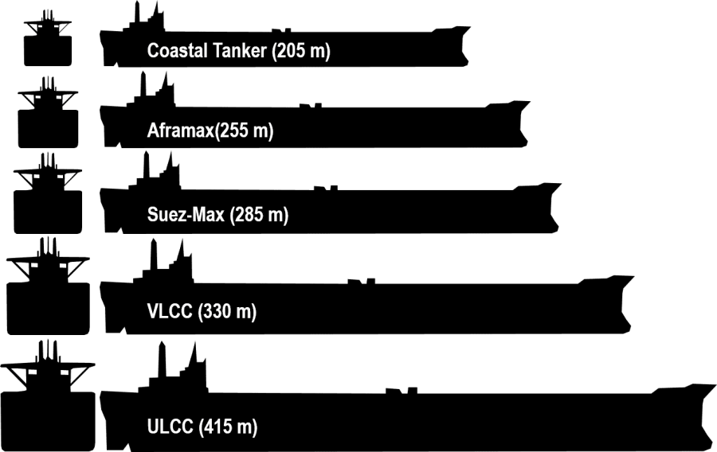

Double-Hulled Tanker

A double-hulled tanker refers to an oil tanker which has a double hull. They reduce the likelihood of leaks occurring than in single-hulled tankers, and their ability to prevent or reduce oil spills led to double hulls being standardized for oil tankers and other types of ships including by the International Convention for the Prevention of Pollution from Ships or MARPOL Convention. After the Exxon Valdez oil spill disaster in Alaska in 1989, the US Government required all new oil tankers built for use between US ports to be equipped with a full double hull.

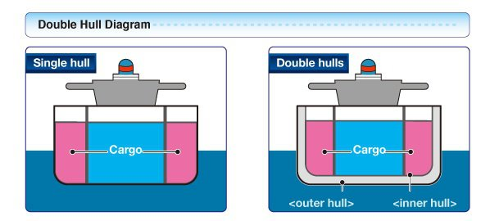

A number of manufacturers have embraced oil tankers with a double hull because it strengthens the hull of ships, reducing the likelihood of oil disasters in low-impact collisions and groundings over single-hull ships. They reduce the likelihood of leaks occurring at low speed impacts in port areas when the ship is under pilotage. Research of impact damage of ships has revealed that double-hulled tankers are unlikely to perforate both hulls in a collision, preventing oil from seeping out. However, for smaller tankers, U shaped tanks might be susceptible to "free flooding" across the double bottom and up to the outside water level each side of the cargo tank. Salvors prefer to salvage doubled-hulled tankers because they permit the use of air pressure to vacuum out the flood water. In the 1960s, collision proof double hulls for nuclear ships were extensively investigated, due to escalating concerns over nuclear accidents.

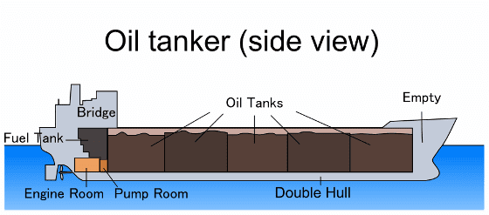
The ability of double-hulled tankers to prevent or reduce oil spills led to double hulls being standardized for other types of ships including oil tankers by the International Convention for the Prevention of Pollution from Ships or MARPOL Convention. In 1992, MARPOL was amended, making it "mandatory for tankers of 5,000 DWT and more ordered after 6 July 1993 to be fitted with double hulls, or an alternative design approved by IMO". However, in the aftermath of the Erika incident of the coast off France in December 1999, members of IMO adopted a revised schedule for the phase-out of single-hull tankers, which came into effect on 1 September 2003, with further amendments validated on 5 April 2005.

After the Exxon Valdez oil spill disaster, when that ship grounded on Bligh Reef outside the port of Valdez, Alaska in 1989, the US Government required all new oil tankers built for use between US ports to be equipped with a full double hull. However, the damage to the Exxon Valdez penetrated sections of the hull (the slops oil tanks, or slop tanks) that were protected by a double bottom, or partial double hull.

Although double-hulled tankers reduce the likelihood of ships grazing rocks and creating holes in the hull, a double hull does not protect against major, high-energy collisions or groundings which cause the majority of oil pollution, despite this being the reason that the double hull was mandated by United States legislation. Double-hulled tankers, if poorly designed, constructed, maintained and operated can be as problematic, if not more problematic than their single-hulled counterparts. Double-hulled tankers have a more complex design and structure than their single-hulled counterparts, which means that they require more maintenance and care in operating, which if not subject to responsible monitoring and policing, may cause problems. Double hulls often result in the weight of the hull increasing by at least 20%, and because the steel weight of double-hulled tanks should not be greater than that of single-hulled ships, the individual hull walls are typically thinner and theoretically less resistant to wear. Double hulls by no means eliminate the possibility of the hulls breaking apart. Due to the air space between the hulls, there is also a potential problem with volatile gases seeping out through worn areas of the internal hull, increasing the risk of an explosion.

Although several international conventions against pollution are in place, as of 2003 there was still no formal body setting international mandatory standards, although the International Safety Guide for Oil Tankers and Terminals (ISGOTT) does provide guidelines giving advice on optimum use and safety, such as recommending that ballast tanks are not entered while loaded with cargo, and that weekly samples are made of the atmosphere inside for hydrocarbon gas. Due to the difficulties of maintenance, ship builders have been competitive in producing double-hulled ships which are easier to inspect, such as ballast and cargo tanks which are easily accessible and easier to spot corrosion in the hull. The Tanker Structure Cooperative Forum (TSCF) published the Guide to Inspection and Maintenance of Double-Hull Tanker Structures in 1995 giving advice based on experience of operating double-hulled tankers.

Mid-deck tanker
A mid-deck oil tanker is a tanker design which includes an additional deck intended to limit spills if the tanker is damaged. The extra deck is placed at about the middle of the draft of the ship. This design is an alternative to the double-hull tanker design, and is superior in terms of spill volume.
Although double-hull design is superior in low energy casualties and prevents spillage in small casualties, in high energy casualties where both hulls are breached, oil can spill through the double-hull and into the sea. In grounding events of this type, a mid-deck design overcomes this by eliminating the double-bottom compartments that are void with air. Since the density of seawater is greater than that of oil, water comes into the tanks instead of oil escaping out, and rather than spilling, oil is vented upwards into overflow tanks.
A variation on the mid-deck tanker is the Coulombi Egg Tanker, which was approved by IMO as an alternative to the double hull concept. The United States Coast Guard does not allow this design to enter US waters, effectively preventing it from being built, although it is superior to the double hull in high energy casualties.

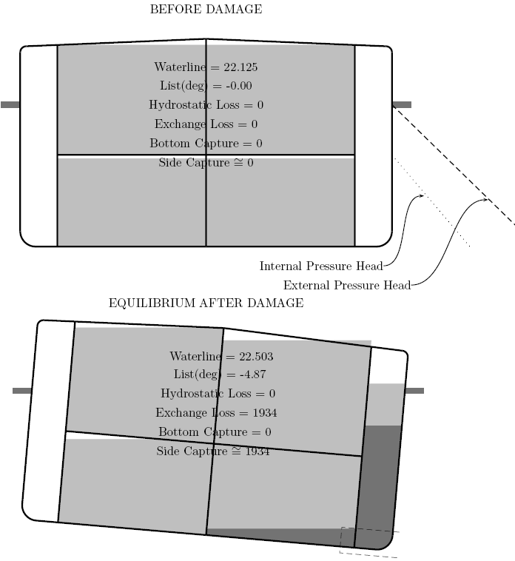
Mid-Deck Tanker, damage up 3 m. Light gray is oil, dark gray is seawater.

Types of Chemical Tankers
A chemical tanker is a type of tanker ship designed to transport chemicals in bulk. As defined in MARPOL Annex II, chemical tanker means a ship constructed or adapted for carrying in bulk any liquid product listed in chapter 17 of the International Bulk Chemical Code. As well as industrial chemicals and clean petroleum products, such ships also often carry other types of sensitive cargo which require a high standard of tank cleaning, such as palm oil, vegetable oils, tallow, caustic soda, and methanol.

Oceangoing chemical tankers range from 5,000 tons deadweight (DWT) to 35,000 DWT in size, which is smaller than the average size of other tanker types due to the specialized nature of their cargo and the size restrictions of the port terminals where they call to load and discharge.
Chemical tankers normally have a series of separate cargo tanks which are either coated with specialized coatings such as phenolic epoxy or zinc paint, or made from stainless steel.
The coating or cargo tank material determines what types of cargo a particular tank can carry: stainless steel tanks are required for aggressive acid cargoes such as sulfuric and phosphoric acid, while 'easier' cargoes — such as vegetable oil — can be carried in epoxy coated tanks. The coating or tank material also influences how quickly tanks can be cleaned. Typically, ships with stainless steel tanks can carry a wider range of cargoes and can clean more quickly between one cargo and another, which justifies the additional cost of their construction.

Main characteristics of chemical tankers
Chemical tankers often have a system for tank heating in order to maintain the viscosity of certain cargoes, typically by passing pressurized steam through stainless steel 'heating coils' in the cargo tanks, transferring heat into the cargo which circulates in the tank by convection. All modern chemical tankers feature double hull construction and most have one hydraulically driven, submerged cargo pump for each tank with independent piping, which means that each tank can load a separate cargo without any mixing. Consequently, many oceangoing chemical tankers may carry numerous different grades of cargo on the same voyage, often loading and discharging these "parcels" at different ports or terminals.
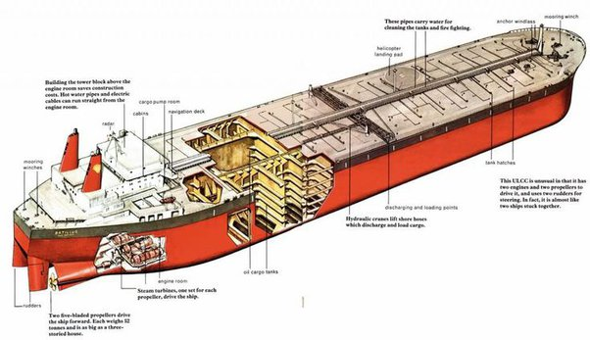
This means that the scheduling, stowage planning and operation of such ships requires a high level of coordination and specialist knowledge, both at sea and on shore. Tank cleaning after discharging cargo is a very important aspect of chemical tanker operations, because tanks which are not properly cleaned of all cargo residues can adversely affect the purity of the next cargo loaded. Before tanks are cleaned, they must be properly ventilated and checked to be free of potentially explosive gases.
Chemical tankers usually have transverse stiffeners on deck rather than inside the cargo tanks, in order to make the tank walls smooth and thus easier to clean using permanently fitted tank cleaning machines.
Cargo tanks empty or filled, are normally protected against explosion by inert gas blankets. Often nitrogen is the inert gas used, supplied either from portable gas bottles or a Nitrogen generator.
Most new chemical tankers are built by shipbuilders in Japan, Korea or China, with other builders in Turkey, Italy, Germany and Poland. Japanese shipbuilders now account for the large majority of stainless steel chemical tankers built, as welding stainless steel to the accuracy required for cargo tank construction is a skill which is difficult to acquire.

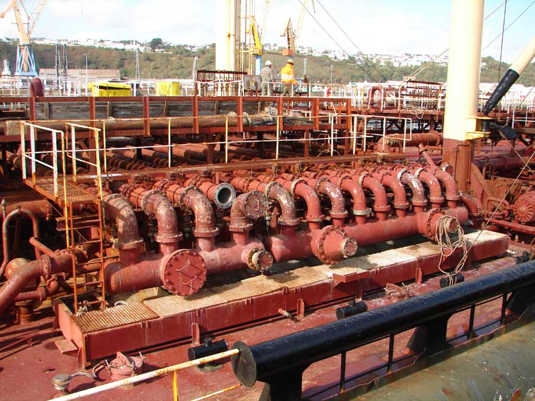
The deck of a chemical tanker has a complicated piping system.

Notable major chemical tanker operators include Stolt-Nielsen, Odfjell, Navig8 and Mitsui O.S.K. Lines. Charterers, the end users of the ships, include oil majors, industrial consumers and specialist chemical companies.

Classification
In general, ships carrying chemicals in bulk are classed into three types:
- Type 1: is a chemical tanker intended to transport Chapter 17 of the IBC Code products with very severe environmental and safety hazards which require maximum preventive measures to preclude an escape of such cargo.
- Type 2: is a chemical tanker intended to transport Chapter 17 of the IBC Code products with appreciably severe environmental and safety hazards which require significant preventive measures to preclude an escape such as cargo.
- Type 3: is a chemical tanker intended to transport Chapter 17 of the IBC Code products with sufficiently severe environmental and safety hazards which require a moderate degree of containment to increase survival capability in a damaged condition. Most chemical tankers are IMO 2 and 3 rated, since the volume of IMO 1 cargoes is very limited.

Basic knowledge of ship arrangement of an oil tanker and chemical tankers

Cargo Tanks

- Independent tank: This is a cargo-containment unit that is not contiguous with, or part of, the hull structure. An independent tank is built and installed to eliminate or minimize stressing that result from stressing or motion of the adjacent hull structure. An independent tank is not essential to the structural completeness of the ship's hull and is known as a Type 1 tank.

- Integral tank: This is a cargo-containment area that forms part of the ship's hull that may be stressed in the same manner and by the same loads as the contiguous hull structure. This is normally essential to the structural completeness of the ship's hull and is known as a type 2 tank.
- Gravity tank: This is a tank with a design pressure of not greater than 0.07 MPa gauge at the top of the tank. A gravity tank may be independent or integral. It will be constructed and tested according to recognized standards and will take into account the temperature of carriage and the relative density of the cargo.
- Pressure tank: This is a tank with a design pressure greater than 0.07 MPa gauge. A pressure tank must be an independent tank and should have a configuration that permits the application of pressure-vessel design criteria of recognized standard.

Segregated Ballast
It means the ballast water introduced into a tank which is completely segregated from the cargo oil and oil fuel system & which is permanently allocated to the carriage of ballast or to cargos other than oil & Noxious Liquid substances.

Slop tanks
Tanks in an oil tanker used to collect drainings, tank washings and other oily mixtures.
Slop tanks are the focal point of the Load-On-Top system used on crude oil tankers to prevent pollution of the sea. Design of these tanks and their operating procedures strongly affect the degree of oil-water separation achieved. This paper presents the results of an investigation undertaken to define designs and procedures for improving separation and minimizing oil discharge to sea. The program was funded in part by the U.S. Maritime Administration.
Based on tanker experience and laboratory tests with tank models, guidelines on capacity, structure, inlets, outlets, system design, and wastewater handling, procedures were developed.
The guidelines aim at assuring successful Load-On-Top operations by:
- Providing tanker operational flexibility for handling oily water,
- Minimizing the degree of oil-water mixing,
- Avoiding re-dispersion of separated oil during feeding and discharging operations, and
- Eliminating the possibility of accidental oil contamination.
This investigation provides a basis for future large-scale or shipboard studies to improve the performance of slop tanks on existing tankers as well as on future tankers.

Cofferdams
It refers to an insulating space between two watertight bulkheads or decks within a ship. A cofferdam may be a void (empty) space or a ballast space. Cofferdams are usually employed to ensure oil or other chemicals do not leak into machinery spaces. If two different cargoes that react dangerously with each other are carried on the same vessel, one or more cofferdams are usually required between the cargo spaces.

Peak Tanks
Forepeak and Afterpeak Tanks. These tanks are at the ends of the ship. They are usually used for ballast to ‘trim’ the ship; that is, to keep it level or at the angle required.
The forepeak is the space between the stem and the collision bulkhead. The distance between the stem and the collision bulkhead must be at least 5 per cent of the ships’ length and not more than 8 per cent. The forepeak tank is the part of the forepeak up to the deck. The after peak tank occupies the space between the stern and the after peak tank bulkhead. Both peak tanks may be used for fresh water or ballast.

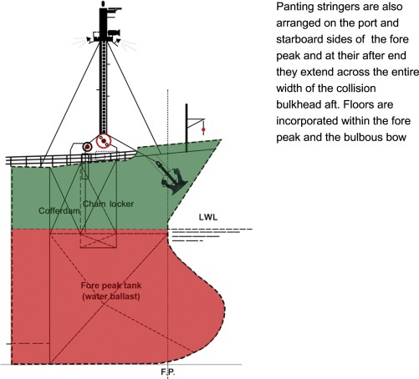

Deep Tank
In ship-building, a tank formed by partitions or bulkheads cutting off a part of the hold and specially constructed to hold water ballast. See ballast-tank. A mid-ship deep-tank is in the middle of the length; the forepeak and after peak tanks, or trimming tanks, are at the ends of the vessel.

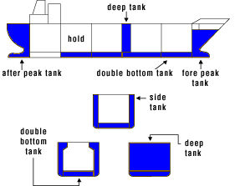
Cargo tanks of a tanker are required to be provided with venting systems to prevent both over and under pressurization of the tank. Two types of venting system are specified by the Code, namely “open” and “controlled”.
Open tank venting system – An open venting system is for cargoes which are of little or no flammable or toxic hazard.
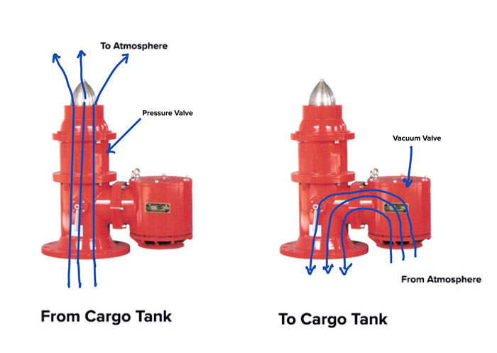
Pressure-vacuum valves
Controlled tank-venting system – Controlled venting systems are required to be fitted in all tanks carrying cargoes emitting harmful or flammable vapours. Each tank must be fitted with pressure/vacuum valve to relieve over-pressure or under-pressure.
Venting of cargo tanks during cargo transfer or cargo related operations must be carried out in accordance with applicable international, national, port and terminal regulations. On chemical tankers the general rule is that the primary venting system is PV valves and the secondary means are cargo tanks pressure monitoring system.
Tank vent system outlets are located at a safe distance from all areas where personnel who are not involved in cargo work may be present, to ensure that toxic vapours are diluted to a safe level of concentration before they can reach such an area. The safe distances specified depend on the severity of the toxic hazard. In all cases the principles described in the IMO Codes will have been met by the ship's design.

Cargo tanks venting arrangement - SOLAS requirement
The cargo tank venting system should be set for the type of operation to be performed. Cargo vapour displaced from tanks during loading or ballasting should be vented through the installed venting system to atmosphere, except when return of the vapour to shore is required. The cargo or ballast loading rate should not exceed a rate of vapour flow within the capacity of the installed system.
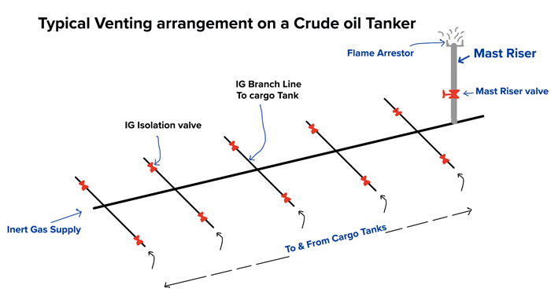
In the case of ships fitted with a venting system which is common to several tanks, it is important to remember that vapours (or liquid in the event of overfill) may pass through the venting system from one tank into another, and thereby cause contamination of cargo or tank atmosphere.
A required level of maintenance and inspection will be necessary to ensure the cleanliness of the venting system, and in particular of the P/V valves, high velocity valves and devices to prevent the passage of flame into cargo tanks. Particular attention should be given to the possibility of flame screens becoming blocked by dirt, freezing water, or vapour condensation from certain chemical cargoes - e.g., those with high melting points or liable to polymerase -since blockage can severely jeopardize tank integrity.

Pressure-vacuum valve (P/V valve)
A valve which keeps the tank over pressure or under pressure within approved, limits. P/V valve provides for the flow of the small volumes of vapour, air or inert gas mixtures caused by thermal variations in a cargo tank. The vacuum valve opens if the pressure in the tank falls below a pre-set level – to draw air into the tank through a flame trap. In the event of over-pressure, two release valves open to ensure that venting is upwards and at high velocity, to avoid concentrations of gas on deck.
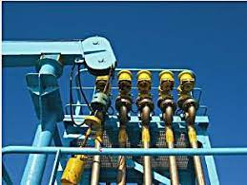
Pressure-vacuum valve (P/V valve)

The IBC Code requires the ship to be able to return vapours of most toxic chemicals to shore. When a tank is connected to a vapour return line, it is important to keep a safe pressure balance between the ship and shore. The vapours should be evacuated fast enough to keep the pressure in the tank below the set opening pressure of any pressure relief valve in the tank venting system; IMO guidelines recommend a maximum tank pressure of 80% of the set pressure. It is thus critically important clearly to agree in advance with the shore terminal management what the liquid loading rate and the pressure at the vapour connection will be, and to plan how they will be controlled.

Liquid should not be permitted to enter the vapour return line. If liquid gets into the vapour line it will cause the cross section available for the flow of vapour to be reduced, as a result of which the pressure inside the tank can rise rapidly. Loading should be suspended until the pressure is released, and the presence of liquid dealt with.
Connection of hoses intended for vapour transfer to manifold flanges of pipelines for liquid transfer is prevented by a stud permanently fixed between two bolt holes in the presentation flange of the ship's vapour return manifold. The stud will fit into a corresponding additional hole in the flange of the shore vapour hose. Vapour connections should also be identified by painting and stenciling in a standard way.
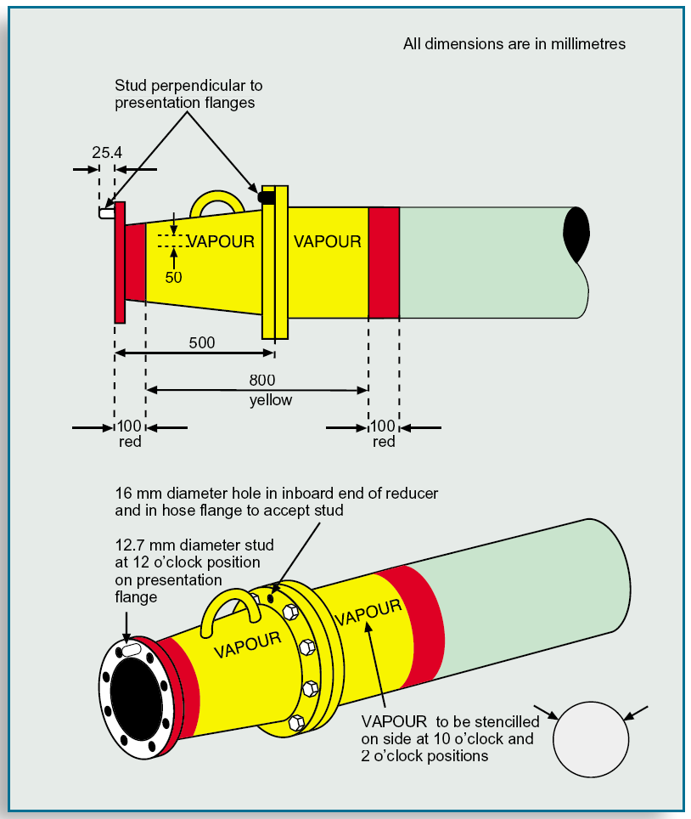
Vapour manifold presentation flanges, orientation and labelling

1.4 Pumps and eductors

The function of any pump is to transfer liquid from one point to another and this involves the use of piping. Such a transfer in a tanker can be divided into two parts:
- The movement of liquid from the tank to the pump. This is a function of the pump and its installation design. These factors are beyond the control of the ship provided the design ratings of the pump are maintained.
- The onward movement of the liquid from the pump to its destination. This is an area where the efficient operation of the pumps is essential if optimum results are to be obtained.

The major factors influencing pumping performance are discussed below. The flow of liquid to and from the pump must be matched exactly and this requires the flow on the suction side to be equal or greater than the discharge rate of the pump. Where the flow to the pump suction falls below the pumping rate cavitation will occur with the possibility of loss of suction and pump damage.
Centrifugal pumps do not suck liquids. The only factors which cause liquid to flow to the pump are:
- Pressure acting on the surface of the liquid.
- The height of the liquid level in the tank in relation to the pump suction. Since no centrifugal pump can generate a total vacuum at its suction inlet, only a proportion of the atmospheric pressure can be usefully employed. Therefore, before a pump can operate satisfactorily, a certain pressure must exist at the pump suction and this is known as the required Nett Positive Suction Head.

Types of Pumps

Centrifugal Pumps
The centrifugal pump has for many years been the most suitable pump where a high pumping capacity is the most important factor. The size and cost of such a pump does not increase in proportion with the throughput, as it is not a positive displacement pump. It requires either the provision of ancillary self-priming equipment for the removal of air in the system or a separate stripping system.
In a centrifugal pump the motive force is provided by a rotating impeller which takes its suction at its center and centrifuges the pumped liquid outwards to the casing discharge. The head generated is dependent on the diameter, blade angle and speed of rotation of the impeller. Flow rate is affected by the pressure in the discharge system and can fall to zero. Reverse flow through the pump can occur if a non-return valve is not fitted and operational on the discharge side of the pump.
The correct and efficient use of centrifugal pumps requires the observance of certain basic operating principles. Guidance on these principles is given here however, as manufacturers may incorporate special design features to meet operational requirements, the information given here must be read in conjunction with the manufacturers operating instructions and on board procedures organized.
The basic characteristics of a centrifugal pump are:
- Throughput varies with speed.
- Head varies as speed squared.
- Power required varies as speed cubed.

These relationships are subject to appreciable variation caused by the system in which the pump operates.

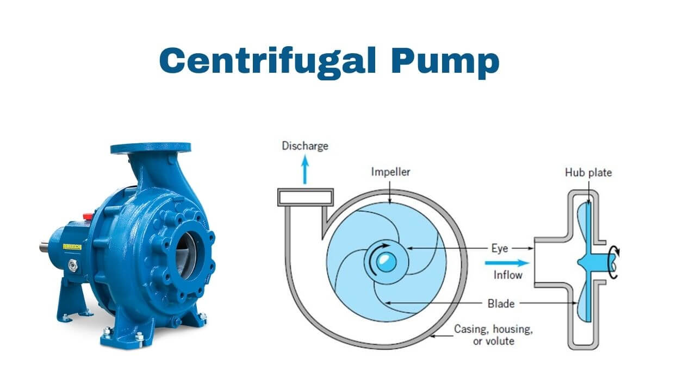

Positive Displacement Pump
Unlike the centrifugal pump, the positive displacement pumps used in dedicated stripping systems are capable of a low suction pressure and the ability to pick-up suction without external priming. This type of pump includes steam reciprocating pumps and ‘screw’ type pumps. Both types are now mainly used for stripping tanks or as specialized cargo pumps.
The suction and discharge valves of a positive displacement pump must always be open before starting the pump and must remain open until the pump is stopped. These pumps must not be operated in excess of their design speed and particular care must be taken to avoid these pumps over-speeding when they lose suction. Pressure relief devices must be checked at regular intervals to ensure their correct operation.
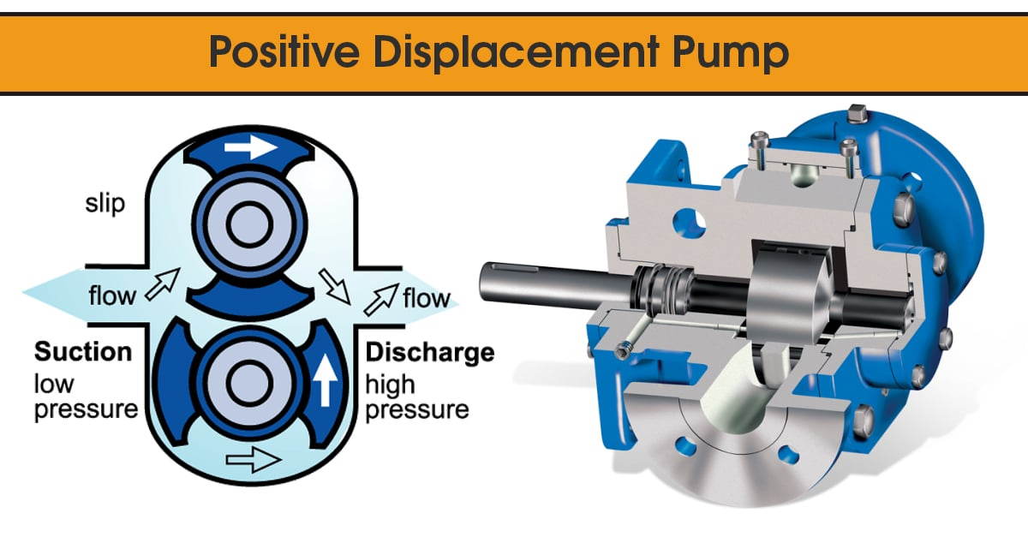

Submerged Pumps
Submerged pumps are relatively common on chemical carriers. This type of pump is usually powered hydraulically or electrically and provides for a pump located in each tank. Manufacturer’s instructions must be complied with for efficient operation of these pumps.
Submersible pumps are purged, using inert gas (ship’s IG or nitrogen) or air, as a means of checking for seal condition and tightness. The pumps must be purged before and after every loading/discharging/tank cleaning operation and the appropriate record form completed.
If the purging records indicate a deviation from the manufacturer’s recommended parameters, such as pump cofferdam is blocked or excessive seal leakage being detected, the management office is to be notified and appropriate corrective action is to be taken at the first opportunity.
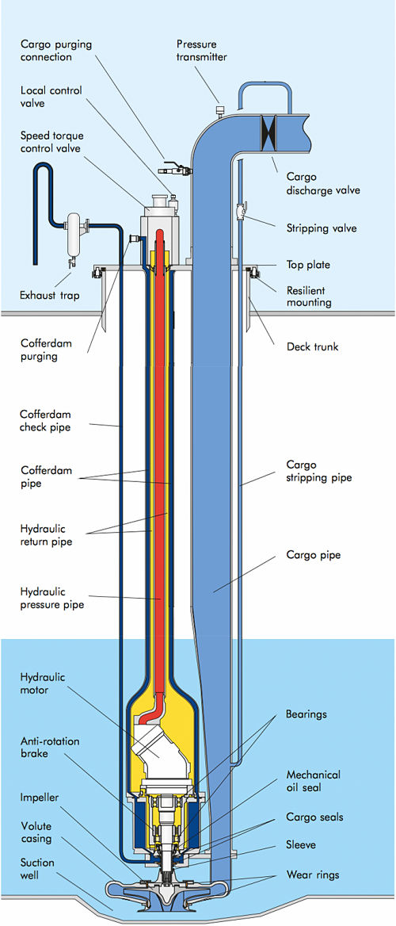

Portable Submersible (Emergency) Pump
Portable submersible pumps, are provided on chemical ships and other specialized liquid cargo carriers, for discharging cargo in the event of a main cargo pump failure. The pumps are usually hydraulically driven and lowered directly into the tank generally through a tank cleaning hatch.
All necessary safety precautions relevant to the actual cargo being handled are to be observed and permission obtained from the local port authorities before operations are commenced. It is a good practice to shut down the hydraulic oil pressure system before connecting and disconnecting hydraulic hoses of portable hydraulic driven emergency pumps.

Screw Pumps
A screw pump is a positive-displacement (PD) pump that use one or several screws to move fluids or solids along the screw(s) axis. In its simplest form (the Archimedes' screw pump), a single screw rotates in a cylindrical cavity, thereby moving the material along the screw's spindle. This ancient construction is still used in many low-tech applications, such as irrigation systems and in agricultural machinery for transporting grain and other solids.
Development of the screw pump has led to a variety of multiple-axis technologies where carefully crafted screws rotate in opposite directions or remains stationary within a cavity. The cavity can be profiled, thereby creating cavities where the pumped material is "trapped".
In offshore and marine installations, a three-spindle screw pump is often used to pump high-pressure viscous fluids. Three screws drive the pumped liquid forth in a closed chamber. As the screws rotate in opposite directions, the pumped liquid moves along the screws' spindles.
Three-spindle screw pumps are used for transport of viscous fluids with lubricating properties. They are suited for a variety of applications such as fuel-injection, oil burners, boosting, hydraulics, fuel, lubrication, circulating, feed and so on.
Compared to centrifugal pumps, positive-displacement pumps have several advantages. The pumped fluid is moving axially without turbulence which eliminates foaming that would otherwise occur in viscous fluids. They are also able to pump fluids of higher viscosity without losing flow rate. Also, changes in the pressure difference have little impact on PD pumps compared to centrifugal pumps.
The term ‘screw pump' is often used generically. However, this generalization can be a pitfall as it fails to recognize the different product or ‘screw' configurations, as well as the uses, advantages and design considerations for each. The design differences of each screw configuration and pump type make each suitable for different applications and handling fluids with varying characteristics.
Each ‘screw pump' operates on the same basic principle of a screw turning to isolate a volume of fluid and convey it. However, the mechanical design of each is different. The primary difference is the number of screws: one, two, three or more.

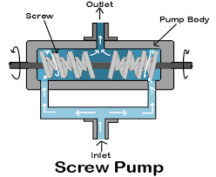

Piston Pump
A piston pump is a type of positive displacement pump where the high-pressure seal reciprocates with the piston. Piston pumps can be used to move liquids or compress gases. They can operate over a wide range of pressures. High pressure operation can be achieved without a strong effect on flow rate. Piston pumps can also deal with viscous media and media containing solid particles.
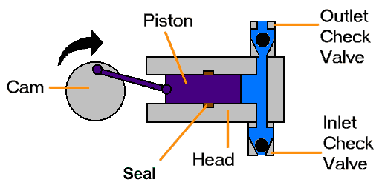

The two main types of piston pump are the lift pump and the force pump. Both types may be operated either by hand or by an engine.
- Lift pump
In a lift pump, the upstroke of the piston draws water, through a valve, into the lower part of the cylinder. On the downstroke, water passes through valves set in the piston into the upper part of the cylinder. On the next upstroke, water is discharged from the upper part of the cylinder via a spout.

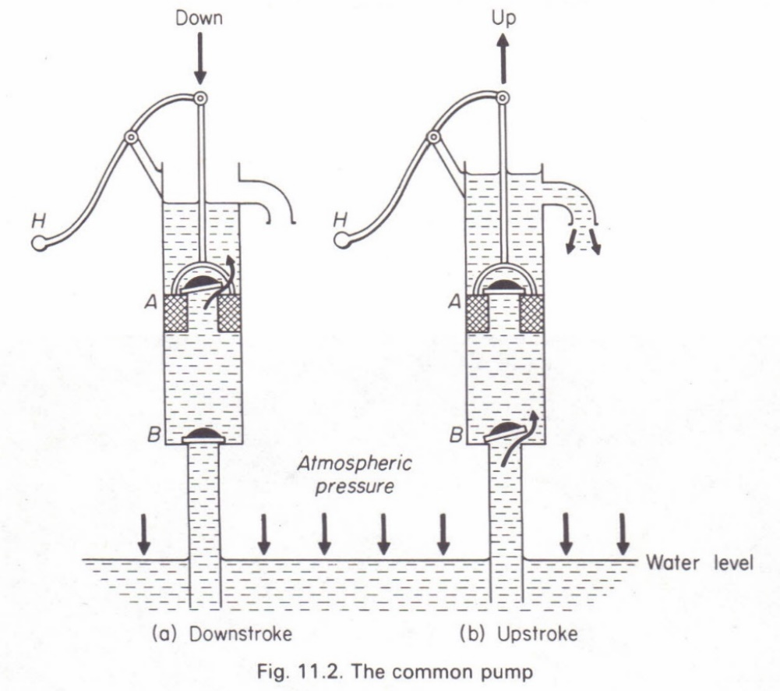

- Force pump
In a force pump, the upstroke of the piston draws water, through an inlet valve, into the cylinder. On the downstroke, the water is discharged, through an outlet valve, into the outlet pipe.
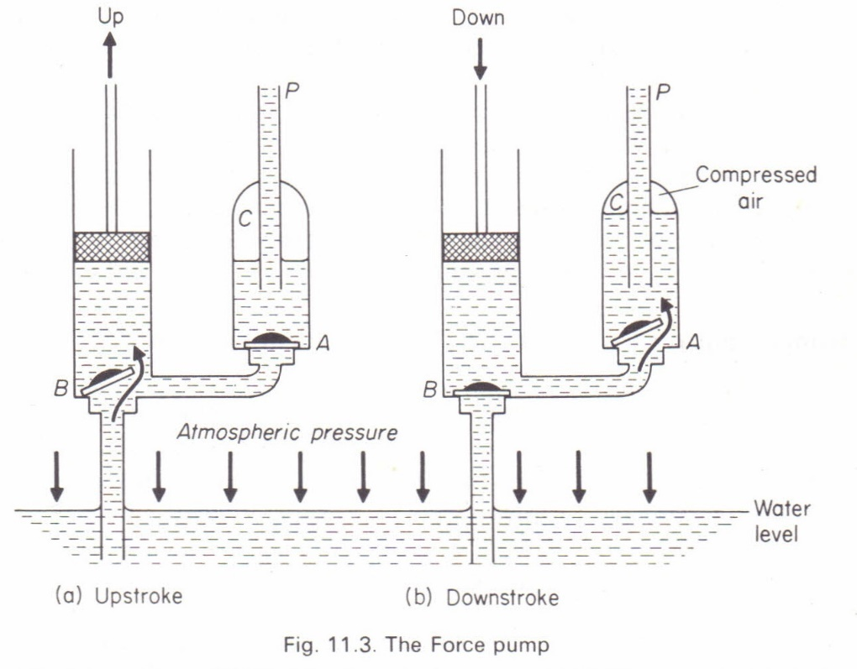

Use of eductors
Eductors may be used for ballast stripping purposes. To strip efficiently, an eductor used for tank cleaning operations should have a capacity of about twice the rate of liquid being introduced to the tanks.
- Eductors are always to be operated at or near their design driving pressure as, in general, lower driving pressures will considerably reduce eductor efficiency. Higher back pressures in the system than the eductor was designed for can also reduce suction capacity.
- The eductor drive liquid must always be flowing before the suction valve is opened to prevent back flow of the driving liquid to the tank suction.
- When shutting down an eductor the suction valve is to remain open until the eductor is stopped to prevent the eductor drawing a vacuum on the suction line.
- If, during use, the eductor driving pressure falls below the required operating pressure, the eductor suction valve is to be closed to prevent backflow of the driving liquid. The tank suction must not be used to prevent backflow as the suction pipework is not designed for such high operating pressures.

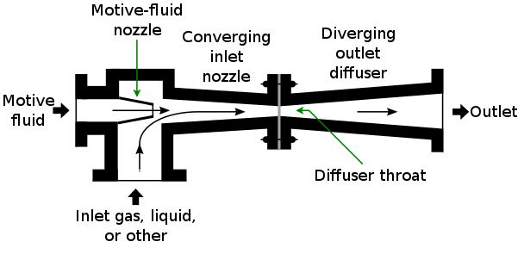

Cargo heating system
In a modern chemical tanker in order to maintain product quality, to minimize the potential for discoloration, and to facilitate some liquid cargo transport in a safe manner cargo heating is required.
The voyage orders will contain heating information, if heating is required. As a rule the final heating instructions are given by the Shipper in writing to the Master / Chief Officer in the port of loading. If those written instructions are not given, the master should request them and issue a Letter of Protest if they are not received at departure. In the latter case the management office should be immediately informed.
The heating instructions may contain any, or all, of the following:
- Minimum and maximum temperature during the voyage.
- Minimum and maximum temperature during discharge.
- Maximum temperature of adjacent cargo.
- Heating medium (when loading edible oils only steam and / or hot water should be utilized as the heating medium in coils / heat exchangers. Thermal oil should not be used as a heating medium for edible oils).
- Maximum temperature of the heating medium.
- The maximum possible temperature increases per unit of time: delta T°C/hour.

The heating of liquid cargo is a highly important matter as it regards the transport of high viscous fluids (crude oil, fuel oil, virgin naphtha, molasses, etc.). For any type of crude oil there exists a minimal temperature that must be maintained during the transport, because under it there arise dangerous phenomena of settling. Moreover, normally a still higher temperature must be reached in order to obtain the necessary fluidity of the transported liquid needed during the pumping and discharging operations.

The heating system must assure adequate mechanical resistance to the vibrations and to the stress transmitted by the hull to the heating coils. Moreover, it must guarantee resistance to the corrosion provoked by the cargo and the sea-water used for the washing and ballasting operations. Finally, the system must be light and simple to be installed.
Normally the heating of the liquid cargo of the tanks can be realized with coils or with prefabricated elements.

The traditional concept of tank heating was to use a serpentine coil manufactured from pipes, laid at the bottom of the tank. The heating fluids such as steam / thermal fluids are passed through these pipes to achieve heating.

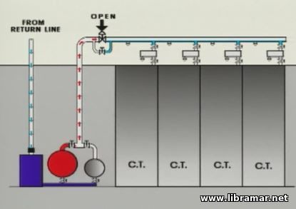

This traditional method did work fine and satisfactorily when the average tank sizes were relatively smaller. This concept itself was innovative once upon a time and gained popularity due to easy availability of raw material (in this case pipes), easy concept for design and fabrication.
In many instances of tank designs, the tank heating had been a matter of lesser importance due to several reasons such as:
- Heating coil design and fabrication is considered as part of tank design.
- Supply & installation of heating coil in the scope of tank fabrication and not routed through thermal or heat transfer designers.
- Thermal Performance subject to interpretation due to Changing temperatures over the day & year (due to changing seasons)
- Absence of uniformly accepted standard / code for measurement of thermal performance
- Traditionally the tank sizes had been relatively small. Due to changing dynamics and cost structure, the average storage tank sizes are increasing nowadays.
- The traditional method of heating with pipes worked fine for smaller tanks. Eventually an extension of the same traditional concept was being adopted for many larger tanks. On those projects, heating became more complicated.
- Heating coils may be installed in Slop Tanks to heat and separate water in the emulsion layer.

Inert Gas System
Oil tankers carry oil of different grades and quality, having property to produce flammable vapors and gases when loaded for transportation. Even with no cargo on board, there can be harmful flammable gases present in the hold. When the vapor produced by an oil cargo is mixed with certain concentration of air primarily containing oxygen, it can result in explosion which results in damages to the property, marine pollution and loss of life.
For safety against such explosion, Inert gas system is used on board. It can be through as a separate inert gas plant or flue gas produced by ship’s boiler. Inert gas system is the most important integrated system for oil tankers for safe operation of the ship. Inert gas is the gas which contains insufficient oxygen (normally less than 8 %) to suppress combustion of flammable hydrocarbon gases.
Inert gas system spreads the inert gas over the oil cargo hydrocarbon mixture which increases the lower explosion limit LEL (lower concentration at which the vapors can be ignited), simultaneously decreasing the Higher explosion limit HEL (Higher concentration at which vapor explodes). When the concentration reaches around 10 %, an atmosphere is created inside tank in which hydrocarbon vapors cannot burn. The concentration of inert gas is kept around 5% as a safety limit.

Components and description of IG system
The following components are used in a typical inert gas system in oil tankers:
- Exhaust gases source: inert gas source is taken from exhaust uptakes of boiler or main engine as contains flue gases in it.
- Inert gas isolating valve: It serve as the supply valve from uptake to the rest of the system isolating both the systems when not in use.
- Scrubbing tower: Flue gas enters the scrub tower from bottom and passes through a series of water spray and baffle plates to cool, clean and moist the gases. The SO2 level decreases up to 90% and gas becomes clear of soot.
- Demister: Normally made of polypropylene, it is used to absorb moisture and water from the treated flue gas.
- Gas Blower: Normally two types of fan blowers are used, a steam driven turbine blower for I.G operation and an electrically driven blower for topping up purpose.
- I.G pressure regulating valve: The pressure within the tanks varies with the property of oil and atmospheric condition. To control this variation and to avoid overheating of blower fan, a pressure regulator valve is attached after blower discharge which re-circulates the excess gas back to scrubbing tower.
- Deck seal: Purpose of the deck seal is to stop the gases to return back which are coming from the blower to cargo tanks. Normally wet type deck seals are used. A demister is fitted to absorb the moisture carried away by the gases.
- Mechanical non return valve: It is an additional non return mechanical device in line with deck seal.
- Deck isolating valve: The engine room system can be isolated fully with the deck system with the help of this valve.
- Pressure Vacuum (PV) breaker: The PV breaker helps in controlling the over or under pressurization of cargo tanks. The PV breaker vent is fitted with flame trap to avoid fire to ignite when loading or discharging operation is going on when in port.
- Cargo tank isolating valves: A vessel has numbers of cargo holds and each hold is provided with an isolating valve. The valve controls the flow of inert gas to hold and is operated only by a responsible officer in the vessel.
- Mast riser: Mast riser is used to maintain a positive pressure of inert gas at the time of loading of cargo and during the loading time it is kept open to avoid pressurization of cargo tank.
- Safety and alarm system: The Inert gas plant is provided with various safety features to safeguard the tank and its own machinery.

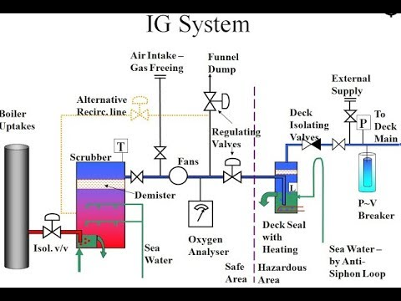

Following are various alarms (with Shutdown) incorporated in the Inert Gas plant on board ship:
- High Level in scrubber leads to alarm and shutdown of blower and scrubber tower
- Low pressure sea water supply (approx. 0.7 bar) to scrubber tower leads to alarm and shutdown of blower
- Low pressure sea water supply (approx. 1.5 bar) to deck seal leads to alarm and shutdown of blower
- High inert gas temperature (approx. 70 deg C) leads to alarm and shutdown of blower
- Low pressure in line after blower (approx. 250mm wg) leads to alarm and shutdown of blower
- Oxygen content high (8%) leads to alarm and shutdown of gas delivery to deck
- Low level in deck seal leads to alarm and shutdown of gas delivery to deck
- Power failure leads to alarm and shutdown of blower and scrubber tower
- Emergency stop leads to alarm and shutdown of blower and scrubber tower.

Following are various alarms incorporated in the Inert Gas plant:
- Scrubber low level.
- Deck seal High level.
- Low O2 Content (1%).
- High O2 Content (5%).
- Low lube oil pressure alarm.

Working of Inert Gas Plant
The basis of inert gas production in the IG plant is the flue gas generated from the ship’s boiler. The high temperature gas mixture from the boiler uptake is treated in an inert gas plant which cleans, cools and supplies the inert gas to the individual tanks via PV valves and breakers to ensure safety of tank structure and atmosphere.
The system can be divided into two basic groups:
- A production plant to produce inert gas and deliver it under pressure, by means of blower(s), to the cargo tanks.
- A distribution system to control the passage of inert gas into the appropriate cargo tanks at the required time.

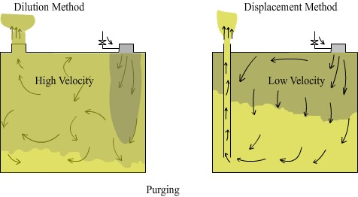

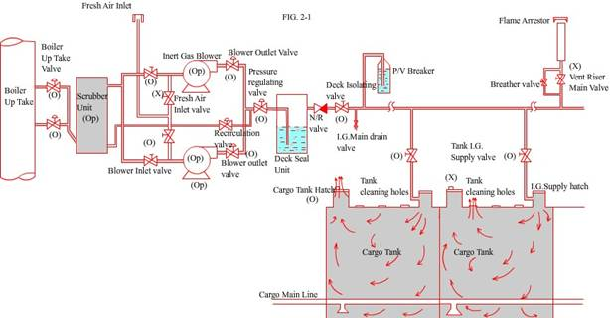

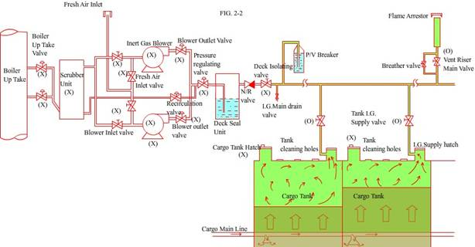

Cargo measurements systems
It is a usual practice to measure the cargo level aboard ship from time to time. The values obtained must be very accurate as inaccurate values may lead to environmental hazards or pollution. If the cargo overflows it will definitely cause pollution, so continuous monitoring of the cargo level is important.
There are different methods of gauging a cargo tank. Some of the devices used for the measurement of the cargo level on different tankers are:
- Float gauges.
- Radar gauges.
- Ultrasonic gauges.
- UTI indicators.
- Slip tubes.

Float gauges
Float gauges have been used widely on all gas carriers. Their construction is very simple, consisting of a float attached by a tape to an indicating device. The indicating device can be arranged so that the reading can be read out remotely or locally as desired. These are also fitted with isolation valves so that the float alone can be taken out and be serviced if required. A typical float level gauge used in a gas tanker is shown below.

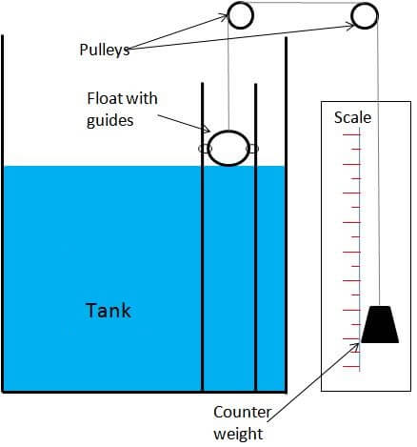

Radar gauges
This is another type of gauging equipment that operates on the principle of radar. This type of gauge is used on all modern tankers now-a-days for their accuracy and reliability. Radar gauges operate at very high frequencies (11 gigahertz). In case of gas carriers, the siting of the transmitter on the tank dome is very important for the most accurate operation.

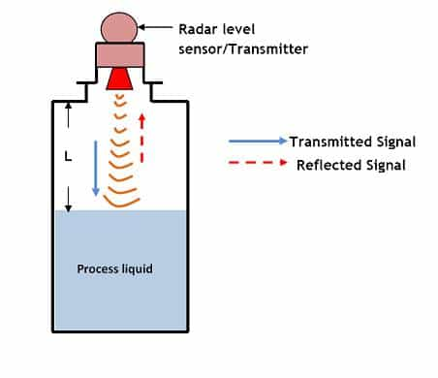

Advantages of Radar gauges
- Since the antenna is the only moving part inside the tank, it is highly accurate and highly reliable.
- Radar waves are most suitable because they are not affected by the atmosphere above the cargo in the tank.

Ultrasonic gauges
The working principle of the ultrasonic gauge is very similar to that of the echo sounders.

Usually they will measure either the ullage (unfilled space) or they will measure the depth of the liquid by reflecting sound waves from the liquid surface. The receiver may be located either on the tank dome (in gas carriers) or at the bottom of the tank. This type of gauge is not reliable, to be specific, because there may be problems in obtaining satisfactory readings when loading by spray lines. Another disadvantage is that the reading may vary depending upon changes in temperature and pressure.

UTI indicators
These are used widely on crude oil tankers. This type of gauge, as the name implies, measures the ullage, temperature, and interface. These are used during the final phases of loading and during the voyage. Sensors are provided at the bottom to indicate the water interface since most of the crude will contain water.

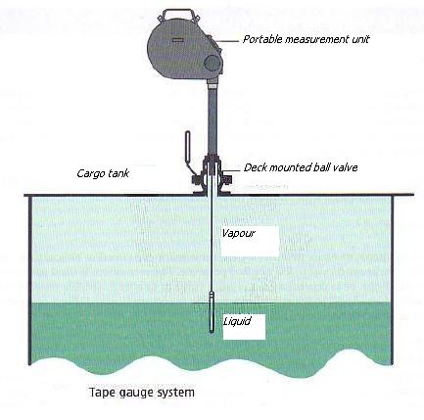

Slip tubes
As per the Gas Codes, slip tubes are classified under restricted type of gauging device. These are used widely on gas tankers. They are grouped under restricted type of gauging since there is a possibility of some amount of cargo vapor or liquid being released to the atmosphere during the measurement of the level. Care should be taken while using these types of gauges so that it doesn’t cause any harm to the environment. Some terminals forbid the use of these types of gauges for some types of cargoes.

They have an orifice (with a diameter restricted to 1.5 mm, unless an excess overflow valve is fitted) at the upper end which allows the liquid or vapor to be released to the atmosphere. The reading can be observed from the markings on the tube when the liquid level has reached them. Initially the vapor will be vented and then the liquid level rises.

Physical properties of oil and chemicals

Basic physics

State of Aggregation
Every material in our environment is in a particular state, like liquid, solid or gaseous. Every material can be in every state. Sometimes it is quite difficult to imagine materials like iron in a gaseous state, but if a certain level of temperature is reached, also iron can be in a gaseous state.

This statement leads us to the next important characteristic concerning states of aggregation: Every material can be in every state of aggregation and the state of aggregation depends on the material's temperature. For example, water is a material, which you know in every state. Water in a solid state you can find in winter-times outside, when it is snowing. Water in a liquid state you are drinking and water in a gaseous state you find in the sky, when it is cloudy. So, there is one material (in this case: water), in three different states. The state of water depends on special temperatures. Water changes it state from liquid to solid, by 0 degrees or lower. To change the state of water from liquid to gaseous you have to heat it up to 100 degrees or more.

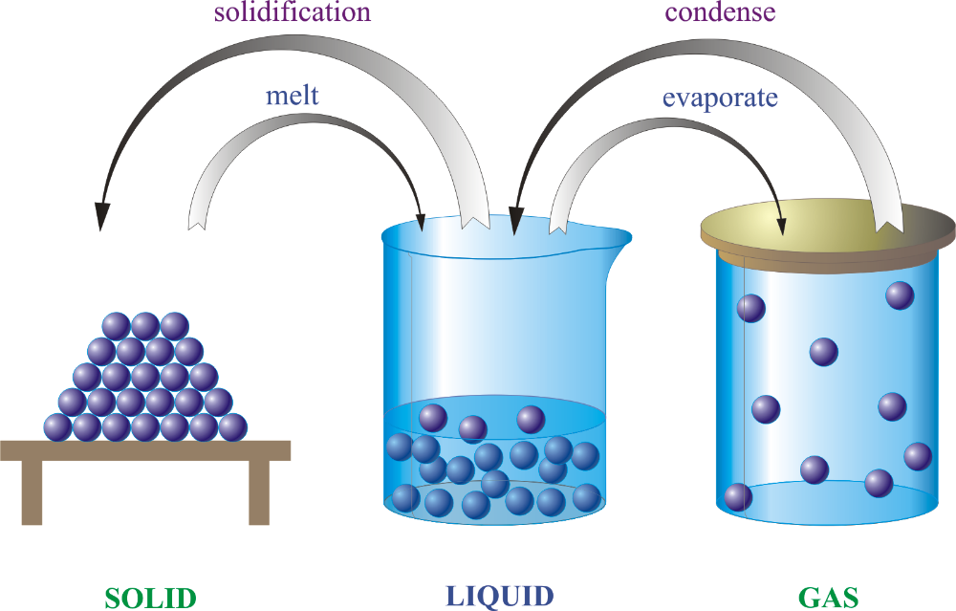

Liquid Density
The density, or more precisely, the volumetric mass density, of a substance is its mass per unit volume. The symbol most often used for density is ρ (the lower case Greek letter rho), although the Latin letter D can also be used. Mathematically, density is defined as mass divided by volume.
Density may be relevant to buoyancy, purity and packaging. Osmium and iridium are the densest known elements at standard conditions for temperature and pressure but certain chemical compounds may be denser.

To simplify comparisons of density across different systems of units, it is sometimes replaced by the dimensionless quantity "relative density" or "specific gravity", i.e. the ratio of the density of the material to that of a standard material, usually water. Thus, a relative density less than one means that the substance floats in water.

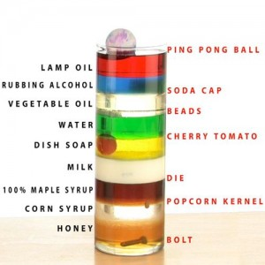

The density of a material varies with temperature and pressure. This variation is typically small for solids and liquids but much greater for gases. Increasing the pressure on an object decreases the volume of the object and thus increases its density. Increasing the temperature of a substance (with a few exceptions) decreases its density by increasing its volume. In most materials, heating the bottom of a fluid results in convection of the heat from the bottom to the top, due to the decrease in the density of the heated fluid. This causes it to rise relative to more dense unheated material.

The reciprocal of the density of a substance is occasionally called its specific volume, a term sometimes used in thermodynamics. Density is an intensive property in that increasing the amount of a substance does not increase its density; rather it increases its mass.

Vapour Density
Vapour density is the density of a vapour in relation to that of hydrogen. It may be defined as mass of a certain volume of a substance divided by mass of same volume of hydrogen.

Vapour Pressure
Vapor pressure or equilibrium vapor pressure is defined as the pressure exerted by a vapor in thermodynamic equilibrium with its condensed phases (solid or liquid) at a given temperature in a closed system. The equilibrium vapor pressure is an indication of a liquid's evaporation rate. It relates to the tendency of particles to escape from the liquid (or a solid). A substance with a high vapor pressure at normal temperatures is often referred to as volatile. The pressure exhibited by vapor present above a liquid surface is known as vapor pressure. As the temperature of a liquid increases, the kinetic energy of its molecules also increases. As the kinetic energy of the molecules increases, the number of molecules transitioning into a vapor also increases, thereby increasing the vapor pressure.
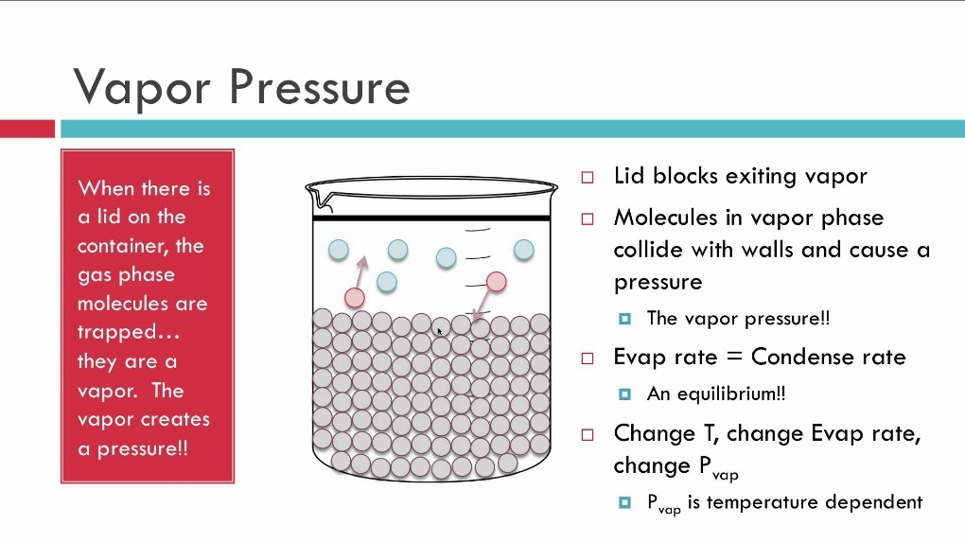

The vapor pressure of any substance increases non-linearly with temperature according to the Clausius–Clapeyron relation. The atmospheric pressure boiling point of a liquid (also known as the normal boiling point) is the temperature at which the vapor pressure equals the ambient atmospheric pressure. With any incremental increase in that temperature, the vapor pressure becomes sufficient to overcome atmospheric pressure and lift the liquid to form vapor bubbles inside the bulk of the substance. Bubble formation deeper in the liquid requires a higher pressure, and therefore higher temperature, because the fluid pressure increases above the atmospheric pressure as the depth increases. More important at shallow depths is the higher temperature required to start bubble formation. The surface tension of the bubble wall leads to an overpressure in the very small, initial bubbles. Thus, thermometer calibration should not rely on the temperature in boiling water.

The vapor pressure that a single component in a mixture contributes to the total pressure in the system is called partial pressure. For example, air at sea level, and saturated with water vapor at 20 °C, has partial pressures of about 2.3 kPa of water, 78 kPa of nitrogen, 21 kPa of oxygen and 0.9 kPa of argon, totaling 102.2 kPa, making the basis for standard atmospheric pressure.

Viscosity
The viscosity of a fluid is a measure of its resistance to gradual deformation by shear stress or tensile stress. For liquids, it corresponds to the informal concept of "thickness"; for example, honey has a much higher viscosity than water.

Viscosity is a property of the fluid which opposes the relative motion between the two surfaces of the fluid that are moving at different velocities. In simple terms, viscosity means friction between the molecules of fluid. When the fluid is forced through a tube, the particles which compose the fluid generally move more quickly near the tube's axis and more slowly near its walls; therefore some stress (such as a pressure difference between the two ends of the tube) is needed to overcome the friction between particle layers to keep the fluid moving. For a given velocity pattern, the stress required is proportional to the fluid's viscosity.

A fluid that has no resistance to shear stress is known as an ideal or inviscid fluid. Zero viscosity is observed only at very low temperatures in superfluids. Otherwise, all fluids have positive viscosity and are technically said to be viscous or viscid. In common parlance, however, a liquid is said to be viscous if its viscosity is substantially greater than that of water, and may be described as mobile if the viscosity is noticeably less than water. A fluid with a relatively high viscosity, such as pitch, may appear to be a solid.

Pour Point
The pour point of a liquid is the temperature below which the liquid loses its flow characteristics. In crude oil a high pour point is generally associated with a high paraffin content, typically found in crude deriving from a larger proportion of plant material. That type of crude oil is mainly derived from a kerogen Type III.

Static electricity
Is an imbalance of electric charges within or on the surface of a material. The charge remains until it is able to move away by means of an electric current or electrical discharge. Static electricity is named in contrast with current electricity, which flows through wires or other conductors and transmits energy.
A static electric charge can be created whenever two surfaces contact and separate, and at least one of the surfaces has a high resistance to electric current (and is therefore an electrical insulator). The effects of static electricity are familiar to most people because people can feel, hear, and even see the spark as the excess charge is neutralized when brought close to a large electrical conductor (for example, a path to ground), or a region with an excess charge of the opposite polarity (positive or negative). The familiar phenomenon of a static shock more specifically, an electrostatic discharge is caused by the neutralization of charge.

Causes of static electricity
Materials are made of atoms that are normally electrically neutral because they contain equal numbers of positive charges (protons in their nuclei) and negative charges (electrons in "shells" surrounding the nucleus). The phenomenon of static electricity requires a separation of positive and negative charges. When two materials are in contact, electrons may move from one material to the other, which leaves an excess of positive charge on one material, and an equal negative charge on the other. When the materials are separated they retain this charge imbalance.
Static electricity presents fire and explosion hazards during the handling of flammable liquids and during other tanker operations such as tank cleaning, dipping, ullaging and sampling. Certain operations can give rise to accumulations of electric charge that may be released suddenly in electrostatic discharges with sufficient energy to ignite flammable product gas/air mixtures. There is, of course, no risk of ignition unless a flammable mixture is present. There are three basic stages leading up to a potential electrostatic hazard:
- Charge separation.
- Charge accumulation.
- Electrostatic discharge.

All three of these stages are necessary for an electrostatic ignition of a flammable atmosphere. Electrostatic discharges can occur as a result of accumulations of charge on:
- Liquid or solid non-conductors, for example a static accumulator oil (such as kerosene) pumped into a tank, or a polypropylene rope.
- Electrically insulated liquid or solid conductors, for example mists, sprays or particulate suspensions in air, or an unbonded metal rod hanging on the end of a rope.

The principles of electrostatic hazards and the precautions to be taken to manage the risks are described fully below.

Charge Separation
Whenever two dissimilar materials come into contact, charge separation occurs at the interface.

The interface may be between two solids, between a solid and a liquid or between two immiscible liquids. At the interface, a charge of one sign (say positive) moves from material A to material B so that materials A and B become respectively negatively and positively charged.
While the materials stay in contact and immobile relative to one another, the charges are extremely close together. The voltage difference between the charges of opposite sign is then very small, and no hazard exists. However, when the materials move relative to one another, the charges can be separated and the voltage difference increased.

The charges can be separated by many processes. For example:
- The flow of liquid product through pipes.
- Flow through fine filters (less than 150 microns) that have the ability to charge products to a very high level, as a result of all the product being brought into intimate contact with the filter surface where charge separation occurs.
- Contaminants, such as water droplets, rust or other particles, moving relative to product as a result of turbulence in the product as it flows through pipes.
- The settling of a solid or an immiscible liquid through a liquid (e.g. water, rust or other particles through the product). This process may continue for up to 30 minutes after completion of loading into a tank.
- Gas bubbles rising up through a liquid (e.g. air, inert gas introduced into a tank by the blowing of cargo lines or vapour from the liquid itself, released when pressure is dropped). This process may also continue for up to 30 minutes after completion of loading.
- Turbulence and splashing in the early stages of loading product into an empty tank. This is a problem in the liquid and in the mist that can form above the liquid.
- The ejection of particles or droplets from a nozzle (e.g. during steaming operations or injection of inert gas).
- The splashing or agitation of a liquid against a solid surface (e.g. water washing operations or the initial stages of filling a tank with product).
- The vigorous rubbing together and subsequent separation of certain synthetic polymers (e.g. the sliding of a polypropylene rope through gloved hands).

When the charges are separated, a large voltage difference can develop between them. A voltage distribution is also set up throughout the neighboring space and this is known as an electrostatic field. Examples of this are:
- The charge on a charged liquid in a tank produces an electrostatic field throughout the tank, both in the liquid and in the ullage space.
- The charge on a water mist formed by tank washing produces an electrostatic field throughout the tank.

If an uncharged conductor is present in an electrostatic field, it has approximately the same voltage as the region it occupies. Furthermore, the field causes a movement of charge within the conductor; a charge of one sign is attracted by the field to one end of the conductor and an equal charge of the opposite sign is left at the opposite end. Charges separated in this way are known as ‘induced charges’ and, as long as they are kept separate by the presence of the field, they are capable of contributing to an electrostatic discharge.

Charge Accumulation
Charges that have been separated attempt to recombine and to neutralize each other. This process is known as ‘charge relaxation’. If one or both of the separated materials carrying charge is a very poor electrical conductor, recombination is impeded and the material retains or accumulates the charge upon it. The period of time for which the charge is retained is characterized by the relaxation time of the material, which is related to its conductivity; the lower the conductivity, the greater the relaxation time.
If a material has a comparatively high conductivity, the recombination of charges is very rapid and can counteract the separation process, and consequently little or no static electricity accumulates on the material. Such a highly conductive material can only retain or accumulate charge if it is insulated by means of a poor conductor, and the rate of loss of charge is then dependent upon the relaxation time of this lesser conducting material.
The important factors governing relaxation are therefore the electrical conductivities of the separated materials, of other conductors nearby, such as tanker’s structure, and of any additional materials that may be interposed between them after their separation.

Electrostatic Discharge
Electrostatic discharge occurs when the electrostatic field becomes too strong and the electrical resistance of an insulating material suddenly breaks down. When breakdown occurs, the gradual flow and charge recombination associated with relaxation is replaced by sudden flow recombination that generates intense local heating (e.g. a spark) that can be a source of ignition if it occurs in a flammable atmosphere. Although all insulating media can be affected by breakdowns and electrostatic discharges, the main concern for tanker operations is the prevention of discharges in air or vapour, so as to avoid sources of ignition.

Electrostatic fields in tanks or compartments are not uniform because of tank shape and the presence of conductive internal protrusions, such as probes and structure. The field strength is enhanced around these protrusions and, consequently, that is where discharges generally occur. A discharge may occur between a protrusion and an insulated conductor or solely between a conductive protrusion and the space in its vicinity, without reaching another object.

Basic chemistry, chemical elements

Chemical Symbol
A chemical symbol is a notation of one or two letters representing a chemical element. The exceptions to the one- to two-letter symbol are the temporary element symbols assigned to designate new or to-be-synthesized elements.
Temporary element symbols are three letters that are based on the element's atomic number.

Chemical Structure
A chemical structure determination includes a chemist's specifying the molecular geometry and, when feasible and necessary, the electronic structure of the target molecule or other solid. Molecular geometry refers to the spatial arrangement of atoms in a molecule and the chemical bonds that hold the atoms together, and can be represented using structural formulae and by molecular models; complete electronic structure descriptions include specifying the occupation of a molecule's molecular orbitals.[citation needed] Structure determination can be applied to a range of targets from very simple molecules (e.g., diatomic oxygen or nitrogen), to very complex ones (e.g., such as of protein or DNA).

Hydrocarbon
Any of a class of organic chemical compounds composed only of the elements carbon (C) and hydrogen (H). The carbon atoms join together to form the framework of the compound, and the hydrogen atoms attach to them in many different configurations. Hydrocarbons are the principal constituents of petroleum and natural gas. They serve as fuels and lubricants as well as raw materials for the production of plastics, fibres, rubbers, solvents, explosives, and industrial chemicals.

Many hydrocarbons occur in nature. In addition to making up fossil fuels, they are present in trees and plants, as, for example, in the form of pigments called carotenes that occur in carrots and green leaves. More than 98 percent of natural crude rubber is a hydrocarbon polymer, a chainlike molecule consisting of many units linked together. The structures and chemistry of individual hydrocarbons depend in large part on the types of chemical bonds that link together the atoms of their constituent molecules.

Nineteenth-century chemists classified hydrocarbons as either aliphatic or aromatic on the basis of their sources and properties. Aliphatic (from Greek aleiphar, “fat”) described hydrocarbons derived by chemical degradation of fats or oils. Aromatic hydrocarbons constituted a group of related substances obtained by chemical degradation of certain pleasant-smelling plant extracts. The terms aliphatic and aromatic are retained in modern terminology, but the compounds they describe are distinguished on the basis of structure rather than origin.

Aliphatic hydrocarbons are divided into three main groups according to the types of bonds they contain: alkanes, alkenes, and alkynes. Alkanes have only single bonds, alkenes contain a carbon-carbon double bond, and alkynes contain a carbon-carbon triple bond. Aromatic hydrocarbons are those that are significantly more stable than their Lewis structures would suggest; i.e., they possess “special stability.” They are classified as either arenes, which contain a benzene ring as a structural unit, or no benzenoid aromatic hydrocarbons, which possess special stability but lack a benzene ring as a structural unit.

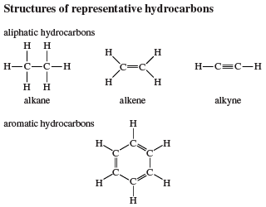

This classification of hydrocarbons serves as an aid in associating structural features with properties but does not require that a particular substance be assigned to a single class. Indeed, it is common for a molecule to incorporate structural unit’s characteristic of two or more hydrocarbon families. A molecule that contains both a carbon-carbon triple bond and a benzene ring, for example, would exhibit some properties that are characteristic of alkynes and others that are characteristic of arenes.

Alkanes are described as saturated hydrocarbons, while alkenes, alkynes, and aromatic hydrocarbons are said to be unsaturated.

Chemical Reaction
A chemical reaction is a process that leads to the transformation of one set of chemical substances to another. Classically, chemical reactions encompass changes that only involve the positions of electrons in the forming and breaking of chemical bonds between atoms, with no change to the nuclei (no change to the elements present), and can often be described by a chemical equation. Nuclear chemistry is a sub-discipline of chemistry that involves the chemical reactions of unstable and radioactive elements where both electronic and nuclear changes can occur.
The substance (or substances) initially involved in a chemical reaction are called reactants or reagents. Chemical reactions are usually characterized by a chemical change, and they yield one or more products, which usually have properties different from the reactants. Reactions often consist of a sequence of individual sub-steps, the so-called elementary reactions, and the information on the precise course of action is part of the reaction mechanism. Chemical reactions are described with chemical equations, which symbolically present the starting materials, end products, and sometimes intermediate products and reaction conditions.
Chemical reactions happen at a characteristic reaction rate at a given temperature and chemical concentration. Typically, reaction rates increase with increasing temperature because there is more thermal energy available to reach the activation energy necessary for breaking bonds between atoms.
Reactions may proceed in the forward or reverse direction until they go to completion or reach equilibrium. Reactions that proceed in the forward direction to approach equilibrium are often described as spontaneous, requiring no input of free energy to go forward. Non-spontaneous reactions require input of free energy to go forward (examples include charging a battery by applying an external electrical power source, or photosynthesis driven by absorption of electromagnetic radiation in the form of sunlight).
Different chemical reactions are used in combinations during chemical synthesis in order to obtain a desired product. In biochemistry, a consecutive series of chemical reactions (where the product of one reaction is the reactant of the next reaction) form metabolic pathways. These reactions are often catalyzed by protein enzymes. Enzymes increase the rates of biochemical reactions, so that metabolic syntheses and decompositions impossible under ordinary conditions can occur at the temperatures and concentrations present within a cell.
The general concept of a chemical reaction has been extended to reactions between entities smaller than atoms, including nuclear reactions, radioactive decays, and reactions between elementary particles as described by quantum field theory.

Reaction Types
- Synthesis. In a synthesis reaction, two or more simple substances combine to form a more complex substance.
- Decomposition. A decomposition reaction is when a more complex substance breaks down into its more simple parts. It is thus the opposite of a synthesis reaction.
- Single replacement. In a single replacement reaction, a single uncombined element replaces another in a compound; in other words, one element trades places with another element in a compound.
- Double replacement. In a double replacement reaction, the anions and cations of two compounds switch places and form two entirely different compounds.
- Oxidation and reduction. Sodium chloride is formed through the redox reaction of sodium metal and chlorine gas Redox reactions can be understood in terms of transfer of electrons from one involved species (reducing agent) to another (oxidizing agent). In this process, the former species is oxidized and the latter is reduced. Though sufficient for many purposes, these descriptions are not precisely correct. Oxidation is better defined as an increase in oxidation state, and reduction as a decrease in oxidation state. In practice, the transfer of electrons will always change the oxidation state, but there are many reactions that are classed as "redox" even though no electron transfer occurs (such as those involving covalent bonds).
- Complexation. In complexation reactions, several ligands react with a metal atom to form a coordination complex. This is achieved by providing lone pairs of the ligand into empty orbitals of the metal atom and forming dipolar bonds. The ligands are Lewis bases, they can be both ions and neutral molecules, such as carbon monoxide, ammonia or water. The number of ligands that react with a central metal atom can be found using the 18-electron rule, saying that the valence shells of a transition metal will collectively accommodate 18 electrons, whereas the symmetry of the resulting complex can be predicted with the crystal field theory and ligand field theory. Complexation reactions also include ligand exchange, in which one or more ligands are replaced by another, and redox processes which change the oxidation state of the central metal atom.
- Acid-base reactions. In the Brønsted–Lowry acid–base theory, an acid-base reaction involves a transfer of protons (H+) from one species (the acid) to another (the base). When a proton is removed from an acid, the resulting species is termed that acid's conjugate base. When the proton is accepted by a base, the resulting species is termed that base's conjugate acid.
- Precipitation. It is the formation of a solid in a solution or inside another solid during a chemical reaction. It usually takes place when the concentration of dissolved ions exceeds the solubility limit and forms an insoluble salt. This process can be assisted by adding a precipitating agent or by removal of the solvent. Rapid precipitation results in an amorphous or microcrystalline residue and slow process can yield single crystals. The latter can also be obtained by recrystallization from microcrystalline salts.
- Solid-state reactions. Reactions can take place between two solids. However, because of the relatively small diffusion rates in solids, the corresponding chemical reactions are very slow in comparison to liquid and gas phase reactions. They are accelerated by increasing the reaction temperature and finely dividing the reactant to increase the contacting surface area.
- Reactions at the solid/gas interface. Reaction can take place at the solid/gas interface, surfaces at very low pressure such as ultra-high vacuum. Via scanning tunneling microscopy, it is possible to observe reactions at the solid/gas interface in real space, if the time scale of the reaction is in the correct range. Reactions at the solid/gas interface are in some cases related to catalysis.
- Photochemical reactions. In this Paterno–Büchi reaction, a photoexcited carbonyl group is added to an unexcited olefin, yielding an oxetane. In photochemical reactions, atoms and molecules absorb energy (photons) of the illumination light and convert into an excited state. They can then release this energy by breaking chemical bonds, thereby producing radicals. Photochemical reactions include hydrogen–oxygen reactions, radical polymerization, chain reactions and rearrangement reactions.

Many important processes involve photochemistry. The premier example is photosynthesis, in which most plants use solar energy to convert carbon dioxide and water into glucose, disposing of oxygen as a side-product. Humans rely on photochemistry for the formation of vitamin D, and vision is initiated by a photochemical reaction of rhodopsin. In fireflies, an enzyme in the abdomen catalyzes a reaction that results in bioluminescence. Many significant photochemical reactions, such as ozone formation, occur in the Earth atmosphere and constitute atmospheric chemistry.

Physical properties of oil and chemicals in bulk

Flash Point
The flash point of a fuel is the temperature at which vapour given off will ignite when an external flame is applied under specified test conditions. A flash point is defined to minimize fire risk during normal storage and handling.
The minimum flash point for fuel in the machinery space of a merchant ship is governed by international legislation. According to the ISO Standard requirements the flash point for all distillate and residual grades except DMX shall be a minimum of 60'C . Ship classification society rules specifically stipulate that fuels with the flash point of less than 60'C are not permitted but with some exception. SOLAS 1974 has similar provisions.
Flash point is considered as a useful indicator of the fire hazard with regard to the storage of marine residual fuels. Flammable vapors may still develop in the tank headspace even if fuels are stored at temperatures below the determined flash point. Two useful documents have been compiled on this subject:
- "The flammability hazards associated with the handling, storage and carriage of residual fuel oil"; published by the Oil Companies International Marine Forum (OCIMF) dated December 1989.
- "International safety guide for oil tankers and terminals" published by the International Chamber of Shipping. Some basic precautions from the above important papers are given below:
- Flame screens on tank vents shall be maintained in good order and condition.
- Temperatures in the fuel system shall conform to recognized codes of practice.
- All electrical fittings in tank headspaces must be designed for hazardous conditions and meet appropriate safety standards.
- Any sources of ignition in the vicinity of the vents shall not exist.
- In case that levels of fuel in storage tanks is low, heating coils should be shut down.
- Gas detectors shall be calibrated correctly before they are used to check the flammability of headspace gas.
- Headspace flammability readings shall be considered hazardous if they exceed 50% lower flammable limit (LFL). Low pressure air purging of the headspace will assist to reduce the hazard.
- The risks of electrical charges should be taken into account when using metallic sounding or sampling devices. Such devices should be earthed or bonded to the tank structure.

Volatility
It is a rate at which the price of a security increases or decreases for a given set of returns. Volatility is measured by calculating the standard deviation of the annualized returns over a given period of time. It shows the range to which the price of a security may increase or decrease.
Volatility measures the risk of a security. It is used in option pricing formula to gauge the fluctuations in the returns of the underlying assets. Volatility indicates the pricing behavior of the security and helps estimate the fluctuations that may happen in a short period of time.
If the prices of a security fluctuate rapidly in a short time span, it is termed to have high volatility. If the prices of a security fluctuate slowly in a longer time span, it is termed to have low volatility.

Upper flammability limit (UFL)
Highest concentration (percentage) of a gas or a vapor in air capable of producing a flash of fire in presence of an ignition source (arc, flame, heat). Concentrations higher than UFL or UEL are "too rich" to burn. Operating above the UFL is usually avoided for safety because air leaking in can bring the mixture into combustibility range.

Lower flammability limit (LFL)
The lowest concentration (percentage) of a gas or a vapor in air capable of producing a flash of fire in presence of an ignition source (arc, flame, heat). The term is considered by many safety professionals to be the same as the lower explosive level (LEL). At a concentration in air lower than the LFL, gas mixtures are "too lean" to burn. Methane gas has an LFL of 5.0%. If the atmosphere has less than 5.0% methane, an explosion cannot occur even if a source of ignition is present.
Percentage reading on combustible air monitors should not be confused with the LFL concentrations. Explosimeter designed and calibrated to a specific gas may show the relative concentration of the atmosphere to the LFL—the LFL being 100%. A 5% displayed LFL reading for methane, for example, would be equivalent to 5% multiplied by 5.0%, or approximately 0.25% methane by volume at 20 degrees C. Control of the explosion hazard is usually achieved by sufficient natural or mechanical ventilation, to limit the concentration of flammable gases or vapors to a maximum level of 25% of their lower explosive or flammable limit.

Auto-Ignition Temperature
The auto ignition temperature or kindling point of a substance is the lowest temperature at which it spontaneously ignites in normal atmosphere without an external source of ignition, such as a flame or spark. This temperature is required to supply the activation energy needed for combustion. The temperature at which a chemical ignites decreases as the pressure or oxygen concentration increases. It is usually applied to a combustible fuel mixture.
Auto ignition temperatures of liquid chemicals are typically measured using a 500-millilitre (18 imp fl oz; 17 US fl oz) flask placed in a temperature-controlled oven in accordance with the procedure described in ASTM E659.
When measured for plastics, auto ignition temperature can be also measured under elevated pressure and at 100% oxygen concentration. The resulting value is used as a predictor of viability for high-oxygen service. The main testing standard for this is ASTM G72.

Spontaneous combustion
Spontaneous combustion or spontaneous ignition is a type of combustion which occurs by self-heating (increase in temperature due to exothermic internal reactions), followed by thermal runaway (self-heating which rapidly accelerates to high temperatures) and finally, auto ignition.

Polymerization
In polymer chemistry, polymerization is a process of reacting monomer molecules together in a chemical reaction to form polymer chains or three-dimensional networks. There are many forms of polymerization and different systems exist to categorize them.

Reactivity
In chemistry, reactivity is the impetus for which a chemical substance undergoes a chemical reaction, either by itself or with other materials, with an overall release of energy.

Tanker safety culture and safety management
Following the implementation of the ISM Code, which became mandatory on 1st July 2002, for all commercial ocean-going ships and yachts > 500 GT, there has been a significant reduction in marine incidents and casualties. For the inland shipping & cruise industry such a Code does not exist and a Safety Management System (SMS) for inland ship owners and managers is not (yet) required. However, inland ship owners & managers can choose to develop and implement a SMS on a voluntary basis, such as according to the international recognized British Occupational Health and Safety Management System Standard; OHSAS 18001 (soon to be replaced by a new international standard ISO 45001).
Although having a SMS in a company organization and on board it's ships will certainty help to reduce incidents and casualties, a number of recent high-profile incidents suggest that the absence of a fully implemented 'Safety Culture' on board ships and yachts is still an issue.

The Role of a 'Safety Culture' in Preventing Accidents and Incidents
The purpose of any Safety Management System that embraces an effective safety culture, is to prevent human accidents and ship incidents.
Instead, one would then experience what is termed a ‘hazardous occurrence’ or a ‘near miss’. A near miss is defined by the International Maritime Organization (IMO) as;
“A sequence of events and / or conditions that could have resulted in loss or injury. This loss or injury was prevented by a casual break in the chain of events and / or conditions”.
The below illustrative model shows the concept of factors combining to lead to an accident or incident. The model uses the concept of Swiss cheese slices to represent accident barriers (physical and procedural), that are placed by the company and ship’s senior crew to prevent accidents.



The below illustration shows the hierarchy of 'hazard control' to minimize or eliminate exposure to hazards:
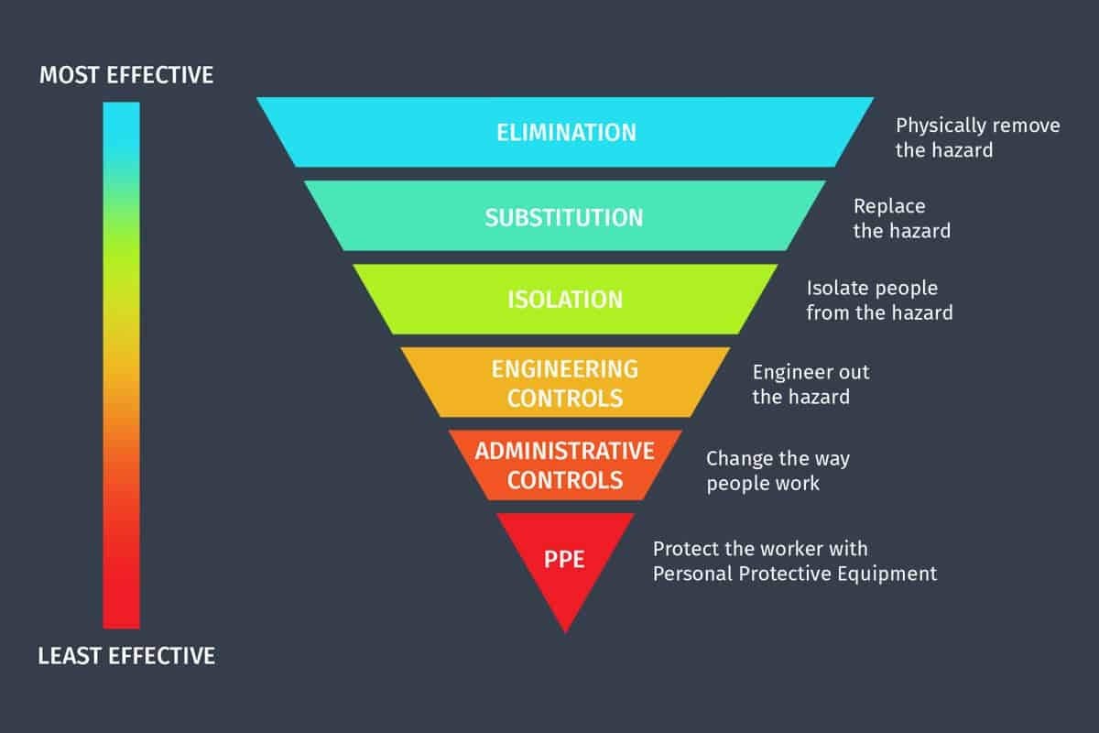

Defining a Safety Culture
While the ISM Code states that one of its key objectives is to establish a ‘Safety Culture’ in shipping companies and on board ships, it does not actually define the meaning of the term. However, a safety culture may be described as;
"The values and practices that management, office staff and crew share to ensure that risks are always minimized and mitigated to the greatest degree possible."
In other words, with an effective safety culture, safety (and pollution prevention) is always the highest priority. The company, its staff and ship’s crew will always and automatically, think about the implications for safety of every action they take, rather than simply following safety procedures because they have been imposed from the outside by e.g. statutory regulations. In an effective safety culture, everyone employed by the company, whether an office manager, captain, purser or a sailor, truly believes in and understands the purpose of established safety procedures, and will think about safety, and the means of improving it, as a matter of course.
Analysis of serious accidents in the shipping industry have demonstrated that the people involved are usually highly trained, competent and experienced and that the underlying cause of the accident (which could have been prevented) was a failure to follow established procedures.
The key to maintaining a safety culture is for all concerned to recognize that it is a matter of enlightened self-interest. The crew will be less likely to be the victims of accidents, and the company can use safety culture as a means of maximizing the financial benefit and cost savings that may be derived from implementing an effective Safety Management System. It is important that companies recognize that investment in safety produces results in financial savings and is thus not a ‘cost’ post. It is a fact that improvement of safety on board saves human lives as well as money, because:
- H&M and P&I Insurance seldom covers 100% of the losses, plus insurance premiums increase following frequent accidents.
- Criminal penalties for safety or pollution prevention negligence can be considerable.
- During repair periods following a ship incident, ships are out of operation.
- Major accidents and / or pollution fines will damage a company’s reputation.
- Accidents lead to increased scrutiny by flag administrations and port state control inspectors.
- Accidents and prosecutions adversely affect the public’s perception of the company.

As identified by the ISM Code, commitment from the highest level of the company and from on board management is vital to ensure that personnel and crew will act safely at all times. Without commitment from senior management the efforts of everyone else in support of the Safety Management System will be wasted.

Measuring safety performance and behavior
In order to achieve an effective safety culture, it is essential to have the means to monitor and measure the safety performance in order to identify ways in which safety can be improved. Historical accident data research has shown that for approximately every 300 unsafe acts (or near-misses), 29 unsafe acts are likely to result in injury. Out of these 29 injuries one is statistically likely to result in a major injury or even death. Thus, the reduction or prevention of 300 unsafe acts is likely to prevent a major injury.
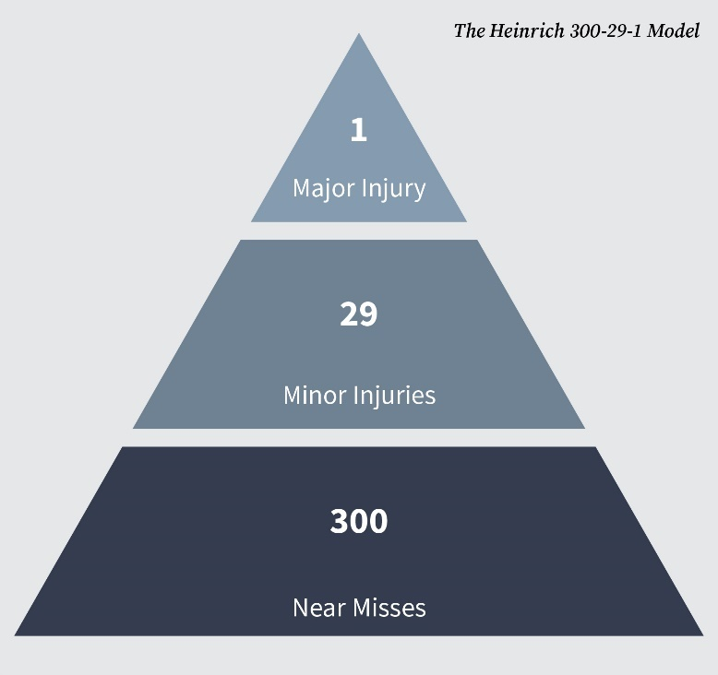

Modifying Behavior
A key aim of a safety culture should be to modify the behavior of company personnel and / or ship’s crew (where required), so that they ‘believe in safety, think safety and are committed to safety. Developing an effective safety culture based on the concept of continuous improvement, personal commitment and responsibility by all, is a long term process and involves hard work and effort. Experience gained through the proper implementation of a SMS should already result in changes in behavior, but other measures may also be required. Some companies may wish to conduct ‘behavioral safety assessment’ programmes, by e.g. using outside expert consultants to oversee changes to the company’s safety culture. The process of a behavioral safety assessment programme can be seen in the below figure:

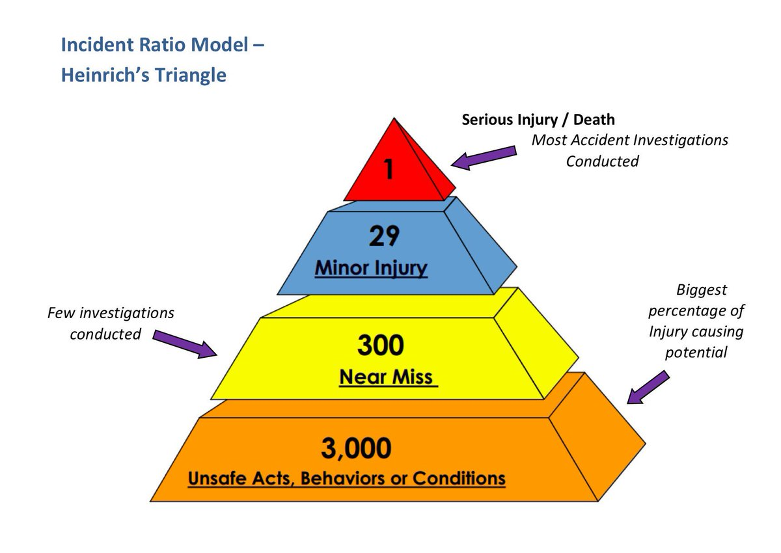

Reporting accidents, near misses and non-conformities
When a major incident occurs it is common for considerable time, effort and money to be spent establishing what happened and what the root cause was. Following the investigation, when the causal factors are known, it is often discovered that these were already apparent and visible long before the incident occurred. Reporting such factors and events at an early stage, followed by appropriate remedial action, can prevent accidents that lead to damage, pollution, injury or loss of life. However, it is also important for the company and crew to recognize the importance and value of reporting non-conformities and hazardous occurrences (near misses). It is important to ensure that all personnel, ashore and at sea, understand that when a non-conformity or near miss is reported that the intention is not to find someone to blame. Rather, the identification of non-conformities or near misses provides an opportunity to investigate WHY they occurred.
The causal factors underlying near misses are the same as those which lead to accidents resulting with injury or loss of life. By having an understanding of WHY incidents have occurred it is possible to introduce corrective action. Once a corrective action has been taken, the chances of an actual accident or incident, resulting in injury, damage or pollution, will be greatly reduced.

Just culture vs Blame culture
A Just Culture is an atmosphere of trust in which people are encouraged, even rewarded, for providing essential safety related information, but in which they are also clear about where the line must be drawn between acceptable and unacceptable behavior. Under Just Culture conditions, individuals are not blamed for honest errors, but are held accountable for willful violations and gross negligence. People are less willing to inform the company or a captain about their own errors and other safety problems or hazards if they are afraid of being punished or prosecuted. Such lack of trust of employees prevents the management from being properly informed of the actual risks. Managers and captains are then unable to make the right decisions in order to improve safety. Within the context of a just culture, it is essential that the company clearly defines the circumstances under which they will guarantee a non-disciplinary outcome and confidentiality. It is important that companies provide training and information about their approach to adopting a ‘just culture’ for crew, as well as for shore management.


Hazards
A hazard is an agent which has the potential to cause harm to a vulnerable target. The terms "hazard" and "risk" are often used interchangeably. However, in terms of risk assessment, these are two very distinct terms. A hazard is any agent that can cause harm or damage to humans, property, or the environment. Risk is defined as the probability that exposure to a hazard will lead to a negative consequence, or more simply, a hazard poses no risk if there is no exposure to that hazard.
Hazards can be dormant or potential, with only a theoretical probability of harm. An event that is caused by interaction with a hazard is called an incident. The likely severity of the undesirable consequences of an incident associated with a hazard, combined with the probability of this occurring, constitute the associated risk. If there is no possibility of a hazard contributing towards an incident, there is no risk.
Hazards can be classified as different types in several ways. One of these ways is by specifying the origin of the hazard. One key concept in identifying a hazard is the presence of stored energy that, when released, can cause damage. Stored energy can occur in many forms: chemical, mechanical, thermal, radioactive, electrical, etc. Another class of hazard does not involve release of stored energy, rather it involves the presence of hazardous situations. Examples include confined or limited egress spaces, oxygen-depleted atmospheres, awkward positions, repetitive motions, low-hanging or protruding objects, etc. Hazards may also be classified as natural, anthropogenic, or technological. They may also be classified as health or safety hazards, by the populations that may be affected, and the severity of the associated risk. In most cases a hazard may affect a range of targets, and have little or no effect on others.
Identification of hazards assumes that the potential targets are defined, and is the first step in performing a risk assessment.

Health hazards

Skin Contact
Many petroleum products, especially the more volatile ones, cause skin irritation and remove essential oils from the skin, leading to dermatitis. They are also irritating to the eyes. Certain heavier oils can cause serious skin disorders on repeated and prolonged contact. Direct contact with petroleum should always be avoided by wearing the appropriate protective equipment, especially impermeable gloves and goggles.

Ingestion
Petroleum has low oral toxicity, but when swallowed it causes acute discomfort and nausea. There is then a possibility that liquid petroleum may be drawn into the lungs during vomiting and this can have serious consequences, especially with higher volatility products, such as gasolines and kerosene.

Petroleum Gases
Comparatively small quantities of petroleum gas, when inhaled, can cause symptoms of diminished responsibility and dizziness similar to drunkenness, with headache and irritation of the eyes. The inhalation of a sufficient quantity can be fatal. These symptoms can occur at concentrations well below the Lower Flammable Limit. However, petroleum gases vary in their physiological effects and human tolerance to these effects also varies widely. It should not be assumed that because conditions can be tolerated the gas concentration is within safe limits. The smell of petroleum gas mixtures is very variable and in some cases the gases may dull the sense of smell. The impairment of smell is especially likely, and particularly serious, if the mixture contains hydrogen sulphide. The absence of smell should never be taken to indicate the absence of gas.

Exposure Limits
The toxic hazards to which personnel are exposed in tanker operations arise almost entirely from exposure to gases of various kinds. A number of indicators are used to measure the concentrations of toxic vapours and many substances have been assigned Threshold Limit Values (TLVs), sometimes referred to as Permissible Exposure Limits (PELs). The term Permissible Exposure Limithas been discontinued in this publication, as operational procedures should be aimed at reducing personnel’s exposure to a minimum and not to a permissible level. Exposure limits may be set by international organizations, national administrations or by local regulatory standards. Any limits established by regulation should not be exceeded. Industry bodies and oil companies often refer to the American Conference of Governmental Industrial Hygienists (ACGIH) which has established guidelines on limits that should protect personnel against harmful vapours in the working environment. The values quoted are expressed as Threshold Limit Values (TLVs) in parts per million (ppm) by volume of gas in air. In spite of the fact that serious health effects are not believed likely as a result of exposure to TLV concentrations, the values are only guidelines. Best practice is to maintain concentrations of all atmospheric contaminants as low as is reasonably practicable. In the following text the term TLV-TWA (Time Weighted Average) is used. Because they are averages, TWAs assume short-term excursions above the TLV-TWA that are not sufficiently high to cause injury to health and that are compensated by equivalent excursions below the TLV-TWA during the conventional 8-hour working day.

Effects
The main effect of petroleum gas on personnel is to produce narcosis. The symptoms include headache and eye irritation, with diminished responsibility and dizziness similar to drunkenness. At high concentrations, these lead to paralysis, insensibility and death. The toxicity of petroleum gases can vary widely depending on the major hydrocarbon constituents of the gases. Toxicity can be greatly influenced by the presence of some minor components such as aromatic hydrocarbons (e.g. benzene) and hydrogen sulphide. A TLV-TWA of 300 ppm, corresponding to about 2% LFL, is established for gasoline vapours. Such a figure may be used as a general guide for petroleum gases but must not be taken as applicable to gas mixtures containing benzene or hydrogen sulphide. The human body can tolerate concentrations somewhat greater than the TLV-TWA for short periods.

Oxygen Deficiency
Human beings normally breathe air that is 20.9 percent oxygen by volume under normal atmospheric pressure conditions. When the concentration of oxygen decreases even slightly by a little more than 1 percent to 2 percent, people immediately begin to feel the effects. Healthy individuals are unable to work strenuously and their coordination may be affected in oxygen environments of 15 percent to 19 percent. With the depletion of oxygen to a mix of only 10 percent to 12 percent, respiration increases, lips turn blue and judgment is impaired. Fainting and unconsciousness begin to occur at 8 percent to 10 percent oxygen. Death occurs in 8 minutes at 6 percent to 8 percent oxygen; recovery is possible after 4 to 5 minutes if oxygen is restored. These values are approximate and may vary greatly depending on an individual’s health, physical activity and the specific working environment that they encounter.
There are a variety of causes that lead to oxygen deficiency. Leaking materials from storage tanks, natural gas lines, process valves and more release gas that displaces oxygen in poorly ventilated areas or confined spaces. Decomposing organic matter, such as animal, human or plant waste, produces methane, carbon monoxide, carbon dioxide and hydrogen sulfide that displace or consume oxygen. Even corrosion, such as rust, or fermentation or other forms of oxidation will consume oxygen and pose a hazard.

Confined Spaces
Oxygen deficiency often occurs in confined spaces, which are defined as being large enough and configured so that a person can enter and perform assigned work. Confined spaces have restricted means for entry or exit, and they are not designed for continuous employee occupancy.
Some confined spaces are designated as “permit-required” areas. These areas have material with the potential for engulfment, and are configured so an employee or responder could be trapped or asphyxiated by inwardly converging walls. They have a floor that slopes or tapers to a smaller cross-section, or they may have any other recognized serious safety or health hazard.
Many confined spaces are easy to recognize, such as manholes, sewers, boilers, silos, vessels, vats, pipelines, tunnels, storage tanks, ship compartments and underground vaults. Other confined spaces are less obvious, including open-topped water and degreaser tanks, open pits and enclosures with bottom access. These confined spaces prohibit natural ventilation, are potential sources of gas generation and can prevent gases from escaping to cause a hazardous atmosphere.
Let’s face it: If a work area isn’t properly ventilated or hazardous materials are in use, then there is serious potential for oxygen-deficient or toxic gas conditions that could harm workers or rescuers. Explosive and toxic gases, including hydrogen sulfide and carbon monoxide, combined with a lack of oxygen, are the cause of most confined space accidents.
Heroic efforts by would-be rescuers who are overcome by oxygen deficiency or other toxic gases actually result in 60 percent of all fatalities. When an accident occurs, sound the alarm, get help and call the professionals. One accident victim is more than enough. Do not attempt a rescue without knowing the hazard, understanding the required response and using the proper safety equipment.
Some reasons for oxygen deficiency in an enclosed space could be:
- An Inert Atmosphere.
- Displaced Oxygen due to present of Cargo Vapour.
- Combustion.
- Chemical Reactions.
- Rusting.
- Drying Paint.
- Microbial activity.

When our body is not getting enough oxygen, it’s giving us many warning signs:
- Feeling constantly tired.
- Overall weakness of the body.
- Headaches or vertigo.
- It is hard for us to concentrate for work or study.
- Memory los.
- Irritability.
- Blood circulation problems.
- Indigestion problems.
- Anxiety, depression and stress.
- Weakened resistance to colds and flu.
- Various bacterial, fungal, viral and parasitic infections.

Such body states can indicate that your body is lacking oxygen. When this happens, our body cells get less efficient and all body processes slow down. The organ which is most sensitive to oxygen deficiency is our brain. As the main organ of our nervous system, brain uses 20 percent of all the oxygen we inhale. Brain cells take care of body activity coordination – the better the nervous conductivity, the better is our responsiveness and ability to concentrate. To avoid decreased oxygen in the brain (brain hypoxia), we should take care of sufficient oxygen supply at all times.
This is especially important for athletes, very active recreational sportsmen, divers, alpinists and those who are confronted with high intellectual strains. In case you fit in one of these groups, we recommend you to try out the oxygen supplement in a can – natural, healthy, and safe way to assist your body to achieve maximum results.

Signs and Symptoms of Asphyxia
Any of the following symptoms can lead to asphyxia.
- Difficulty and/ or noisy breathing, which may ultimately lead to cessation
- Rapid pulse
- High blood pressure (hypertension)
- Cyanosis of the face
- Swollen veins on the head and neck
- Convulsions
- Paralysis
- Slowly losing consciousness

Environmental hazards

Pollution
Is the introduction of contaminants into the natural environment that cause adverse change. Pollution can take the form of chemical substances or energy, such as noise, heat or light. Pollutants, the components of pollution, can be either foreign substances/energies or naturally occurring contaminants. Pollution is often classed as point source or nonpoint source pollution. In 2015, pollution killed 9 million people in the world.
Humans impact the environment in several ways. Common effects include decreased water quality, increased pollution and greenhouse gas emissions, depletion of natural resources and contribution to global climate change. Some of these are the direct result of human activities, whereas others are secondary effects that are part of a series of actions and reactions.

Water Pollution
One of the biggest impacts humans have on aquatic systems is excess nutrient inputs. Nutrients, like nitrogen and phosphorus, are essential to the health and survival of aquatic plants and animals. However, humans introduce large quantities of nutrients, primarily through overuse of fertilizers. Too many nutrients can rapidly reduce water quality by causing overgrowth of certain bacteria and algae that use the oxygen necessary for other species to survive. Even more problematic is that these nutrients can be transported downstream to other streams, rivers and bays. Therefore, nutrients can reduce water quality in places far removed from where they were first introduced.

Air Pollution
The majority of air pollution is the result of human activities. For example, increased fossil fuel combustion from motor vehicles, industrial factories and power plants all pump large quantities of air pollutants, such as carbon monoxide, ozone and nitrous oxides, into the atmosphere. Other air pollutants, such as lead-based compounds, can lead to serious health effects like cancer, or other types of reproductive effects and birth defects.

Climate Change
According to the U.S. Environmental Protection Agency, human activities are largely responsible for an increase in temperature around the globe, primarily due to carbon dioxide and other greenhouse gas emissions. This increase in temperature is leading to changes in where crops can grow and where certain fish or animals can be found, all vital for feeding an increasing human population. The rise in global temperatures is also causing glaciers to melt, releasing water that causes sea levels to rise and threaten coastal communities and economies that rely on coastal resources.

Marine pollution
It occurs when harmful, or potentially harmful, effects result from the entry into the ocean of chemicals, particles, industrial, agricultural, and residential waste, noise, or the spread of invasive organisms. Eighty percent of marine pollution comes from land. Air pollution is also a contributing factor by carrying off pesticides or dirt into the ocean. Land and air pollution have proven to be harmful to marine life and its habitats.
The pollution often comes from nonpoint sources such as agricultural runoff, wind-blown debris, and dust. Nutrient pollution, a form of water pollution, refers to contamination by excessive inputs of nutrients. It is a primary cause of eutrophication of surface waters, in which excess nutrients, usually nitrates or phosphates, stimulate algae growth. Many potentially toxic chemicals adhere to tiny particles which are then taken up by plankton and benthic animals, most of which are either deposit feeders or filter feeders. In this way, the toxins are concentrated upward within ocean food chains. Many particles combine chemically in a manner highly depletive of oxygen, causing estuaries to become anoxic.
When pesticides are incorporated into the marine ecosystem, they quickly become absorbed into marine food webs. Once in the food webs, these pesticides can cause mutations, as well as diseases, which can be harmful to humans as well as the entire food web. Toxic metals can also be introduced into marine food webs. These can cause a change to tissue matter, biochemistry, behavior, reproduction, and suppress growth in marine life. Also, many animal feeds have a high fish meal or fish hydrolysate content. In this way, marine toxins can be transferred to land animals, and appear later in meat and dairy products.
In order to protect the ocean from marine pollution, policies have been developed internationally. There are different ways for the ocean to get polluted, therefore there have been multiple laws, policies, and treaties put into place throughout history.
Ships can pollute waterways and oceans in many ways. Oil spills can have devastating effects. While being toxic to marine life, polycyclic aromatic hydrocarbons (PAHs), found in crude oil, are very difficult to clean up, and last for years in the sediment and marine environment.
Oil spills are probably the most emotive of marine pollution events. However, while a tanker wreck may result in extensive newspaper headlines, much of the oil in the world's seas comes from other smaller sources, such as tankers discharging ballast water from oil tanks used on return ships, leaking pipelines or engine oil disposed of down sewers.
Discharge of cargo residues from bulk carriers can pollute ports, waterways, and oceans. In many instances vessels intentionally discharge illegal wastes despite foreign and domestic regulation prohibiting such actions. An absence of national standards provides an incentive for some cruise liners to dump waste in places where the penalties are inadequate. It has been estimated that container ships lose over 10,000 containers at sea each year (usually during storms). Ships also create noise pollution that disturbs natural wildlife, and water from ballast tanks can spread harmful algae and other invasive species.
Ballast water taken up at sea and released in port is a major source of unwanted exotic marine life. The invasive freshwater zebra mussels, native to the Black, Caspian, and Azov seas, were probably transported to the Great Lakes via ballast water from a transoceanic vessel. Meinesz believes that one of the worst cases of a single invasive species causing harm to an ecosystem can be attributed to a seemingly harmless jellyfish. Mnemiopsis leidyi, a species of comb jellyfish that spread so it now inhabits estuaries in many parts of the world. It was first introduced in 1982, and thought to have been transported to the Black Sea in a ship's ballast water. The population of the jellyfish grew exponentially and, by 1988, it was wreaking havoc upon the local fishing industry. "The anchovy catch fell from 204,000 tons in 1984 to 200 tons in 1993; sprat from 24,600 tons in 1984 to 12,000 tons in 1993; horse mackerel from 4,000 tons in 1984 to zero in 1993." Now that the jellyfish have exhausted the zooplankton, including fish larvae, their numbers have fallen dramatically, yet they continue to maintain a stranglehold on the ecosystem.
Invasive species can take over once occupied areas, facilitate the spread of new diseases, introduce new genetic material, alter underwater seascapes, and jeopardize the ability of native species to obtain food. Invasive species are responsible for about $138 billion annually in lost revenue and management costs in the US alone.

Reactivity hazards
The major hazards associated with the safe transportation of liquid chemical cargoes in bulk relate to cargo compatibility, toxicity and flammability. The problem of compatibility of each cargo with the materials used in the construction of the ship and its equipment is significant and the list of cargoes in the IBC Code highlights those cargoes which will react with specific materials.
Cargoes, which react in a hazardous manner with one another, are not permitted to be carried in adjacent cargo tanks or to use common ventilation or pumping and piping systems. Cargoes, which are water-reactive, are not permitted to be stowed adjacent to the ship hull or to ballast tanks containing seawater. Heat-sensitive cargoes, which may polymerize, decompose, become unstable or evolve gas, must not be loaded in tanks adjacent to cargoes, which require to be heated to maintain pumpability. Tanks containing heat-sensitive cargoes are required to be fitted with an alarm system, which continuously monitors the cargo temperature.
The risk of cargo spillage during loading, transfer or discharge operations is high. The crew is required to be provided with chemical resistant overalls, boots and gloves. Showers and eyewashes are required to be available on deck so that in the event of an accident involving the crew, water is immediately available.
Antidotes for all cargoes carried must be available on board in accordance with the Medical First Aid Guide produced by the IMO. Many cargoes listed in the Code are toxic and the crew and shore-based personnel involved in cargo operations must be protected from toxic vapors. When carrying toxic cargoes, chemical tankers are required to have additional chemical-resistant suits and self-contained breathing apparatus suitable for use in a toxic environment. All toxic vapours displaced from a cargo tank during loading must be vented directly to shore reception facilities through a vapour return line.
Many cargoes are required by the Code to be carried in a controlled inert atmosphere, either because of their flammability, toxicity or to prevent oxygen from adversely affecting the quality of the cargo. Bottled nitrogen is normally supplied to the ship for this purpose; however, many of the more sophisticated ships have a nitrogen generating plant installed on board. Unlike on oil tankers, exhaust gas from the main engines is insufficiently clean for use on chemical tankers, and could impair the cargo quality demanded by the shipper. When carrying cargoes, which evolve highly flammable gases, the Code requires that all electrical equipment installed within their vicinity shall be specifically designed for use in hazardous atmospheres. To assist the designer in the selection of safe electrical equipment, the Code lists the temperature class and apparatus groups, as defined in the International Electrotechnical Commission’s Publication’79, for each of the flammable cargoes in the code.

Corrosion hazards
Acids, anhydrides and alkalis are among the most commonly carried corrosive substances. They can rapidly destroy human tissue and cause irreparable damage. They can also corrode normal ship construction materials, and create a safety hazard for a ship. Acids in particular react with most metals, evolving hydrogen gas which is highly flammable. The IMO Codes address this, and care should be taken to ensure that unsuitable materials are not included in the cargo system. Personnel likely to be exposed to these products should wear suitable personal protective equipment

A pyrophoric substance (from Greek πυροφόρος, pyrophoros, "fire-bearing") ignites spontaneously in air at or below 55 °C (130 °F). Examples are iron sulfide and many reactive metals including plutonium and uranium, when powdered or thinly sliced. Pyrophoric materials are often water-reactive as well and will ignite when they contact water or humid air. They can be handled safely in atmospheres of argon or (with a few exceptions) nitrogen. Most pyrophoric fires should be extinguished with a Class D fire extinguisher for burning metals.

Explosion and flammability hazards

Fire triangle
The triangle illustrates the three elements a fire needs to ignite: heat, fuel, and an oxidizing agent (usually oxygen). A fire naturally occurs when the elements are present and combined in the right mixture, meaning that fire is actually an event rather than a thing. A fire can be prevented or extinguished by removing any one of the elements in the fire triangle. For example, covering a fire with a fire blanket removes the oxygen part of the triangle and can extinguish a fire. In large fires where firefighters are called in, decreasing the amount of oxygen is not usually an option because there is no effective way to make that happen in an extended area.
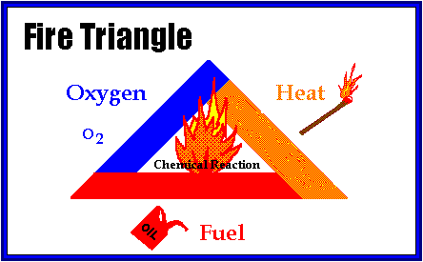

Flammable and combustible liquids
Flammable and combustible liquids do not, by themselves, burn. It is the vapours given off by the liquid that form an ignitable mixture with air. The flash point is the lowest temperature at which the liquid gives off enough vapour to produce an ignitable mixture with air. The flashpoint of gasoline, for example, is about –40OC; the exact flash point varies with the grade of gasoline. This means that at temperatures as cold as –40OC, gasoline can still evaporate quickly enough that its vapours can create an ignitable atmosphere.
Material Safety Data Sheets (MSDSs) provide information such as a product’s flashpoint and any precautionary measures that should be taken when handling the material. It is important to follow the advice provided in the MSDSs when using or working near a product.

Purging and inerting
Where a vessel, tank or piping system previously contained hydrocarbons, it must be made safe for workers by purging or inerting before work begins. Purging displaces or flushes out hydrocarbons by introducing substances such as an inert gas, steam or water.
Purging a hydrocarbon-filled system with air can create an explosive atmosphere. The work procedure must be evaluated to prevent this hazard.
Using air as a purging gas significantly increases the risk of an explosion. Typically, air forced through a system containing a flammable or combustible liquid residue creates a mist cloud of airborne liquid droplets. Flammable liquid droplets evaporate quickly, and can produce an explosive atmosphere. If there is enough liquid residue, the explosive conditions may persist for a very long time – longer than workers may be willing to wait before beginning their work.

Iron sulphide fires
Iron sulphide is a pyrophoric material. This means that it can spontaneously ignite when exposed to air. It is created when iron oxide (rust) is converted into iron sulphide in an oxygen-free atmosphere where hydrogen sulphide gas is present or where the concentration of hydrogen sulphide (H2S) exceeds that of oxygen.
When iron sulphide is subsequently exposed to air, it is oxidized back to iron oxide and either sulfur or sulfur dioxide gas is formed. This chemical reaction between iron sulphide and oxygen generates a considerable amount of heat. In fact, so much heat is released that individual particles of iron sulphide become incandescent and glow. This heat can ignite nearby flammable mixtures.
Most refineries experience spontaneous ignition of iron sulphide either on the ground or inside equipment. Pyrophoric iron fires most commonly occur during shutdowns when equipment and piping are opened for inspection or maintenance.
Iron sulphide fires can be avoided by preventing the sulphide from contacting air. This can be achieved by maintaining a continuous layer of liquid or inert gas between the material and the air. Inerting vessels with nitrogen gas is one such method.

Sources of ignition, including electrostatic hazards

Identifying Ignition Sources
Once fuel and oxygen are present, an ignition source is needed to complete the fire triangle. Hydrocarbons can be ignited in two ways:
- When an external ignition source with sufficient energy to ignite the fuel-oxygen mixture is available (e.g., flames, sparks).
- When the temperature is raised above the auto-ignition temperature (e.g., the compression ignition of a diesel engine). This diagram shows that consideration must be given to the factors that can change the minimum ignition energy and the available ignition energy.

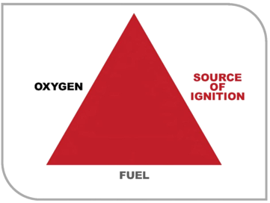

Forced ignition (i.e. external / piloted) is the most common form of accidental ignition. An external ignition source is classified as anything that can deliver enough energy in the form of heat to ignite a substance. This category includes sources such as open flames, electric arcs and sparks and mechanical sparks.
Many of the fire and explosion case studies reviewed on this website were attributed to ignition sources that were difficult to identify. The most likely or apparent ignition source was assumed in these instances. The graph below outlines the ignition sources from the case studies.
The most common sources of ignition are:
- Direct Heat
- Mechanical Sparks occur when there is excessive friction between metals or extremely hard substances. As the two substances rub against each other, small particles are torn off the surfaces.

For a metal to spark, it must satisfy three conditions:
- The energy, which supplies the tearing off of the particles, must be sufficient to heat the metal to high temperatures. Softer metals usually deform before they spark.
- The metal must be able to oxidize and burn easily. Generally, a metal’s sparking temperature is the same as its burning temperature.
- The metal’s specific heat is the last factor. A metal with a low specific heat will reach a higher temperature for the same amount of energy input.

Examples of mechanical sparking include dropping metal tools or chains, and grinding metal with an abrasive disk. Caution should be used when lowering or raising metal wireline tools in a well as less friction is needed to cause sparks at down whole temperatures.
- Chemical Energy
- Electrical Energy

Sparks are the discharge of electrons that may or may not expend all of the energy in a single discharge. An arc is a continuous stream of electrons bridging a gap between two conductive surfaces in close proximity.
The size or intensity of arcs and sparks depends on the resistance of the substance between the points of discharge. Once the voltage is high enough to overcome the dielectric strength of the air, the air will ionize allowing a conductive path for electricity to flow. Due to the high resistively of air, there will generally be enough energy dissipated in an arc or spark to ignite a flammable vapour.
The current or amount of electricity that is flowing will dictate the temperature of the arc. The higher the current, the higher the temperature.
Some common examples of arcs and sparks as an ignition source are listed below.
- Sparking of electric motors, generators, or other electrical rotating equipment
- Arcing between contacts (i.e. switches and relays)
- Arcs due to broken, inadequate, or failed insulation
- Lightning strikes
- Discharge of a charged capacitor through a gas
- Poor contacts between conductors, such as poorly fitted light bulbs and their sockets
- Arcs intentionally created during electric welding

- Electrostatic Discharge
Static electricity is the electrical charging of materials through physical contact and separation and the positive and negative electrical charges formed by this process. If the process is not or cannot be properly grounded, allowing the charge build-up to be safely dissipated, the charge may build up to the point where it will discharge with a static arc, which may provide an ignition source to a nearby mixture of fuel vapour and air.
A common source of static electricity is the movement and transport of nonconductive liquids. When liquids are filtered, sprayed, pumped, mixed, or flow through pipes, static electricity can be generated. This type of “internal” static charge cannot be eliminated by bonding or grounding.
If there is a sufficient potential difference between the surface charge and the metal tank shell, when an object is lowered into the tank or well, a static arc may occur. This is of particular concern if there is a vapour space above the surface of the liquid. For example, the static arc created by well-servicing tools contacting the fluid in a well has ignited this type of air-vapour mixture.
Other causes of electrostatic charge generation are:
- Movement of the ship through the water
- Flow of liquids and gases through pipes and filters
- Settings of solids or immiscible liquids through a liquid
- Ejection of particles or droplets from a nozzle
- Splashing or agitation of a liquid against a solid surface
- Vigorous rubbing together and subsequent separation of certain synthetic polymers.

Toxicity hazards
Toxicity is the degree to which a chemical substance or a particular mixture of substances can damage an organism. Toxicity can refer to the effect on a whole organism, such as an animal, bacterium, or plant, as well as the effect on a substructure of the organism, such as a cell (cytotoxicity) or an organ such as the liver (hepatotoxicity). By extension, the word may be metaphorically used to describe toxic effects on larger and more complex groups, such as the family unit or society at large. Sometimes the word is more or less synonymous with poisoning in everyday usage.
A central concept of toxicology is that the effects of a toxin are dose-dependent; even water can lead to water intoxication when taken in too high a dose, whereas for even a very toxic substance such as snake venom there is a dose below which there is no detectable toxic effect. Toxicity is species-specific, making cross-species analysis problematic. Newer paradigms and metrics are evolving to bypass animal testing, while maintaining the concept of toxicity endpoints.
An inert gas is a gas which does not undergo chemical reactions under a set of given conditions. The noble gases often do not react with many substances, and were historically referred to as the inert gases. Inert gases are used generally to avoid unwanted chemical reactions degrading a sample. These undesirable chemical reactions are often oxidation and hydrolysis reactions with the oxygen and moisture in air. The term inert gas is context-dependent because several of the noble gases can be made to react under certain conditions.
Purified argon and nitrogen gases are most commonly used as inert gases due to their high natural abundance (78% N2, 1% Ar in air) and low relative cost.
Unlike noble gases, an inert gas is not necessarily elemental and is often a compound gas. Like the noble gases the tendency for non-reactivity is due to the valence, the outermost electron shell, being complete in all the inert gases. This is a tendency, not a rule, as noble gases and other "inert" gases can react to form compounds.

Threshold limit value
The threshold limit value (TLV) of a chemical substance is believed to be a level to which a worker can be exposed day after day for a working lifetime without adverse effects. Strictly speaking, TLV is a reserved term of the American Conference of Governmental Industrial Hygienists (ACGIH). TLVs issued by the ACGIH are the most widely accepted occupational exposure limits both in the United States and most other countries.[1] However, it is sometimes loosely used to refer to other similar concepts used in occupational health and toxicology, such as acceptable daily intake (ADI) and tolerable daily intake (TDI). Concepts such as TLV, ADI, and TDI can be compared to the no-observed-adverse-effect level (NOAEL) in animal testing, but whereas a NOAEL can be established experimentally during a short period, TLV, ADI, and TDI apply to human beings over a lifetime and thus are harder to test empirically and are usually set at lower levels. TLVs, along with biological exposure indices (BEIs), are published annually by the ACGIH.
The TLV is an estimate based on the known toxicity in humans or animals of a given chemical substance, and the reliability and accuracy of the latest sampling and analytical methods. It is not a static definition since new research can often modify the risk assessment of substances and new laboratory or instrumental analysis methods can improve analytical detection limits. The TLV is a recommendation by ACGIH, with only a guideline status. As such, it should not be confused with exposure limits having a regulatory status, like those published and enforced by the Occupational Safety and Health Administration (OSHA). The OSHA regulatory exposure limits permissible exposure limits (PELs) published in 29CFR 1910.1000 Table Z1 are based on recommendations made by the ACGIH in 1968, although other exposure limits were adopted more recently. Many OSHA exposure limits are not considered by the industrial hygiene community to be sufficiently protective levels since the toxicological basis for most limits have not been updated since the 1960s. The National Institute for Occupational Safety and Health (NIOSH) publishes recommended exposure limits (RELs) which OSHA takes into consideration when promulgating new regulatory exposure limits.
The TLV for chemical substances is defined as a concentration in air, typically for inhalation or skin exposure. Its units are in parts per million (ppm) for gases and in milligrams per cubic meter (mg/m³) for particulates such as dust, smoke and mist. The basic formula for converting between ppm and mg/m³ for gases is ppm = (mg/m^3) * 24.45 / molecular weight. This formula is not applicable to airborne particles.
Three types of TLVs for chemical substances are defined:
- Threshold limit value − time-weighted average (TLV-TWA): average exposure on the basis of a 8h/day, 40h/week work schedule
- Threshold limit value − short-term exposure limit (TLV-STEL): spot exposure for a duration of 15 minutes, that cannot be repeated more than 4 times per day with at least 60 minutes between exposure periods
- Threshold limit value − ceiling limit (TLV-C): absolute exposure limit that should not be exceeded at any time

There are TLVs for physical agents as well as chemical substances. TLVs for physical agents include those for noise exposure, vibration, ionizing and non-ionizing radiation exposure and heat and cold stress.

Occupational exposure limit - OEL
An occupational exposure limit is an upper limit on the acceptable concentration of a hazardous substance in workplace air for a particular material or class of materials. It is typically set by competent national authorities and enforced by legislation to protect occupational safety and health. It is an important tool in risk assessment and in the management of activities involving handling of dangerous substances. There are many dangerous substances for which there are no formal occupational exposure limits. In these cases, hazard banding or control banding strategies can be used to ensure safe handling.

Vapour leaks and clouds

Minor or major leaks from LNG tanks & dealing with vapour clouds
An emergency can occur at any time and in any situation. Effective action is only possible if pre-planned and practical procedures have been developed and are frequently exercised. The Contingency Plan provides guidelines and instructions that assist in making an efficient response to emergency situations onboard ships.

Major Leak from an LNG Tank- Not Ignited
If a major leak occurs and it cannot be confined then jettisoning should be considered. Inerting of hold spaces shall be done same way as in case of minor leak.
- Sound general alarm
- Stop cargo operation. Activate ESD
- Disconnect loading arms. PERC
- Leave jetty
- As safety measure - Inert the hold space where leakage (Cargo Tank rupture) has been detected until the O2% is reduced to 2%. Continue blowing inert gas to hold space in order to keep temperature as high as possible. Remember to open the vent for hold space in order to avoid overpressure in the hold space
- Transfer cargo to other tanks in order to empty the tank.
- Consider - stability and stress factors.
- Consider - jettisoning. Remember two cargo pumps are required in order to have proper pressure in the nozzle.
- Consider - external assistance
- Prepare firefighting equipment
- Consider - abandonment. Prepare life-rafts, lifeboats

Minor Leaks from an LNG Tank- Not Ignited
If a small leak occurs the vessel will be able to handle the leak through the drip pan. The liquid will flow to the drip pan to be transferred by the eductor (by means of a spray pump), back to the tank. Driving liquid to the eductor is supplied by spray pump. Data to remember: The tank designer advises that if a cargo tank cracks an average of 8 Liter/hour will be released. The Drip pan will be able to contain this kind of leakage for 15 days without transferring cargo to another cargo tank.
- Release pressure in order to avoid further damages
- Isolate the rest of the hold spaces
- Transfer cargo to other tanks, if possible. Note that this is not normally possible on a normally loaded voyage as all tanks are full

Vapour clouds
If there is no immediate ignition of an LNG spill, a vapour cloud may form. The vapour cloud is long, thin, cigar shaped and, under certain meteorological conditions, may travel a considerable distance before its concentration falls below the lower flammable limit. This concentrate is important, for the cloud ignite and burn, with the flame travelling back towards the originating pool.
The cold vapour is denser that air and thus, at least initially, hugs the surface. Weather conditions largely determine the cloud dilution rate, with a thermal inversion greatly lengthening the distance travelled before the cloud becomes non-flammable.
The major danger from an LNG vapour cloud occurs when it is ignited. The heat from such a fire is a major problem. A deflagration (simple burning) is probably fatal to those within the cloud and outside buildings but is not a major threat to those beyond the cloud, though there will be burns from thermal radiations.

When loaded in the cargo tanks, the pressure of the vapour phase is maintained as substantially constant, slightly above atmospheric pressure.

The external heat passing through the tank insulation generates convection currents within the bulk cargo, heated LNG rises to the surface and boils. The heat necessary for the vaporization comes from the LNG and long as the vapour is continuously removed by maintaining the pressure as substantially constant, the LNG remains at the boiling temperature.

If the vapour pressure is reduced by removing more vapour than generated, the LNG temperature will decrease. In order to make up the equilibrium pressure corresponding to its temperature, the vaporization of LNG is accelerated, resulting in an increase heat transfer from LNG to vapour.

Hazards Controls

Inerting, water padding, drying agents and monitoring techniques

Inert Gas
An inert gas is a gas which does not undergo chemical reactions under a set of given conditions. The noble gases often do not react with many substances, and were historically referred to as the inert gases. Inert gases are used generally to avoid unwanted chemical reactions degrading a sample. These undesirable chemical reactions are often oxidation and hydrolysis reactions with the oxygen and moisture in air. The term inert gas is context-dependent because several of the noble gases can be made to react under certain conditions.
Purified argon and nitrogen gases are most commonly used as inert gases due to their high natural abundance (78% N2, 1% Ar in air) and low relative cost.
Unlike noble gases, an inert gas is not necessarily elemental and is often a compound gas. Like the noble gases the tendency for non-reactivity is due to the valence, the outermost electron shell, being complete in all the inert gases. This is a tendency, not a rule, as noble gases and other "inert" gases can react to form compounds.

Inert gas systems on ships
Inert gas is produced on board crude oil carriers (above 8,000 tons) (from Jan 1, 2016) by using either a flue gas system or by burning kerosene in a dedicated inert gas generator. The inert gas system is used to prevent the atmosphere in cargo tanks or bunkers from coming into the explosive range. IG keeps the oxygen content of the tank atmosphere below 5% (on crude carriers, less for product carriers and gas tankers), thus making any air/hydrocarbon gas mixture in the tank too rich (too high a fuel to oxygen ratio) to ignite. IG is most important during discharging and during the ballast voyage when more hydrocarbon vapour is likely to be present in the tank atmosphere. Inert gas can also be used to purge the tank of the volatile atmosphere in preparation for gas freeing - replacing the atmosphere with breathable air - or vice versa.
The flue gas system uses the boiler exhaust as its source, so it is important that the fuel/air ratio in the boiler burners is properly regulated to ensure that high quality inert gas is produced. Too much air would result in an oxygen content exceeding 5%, too much fuel oil would result in carryover of dangerous hydrocarbon gas. The flue gas is cleaned and cooled by the scrubber tower. Various safety devices prevent overpressure, return of hydrocarbon gas to the engine room, or supply of IG with too high oxygen content.

Gas tankers and product carriers cannot rely on flue gas systems (because they require IG with O₂ content of 1% or less) and so use inert gas generators instead. The inert gas generator consists of a combustion chamber and scrubber unit supplied by fans and a refrigeration unit which cools the gas. A drier in series with the system removes moisture from the gas before it is supplied to the deck. Cargo tanks on gas carriers are not inerted, but the hold space around them is. This arrangement allows the tanks to be kept cool using a small heel of cargo while the vessel is in ballast while retaining the explosion protection provided by the inert gas.

Anti-static measures
General Precautions Against Electrostatic Hazards
Whenever a flammable atmosphere could potentially be present, the following measures must be taken to prevent electrostatic hazards:
- The bonding of metal objects to the metal structure of the tanker to eliminate the risk of spark discharges between metal objects that might be electrically insulated. This includes metallic components of any equipment used for dipping, ullaging and sampling.
- The removal from tanks or other hazardous areas of any loose conductive objects that cannot be bonded.
- Restricting the linear velocity of the cargo to a maximum of 1 meter per second at the individual tank inlets during the initial stages of loading, i.e. until:
- the filling pipe and any other structure on the base of the tank has been submerged to twice the filling pipe diameter in order that all splashing and surface turbulence has ceased and
- any water collected in the pipeline has been cleared. It is necessary to load at this restricted rate for a period of 30 minutes or until two pipeline volumes (i.e. from shore tank to ship’s tank) have been loaded into the tank, whichever is the lesser.
- Continuing to restrict the product flow to a maximum of 1 m/s at the tank inlet for the whole operation unless the product is ‘clean’. A ‘clean’ product, within this context, is defined as one which contains less than 0.5% by volume of free water or other immiscible liquid and less than 10 mg/l of suspended solids.
- Avoiding splash filling by employing bottom entry using a fill pipe terminating close to the bottom of the tank.

The following additional precautions should be taken against static electricity during ullaging, dipping, gauging or sampling of static accumulator products:
- Banning the use of all metallic equipment for dipping, ullaging and sampling during loading and for 30 minutes after completion of loading. After the 30 minute waiting period, metallic equipment may be used for dipping, ullaging and sampling, but it must be effectively bonded and securely earthed to the structure of the tanker before it is introduced into the tank, and must remain earthed until after removal.

- Banning the use of all non-metallic containers of more than 1 litre capacity for dipping, ullaging and sampling during loading and for 30 minutes after completion of loading. Non-metallic containers of less than 1 litre capacity may be used for sampling in tanks at any time, provided that they have no conducting components and that they are not rubbed prior to sampling. Cleaning with a high conductivity proprietary cleaner, a solvent such as 70:30 IPA: toluene mix, or soapy water, is recommended to reduce charge generation. To prevent charging, the container should not be rubbed dry after washing.

Operations carried out through a correctly designed and installed sounding pipe are permissible at any time. It is not possible for any significant charge to accumulate on the surface of the liquid within the sounding pipe and therefore no waiting time is required. However, the precautions to be observed against introducing charged objects into a tank still apply and if metallic equipment is used it should be bonded before being inserted into the sounding pipe.

Bonding
The most important countermeasure that must be taken to prevent an electrostatic hazard is to bond all metallic objects together to eliminate the risk of discharges between objects that might be charged and electrically insulated. To avoid discharges from conductors to earth, it is normal practice to include bonding to earth (‘earthing’ or ‘grounding’). On tankers, bonding to earth is effectively accomplished by connecting metallic objects to the metal structure of the tanker, which is naturally earthed through the water. Some examples of objects which might be electrically insulated in hazardous situations and which must therefore be bonded are:
- Ship/shore hose couplings and flanges, except for the insulating flange or single length of non-conducting hose required to provide electrical isolation between the ship and shore. (See Section 17.5.)
- Portable tank washing machines.
- Manual ullaging and sampling equipment with conducting components.
- The float of a permanently fitted ullaging device if its design does not provide an earthing path through the metal tape.

The best method of ensuring bonding and earthing will usually be a metallic connection between the conductors. Alternative means of bonding are available and have proved effective in some applications, for example semi-conductive (dissipative) pipes and ‘O’ rings, rather than embedded metallic layers, for GRP pipes and their metal couplings.
Any earthing or bonding links used as a safeguard against the hazards of static electricity associated with portable equipment must be connected whenever the equipment is set up and not disconnected until after the equipment is no longer in use.
Avoiding Loose Conductive Objects Certain objects may be insulated during tanker operations, for example:
- A metal object, such as a can, floating in a static accumulating liquid.
- A loose metal object while it is falling in a tank during washing operations.
- A metallic tool, lying on a piece of old lagging, left behind after maintenance.

Every effort should be made to ensure that such objects are removed from the tank since there is evidently no possibility of deliberately bonding them. This necessitates careful inspection of tanks, particularly after shipyard repairs.

Ventilation
The venting systems of cargo tanks are to be entirely distinct from the air pipes of the other compartments of the ship. The arrangements and position of openings in the cargo tank deck from which emission of flammable vapours can occur shall be such as to minimize the possibility of flammable vapours being admitted to enclosed spaces containing a source of ignition, or collecting in the vicinity of deck machinery and equipment which may constitute an ignition hazard.
The venting arrangements shall be so designed and operated as to ensure that neither pressure nor vacuum in cargo tanks shall exceed design parameters and be such as to provide for:
- the flow of the small volumes of vapour, air or inert gas mixtures caused by thermal variations in a cargo tank in all cases through pressure/vacuum valves; and
- the passage of large volumes of vapour, air or inert gas mixtures during cargo loading and ballasting, or during discharging.

The venting arrangements in each cargo tank may be independent or combined with other cargo tanks and may be incorporated into the inert gas piping.

The venting arrangements shall be connected to the top of each cargo tank and shall be self-draining to the cargo tanks under all normal conditions of trim and list of the ship. Where it may not be possible to provide self-draining lines, permanent arrangements shall be provided to drain the vent lines to a cargo tank.

The venting system shall be provided with devices to prevent the passage of flame into the cargo tanks. The design, testing and locating of these devices shall comply with the requirements established by the Administration, which shall contain at least the standards adopted by the Organization.

Cargo segregation
In the case of two or more liquid chemical cargoes which react with one another in a hazardous manner, segregation must be done the product data sheets, together with the BCH/IBC Codes are to be studies carefully to determine the compatibility restrictions when carrying different groups of cargoes.
Regarding slops reacting with each other in a hazardous manner, these must not be collected in the same slop tank nor transferred through the same pipes.

Compatibility with Water / Stowage of Heated Cargoes
Some chemical cargoes are not compatible and may even be reactive with water therefore, due consideration is necessary to avoid stowage of such cargoes adjacent to the water ballast tanks. It is also a requirement that the heating coils are to be blown through, cleaned and blanked off, or thermal oil used as a heating medium.
It is recommended that a cargo to be heated is not stowed adjacent to cargoes which have a low boiling point because the excess evaporation will result in consequent cargo loss and possible vapour hazards. As a safe margin, the maximum temperature of the heated cargo must be 10°C below the boiling point of the unheated cargo.
Heated cargoes must never be stowed adjacent to self-reactive cargoes since excess heating of self-reactive cargoes will shorten the life of the stabilizing inhibitor in which the following items are shown must be given by the shipper, or the manufacturer of the cargoes.
- Name and amount of inhibitor added;
- Date inhibitor was added and the length of its effectiveness;
- The action to be taken should the length of the voyage exceed the effective lifetime of the inhibitor;

The Company and Charterers must be informed immediately if a product inhibitor certificate is not made available.

Compatibility with the Coatings of the Cargo Tanks
The suitability of the coating of tanks for loading various chemicals and products must be checked against the paint manufacturer’s data sheets before cargoes are assigned to tanks.
Also, temperature limits imposed by the relevant coatings are not to be exceeded.
Epoxy coatings are capable of absorption of certain chemicals, which could later be released resulting in contamination of future cargoes and possible safety hazards. Similarly “metal pick-up” form recently applied zinc coatings could contaminate sensitive cargoes.

Edible Oils Compatibility
Toxic chemicals, as defined in the BCH/IBC Code, must not be carried as the last cargo immediately prior to edible oils or stowed in adjacent tanks sharing common bulkheads with tanks containing edible oils. Likewise, lengths of pipeline serving tanks containing such toxic products must never run through tanks containing edible oils and vice versa.
For details, refer to FOSFA International (Federation of Oils, Seeds and Fats Association) published lists and procedures.
The FOSFA International “Operation Procedure for Ocean Carriers of Oil and Fats for Edible and Oleao-Chemical Use” requires that the immediate previous cargo for the tanks, lines and pump system designated to load and fats must have been on the FOSFA International “List of Accepted Previous Cargoes or not on the FOSFA International “List of Banned Previous Cargoes” currently in force whichever is appropriate.

Cargo inhibition
In certain conditions of heat, pressure and in the presence of Oxygen, some chemical cargo types can become viscous and possibly solid and dense in nature. This self-reaction can cause some cargoes, especially in the presence of high temperatures and Oxygen, to begin an exothermic reaction, becoming self-heating and rapidly expanding which may result in possibly disastrous consequences for the vessel.
As a precaution against this, a chemical inhibitor may be added to prevent the cargo from bonding with itself, however, one aspect of inhibitors is that they sometimes require Oxygen to activate them and this means that the tank cannot be inerted. When such a situation exists, the management Office must be contacted. See IBC code regarding carriage of inhibited flammable products in cargo tanks of more than 3000m3 and using inerting.
There are many inhibitor types, most of which are toxic and need to be handled with care. Usually the inhibitor is added by the Terminal personnel during the loading programme.
Shippers of inhibited cargoes must advise the vessel (and present an inhibitor certificate onboard prior to loading) of the quantity of inhibitor added, the hazards of the inhibitor, the time validity of the inhibitor, the temperature parameters within which the inhibitor will work and the emergency actions should these be exceeded. Masters are to check that the Inhibitor validity is sufficient for the voyage length.
The vapour of the cargo will not necessarily contain inhibitor as the two liquids will have differing evaporation properties. Therefore, it is possible for some solid polymer build-up to occur in the tank vents / screens, these must be verified as clear during voyage and prior to commencing discharge in order to prevent the possibility of damage from under pressure being created in the tanks during the discharge.
The temperature of inhibited cargoes must be checked and recorded daily in order to be able to note any abnormal rise that may indicate either inhibitor failure and/or polymerization. Notice of any rise or excessive temperatures should be notified immediately to the Management Office with a request for the action to be taken.
Inhibited cargoes often need the presence of some oxygen in the tank atmosphere in order to permit the inhibitor to work properly. The minimum level of oxygen is usually stated on the inhibitor certificate but, as a general rule, a cargo containing an inhibitor that needs oxygen should not be carried in an inerted tank
If nitrogen is bubbled through an inhibited cargo (such as when compressed nitrogen is used to clear the cargo hose after loading) the nitrogen will deplete the oxygen dissolved in the liquid, thereby requiring the inhibitor to take oxygen from the atmosphere. It is possible that excessive nitrogen used for blowing through might linger in the ullage space.

Importance of cargo compatibility
Transporting of dangerous and noxious liquid chemicals in bulk involved various risk factors. Chemical cargoes can be very dangerous, most of them being flammable and/or toxic, some of them extremely so. Between some chemicals violent reactions may occur if the chemicals are mixed in certain proportions. The result may possibly be an eruption and tank rupture. Such an occurrence must be prevented. Water may also have to be considered in this respect.
Leakages through bulkheads occur at times in any tanker. Normally, however, such leakages are only minor seep ages. They will not cause any violent reaction due to the great disproportion in mixture from dangerous proportions. But legislation as expressed in the IMO Chemicals Bulk Code ref (25), and in the US Coast Guard Rules ref (18) and Appendix 3 expressly prohibits the placement of inter-reactive cargoes on both sides of a bulkhead. There must be an empty tank, a cofferdam or a tank with a cargo neutral to both products in between. This requirement causes some headaches in cargo planning. "Diagonal contact'' between tanks is normally considered as sufficient separation between reactive cargoes.

More important, however, is the complete separation of piping systems so that one product cannot inadvertently be pumped into another. To this effect strategic pipe bends may have to be removed and blind flanges fitted on each pipe end. Modern chemical tankers will have blind flange valves fitted. Such a blind flange valve must have a double separation between the products with a drain in the interspace. A single blind flange is not acceptable. Remember also to separate drain lines or slop connections to avoid the possibility of cargo mixing.
The cargo inter- reactions may be of type:
- Chemical reaction: Strong (inorganic) acid plus alikali (or water) causes heat, e g sulphuric acid plus caustic soda or water. Therefore sulphuric acid may not be carried in tanks bordering the side shell or filled ballast tanks. Similarly sulphuric acid may react with a number of hydrocarbons except paraffines (petroleum oils). Amines (aniline, diethylamine) may react with esters (butyl, acetate, ethyl acetate). Caustic soda will react violently with acrolein, acrylonitrile and allyl alcohol.

- Oxidation: An Oxygen-rich compound like propylene oxide may react with an amine (e g diethylamine) or an aldehyde (e g acetaldehyde). An ether (e g ethyl ether) may react with oxygen and from a peroxide which is an explosive hazard. The ether should be inhibited and carried in an inerted (N 2) tank.

- Auto- reaction: Certain hydrocarbons compounds have a tendency to polymerize with time, accelerated by heat, light, sometimes air or other matter such as rust. Polymerization means that several molecules of the same kind binding together to bigger molecules. The compound tends to become more viscous or eventually solidify. Heat is liberated, which accelerates further polymerization.

Chemically most cargoes are monomers, which means that they, before any polymerization, consist of single molecules.

Atmospheric control

Preparing a cargo tank atmosphere: Chemical tanker procedure
Ship checks prior to loading: For some cargoes the IBC Code requires vapour spaces within cargo tanks to have specially controlled atmospheres, principally when the cargo is either air reactive resulting in a hazardous situation, or has a low auto-ignition temperature, or has a wide flammability range.
The correct atmosphere in a tank, can be established either inerting to prevent the formation of flammable mixtures of cargo vapour and air, or padding to prevent chemical reaction between oxygen and the cargo. It may also be necessary to reduce the humidity (dewpoint) of the atmosphere within the cargo system.
The extent of atmosphere control to protect the quality of the cargo will normally be specified by the cargo shippers. Some cargoes are extremely sensitive to commercial contamination or discoloration, and for quality control reasons are carried under a blanket of nitrogen that is very pure and which must often be obtained from shore.

Visual inspection
Visual inspection can only be carried out when tank is gas free by entering the tanks. If the tank is to be entered particular attention has to be paid to the risks of lack of oxygen, toxic and/or explosive tank atmosphere. Always consider the tank ‘dangerous’ and act according to the Enclosed Space Entry procedures. Condition reports of any visual inspections of cargo tanks prior to loading must be maintained on file for subsequent inspection by Third Parties.

Odour check
Some cargoes require being loaded in odor free conditions. It is important that tanks are cleaned accordingly and presented free of odor.
Wall wash tests
Depending on the product to be loaded and the previous product, contamination tests will be carried out with indicators. There are usually tests as follows:
- Chlorides
- Hydrocarbons
- Inhibitor residues
- Lead compounds
- Permanganate time test (PTT)
- pH–tests
- Suspended matter
The results of all Wall Wash Tests are to be recorded in the Wall Wash Test Reports are to be maintained on file.
Wall wash Procedure
This describes an approved method for collecting and analyzing wall wash samples to determine the presence of contaminants on the bulkheads. The procedure involves contacting a constant area of the bulkhead with a given amount of specification grade methanol, collecting the liquid and analyzing it for the presence of chlorides, hydrocarbons, color and particulate matter, or whatever might be required by the Charterer.
Precautions
- Safety Considerations – eye protection is required when collecting the samples to prevent the inadvertent contact of methanol with the eyes during the sample collection process. Gloves should be worn to prevent the absorption of methanol into the skin.
- Disposable plastic gloves are also worn to prevent contamination of the samples during the collection process. (A sufficient amount of chlorides can be absorbed from the skin to cause the sample to fail the chloride analysis.)
- Chlorides are abundant in the marine environment. All sampling equipment including bottles, funnels and other apparatus must be thoroughly rinsed with methanol (of less than 0.2 ppm chlorides content) and stored in plastic containers. Bottles are to be capped prior to sample collection.
- Personnel collecting the samples must be certain that no perspiration or bare skin contacts the sample or sampling equipment while the wall washes are being collected.
Choice of test sites
As a minimum, four sites of approximately 1.2 square feet each must be chosen in each tank. (If additional sites are chosen, 100mls of methanol should be applied to each location and collected in a separate container.)
Any area that appears to have crystalline deposits should definitely be tested.
Separate test of non-typical areas greater than 2 square feet (discolored patches etc.) should be conducted. The sample collected should be labelled with a description of the nontypical area. (These areas should be analysed separately.)
Sample collection procedures
- Choose four surfaces to test.
- Using the plastic wash bottle, squirt methanol on the test section at the highest practical point (normally 1.5 up to 2 metres) above the tank bottom in a stream of about 10cm wide.
- Allow the methanol to run down the wall approximately 15 cm and begin collecting it with the funnel, squirting additional liquid as necessary to rinse the flushing into the sample funnel.
- Continue this process until approximately an area of 10 by 120 cm has been rinsed with 100 mls of methanol.
- After the washings from the four sites are collected, submit a portion of the sample for analysis of chlorides, colour, suspended matter and hydrocarbons, whatever is applicable. The accuracy of this test depends upon consistency.
- Consistent number of sites tested.
- Consistent area tested at each site.
- Consistent amount of methanol applied to each site.
- Consistent amount of methanol recovered from each site.

Equipments and reagents
- Polyethylene washing bottles, 500 ml capacity
- Bottles, glass with screw cap and polyethylene lined, of sufficient capacity to hold the washings.
- Plastic disposable gloves.
- Specification grade methanol (laboratory pure methanol) that has been tested to be less than 0.1ppm chloride by ion chromatography. (High quality methanol is vital to the accuracy of this test.)
- Sample funnel, plastic or stainless steel with one flat side that can be held flush with the bulkheads.

Gas testing
Gas testing is Mandatory prior to work being undertaken in a process or hydrocarbon area that carries a risk to personnel or equipment from exposure to explosive, flammable, toxic or life-threatening vapours.

To ensure compliance to this Rule always undertake a Gas Test:
- When entering a confined space
- Before and during normal working in a Process or Hydrocarbon Area
- When breaking containment on a process system
- When hot working in a Process or Hydrocarbon Area
- When operating diesel plant in a Process or Hydrocarbon Area
- Before allowing an authorized vehicle to enter a Process Area, and during its presence there.
- Whenever the atmosphere could be potentially hazardous or is unknown
- Where there is a suspected hydrocarbon or toxic gas leak

Gas Testing Equipment
- Multigas Monitors – Multigas monitors are capable of measuring a number of gases simultaneously with results displayed continuously. The gases monitored and displayed can include Flammable, Oxygen, Carbon Monoxide, Hydrogen Sulphide, and Carbon Dioxide. Audible and visual alarm is provided making the monitors suitable for deployment in the confined space or as perimeter guard for protection and warning.

- Explosimeter Monitors - Explosimeter are provided to measure only ‘flammable’ gases. The monitor will provide a measurement of the immediate area from which the sample is taken. The instrument shall only be used by personnel who have undertaken the appropriate course.

- Detector Tubes - Detector tubes are single ‘spot’ check devices for detection of gases in the direct vicinity of where the sample is taken. Different detector tubes are provided for different gases. In PDO the typical gas sampled for using detector tubes is H2S and CO2.

Understanding of information on a Material Safety Data Sheet (MSDS)
A safety data sheet (SDS), material safety data sheet (MSDS), or product safety data sheet (PSDS) is an important component of product stewardship, occupational safety and health, and spill-handling procedures. SDS formats can vary from source to source within a country depending on national requirements.

SDSs are a widely used system for cataloging information on chemicals, chemical compounds, and chemical mixtures. SDS information may include instructions for the safe use and potential hazards associated with a particular material or product. The SDS should be available for reference in the area where the chemicals are being stored or in use.

There is also a duty to properly label substances on the basis of physic-chemical, health or environmental risk. Labels can include hazard symbols such as the European Union standard symbols.

A SDS for a substance is not primarily intended for use by the general consumer, focusing instead on the hazards of working with the material in an occupational setting.
It is important to use an SDS specific to both country and supplier, as the same product (e.g. paints sold under identical brand names by the same company) can have different formulations in different countries. The formulation and hazard of a product using a generic name may vary between manufacturers in the same country.
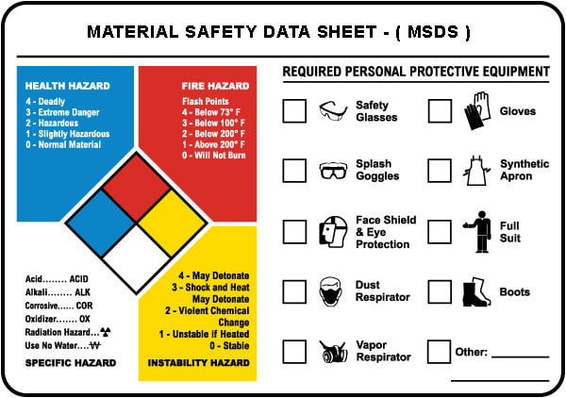

Safety

Function and proper use of gas measuring instruments
A gas detector is a device that detects the presence of gases in an area, often as part of a safety system. This type of equipment is used to detect a gas leak or other emissions and can interface with a control system so a process can be automatically shut down. A gas detector can sound an alarm to operators in the area where the leak is occurring, giving them the opportunity to leave. This type of device is important because there are many gases that can be harmful to organic life, such as humans or animals.
Gas detectors can be used to detect combustible, flammable and toxic gases, and oxygen depletion. This type of device is used widely in industry and can be found in locations, such as on oil rigs, to monitor manufacture processes and emerging technologies such as photovoltaic. They may be used in firefighting.
Gas leak detection is the process of identifying potentially hazardous gas leaks by sensors. These sensors usually employ an audible alarm to alert people when a dangerous gas has been detected. Exposure to toxic gases can also occur in operations such as painting, fumigation, fuel filling, construction, excavation of contaminated soils, landfill operations, entering confined spaces, etc. Common sensors include combustible gas sensors, photoionization detectors, infrared point sensors, ultrasonic sensors, electrochemical gas sensors, and semiconductor sensors. More recently, infrared imaging sensors have come into use. All of these sensors are used for a wide range of applications and can be found in industrial plants, refineries, pharmaceutical manufacturing, fumigation facilities, paper pulp mills, aircraft and shipbuilding facilities, hazmat operations, waste-water treatment facilities, vehicles, indoor air quality testing and homes.

Types of Gas Detectors
Gas detectors can be classified according to the operation mechanism (semiconductors, oxidation, catalytic, photoionization, infrared, etc.). Gas detectors come packaged into two main form factors: portable devices and fixed gas detectors.
Portable detectors are used to monitor the atmosphere around personnel and are either hand-held or worn on clothing or on a belt/harness. These gas detectors are usually battery operated. They transmit warnings via audible and visible signals, such as alarms and flashing lights, when dangerous levels of gas vapors are detected.
Fixed type gas detectors may be used for detection of one or more gas types. Fixed type detectors are generally mounted near the process area of a plant or control room, or an area to be protected, such as a residential bedroom. Generally, industrial sensors are installed on fixed type mild steel structures and a cable connects the detectors to a SCADA system for continuous monitoring. A tripping interlock can be activated for an emergency situation.

Electrochemical
Electrochemical gas detectors work by allowing gases to diffuse through a porous membrane to an electrode where it is either chemically oxidized or reduced. The amount of current produced is determined by how much of the gas is oxidized at the electrode, indicating the concentration of the gas. Manufactures can customize electrochemical gas detectors by changing the porous barrier to allow for the detection of a certain gas concentration range. Also, since the diffusion barrier is a physical/mechanical barrier, the detector tended to be more stable and reliable over the sensor's duration and thus required less maintenance than other early detector technologies.
However, the sensors are subject to corrosive elements or chemical contamination and may last only 1–2 years before a replacement is required. Electrochemical gas detectors are used in a wide variety of environments such as refineries, gas turbines, chemical plants, underground gas storage facilities, and more.

Catalytic bead (Pellistor)
Catalytic bead sensors are commonly used to measure combustible gases that present an explosion hazard when concentrations are between the lower explosion limit (LEL) and upper explosion limit (UEL). Active and reference beads containing platinum wire coils are situated on opposite arms of a Wheatstone bridge circuit and electrically heated, up to a few hundred degrees C. The active bead contains a catalyst that allows combustible compounds to oxidize, thereby heating the bead even further and changing its electrical resistance. The resulting voltage difference between the active and passive beads is proportional to the concentration of all combustible gases and vapors present. The sampled gas enters the sensor through a sintered metal frit, which provides a barrier to prevent an explosion when the instrument is carried into an atmosphere containing combustible gases. Pellistors measure essentially all combustible gases, but they are more sensitive to smaller molecules that diffuse through the sinter more quickly. The measureable concentration ranges are typically from a few hundred ppm to a few volume percent. Such sensors are inexpensive and robust, but require a minimum of a few percent oxygen in the atmosphere to be tested and they can be poisoned or inhibited by compounds such as silicones, mineral acids, chlorinated organic compounds, and sulfur compounds.

Photoionization
Photoionization detectors (PIDs) use a high-photon-energy UV lamp to ionize chemicals in the sampled gas. If the compound has an ionization energy below that of the lamp photons, an electron will be ejected, and the resulting current is proportional to the concentration of the compound. Common lamp photon energies include 10.0 eV, 10.6 eV and 11.7 eV; the standard 10.6 eV lamp lasts for years, while the 11.7 eV lamp typically last only a few months and is used only when no other option is available. A broad range of compounds can be detected at levels ranging from a few ppb to several thousand ppm. Detectable compound classes in order of decreasing sensitivity include: aromatics and alkyl iodides; olefins, sulfur compounds, amines, ketones, ethers, alkyl bromides and silicate esters; organic esters, alcohols, aldehydes and alkanes; H2S, NH3, PH3 and organic acids. There is no response to standard components of air or to mineral acids. Major advantages of PIDs are their excellent sensitivity and simplicity of use; the main limitation is that measurements are not compound-specific. Recently PIDs with pre-filter tubes have been introduced that enhance the specificity for such compounds as benzene or butadiene. Fixed, hand-held and miniature clothing-clipped PIDs are widely used for industrial hygiene, hazmat, and environmental monitoring.

Infrared point
Infrared (IR) point sensors use radiation passing through a known volume of gas; energy from the sensor beam is absorbed at certain wavelengths, depending on the properties of the specific gas. For example, carbon monoxide absorbs wavelengths of about 4.2-4.5 μm. The energy in this wavelength is compared to a wavelength outside of the absorption range; the difference in energy between these two wavelengths is proportional to the concentration of gas present.
This type of sensor is advantageous because it does not have to be placed into the gas to detect it and can be used for remote sensing. Infrared point sensors can be used to detect hydrocarbons and other infrared active gases such as water vapor and carbon dioxide. IR sensors are commonly found in waste-water treatment facilities, refineries, gas turbines, chemical plants, and other facilities where flammable gases are present and the possibility of an explosion exists. The remote sensing capability allows large volumes of space to be monitored.
Engine emissions are another area where IR sensors are being researched. The sensor would detect high levels of carbon monoxide or other abnormal gases in vehicle exhaust and even be integrated with vehicle electronic systems to notify drivers.

Infrared imaging
Infrared image sensors include active and passive systems. For active sensing, IR imaging sensors typically scan a laser across the field of view of a scene and look for backscattered light at the absorption line wavelength of a specific target gas. Passive IR imaging sensors measure spectral changes at each pixel in an image and look for specific spectral signatures that indicate the presence of target gases. The types of compounds that can be imaged are the same as those that can be detected with infrared point detectors, but the images may be helpful in identifying the source of a gas.

Semiconductor
Semiconductor sensors detect gases by a chemical reaction that takes place when the gas comes in direct contact with the sensor. Tin dioxide is the most common material used in semiconductor sensors, and the electrical resistance in the sensor is decreased when it comes in contact with the monitored gas. The resistance of the tin dioxide is typically around 50 kΩ in air but can drop to around 3.5 kΩ in the presence of 1% methane. This change in resistance is used to calculate the gas concentration. Semiconductor sensors are commonly used to detect hydrogen, oxygen, alcohol vapor, and harmful gases such as carbon monoxide. One of the most common uses for semiconductor sensors is in carbon monoxide sensors. They are also used in breathalyzers. Because the sensor must come in contact with the gas to detect it, semiconductor sensors work over a smaller distance than infrared point or ultrasonic detectors.

Ultrasonic
Ultrasonic gas detectors use acoustic sensors to detect changes in the background noise of its environment. Since most high-pressure gas leaks generate sound in the ultrasonic range of 25 kHz to 10 MHz, the sensors are able to easily distinguish these frequencies from background acoustic noise which occurs in the audible range of 20 Hz to 20 kHz. The ultrasonic gas leak detector then produces an alarm when there is an ultrasonic deviation from the normal condition of background noise. Ultrasonic gas leak detectors cannot measure gas concentration, but the device is able to determine the leak rate of an escaping gas because the ultrasonic sound level depends on the gas pressure and size of the leak.
Ultrasonic gas detectors are mainly used for remote sensing in outdoor environments where weather conditions can easily dissipate escaping gas before allowing it to reach leak detectors that require contact with the gas to detect it and sound an alarm. These detectors are commonly found on offshore and onshore oil/gas platforms, gas compressor and metering stations, gas turbine power plants, and other facilities that house a lot of outdoor pipelines.

Holographic
Holographic gas sensors use light reflection to detect changes in a polymer film matrix containing a hologram. Since holograms reflect light at certain wavelengths, a change in their composition can generate a colorful reflection indicating the presence of a gas molecule. However, holographic sensors require illumination sources such as white light or lasers, and an observer or CCD detector.

Proper use of safety equipment and protective devices

Breathing apparatus and tank-evacuating equipment
A self-contained breathing apparatus (SCBA) sometimes referred to as a compressed air breathing apparatus (CABA), or simply breathing apparatus (BA), is a device worn by rescue workers, firefighters, and others to provide breathable air in an immediately dangerous to life or health atmosphere (IDLH). When not used underwater, they are sometimes called industrial breathing sets. The term self-contained means that the breathing set is not dependent on a remote supply (e.g., through a long hose). If designed for use under water, it is called SCUBA (self-contained underwater breathing apparatus).
An SCBA typically has three main components: a high-pressure tank (e.g., 2,216 to 5,500 psi (15,280 to 37,920 kPa), about 150 to 374 atmospheres), a pressure regulator, and an inhalation connection (mouthpiece, mouth mask or face mask), connected together and mounted to a carrying frame.
A self-contained breathing apparatus may fall into two different categories. These are open circuit and closed circuit.

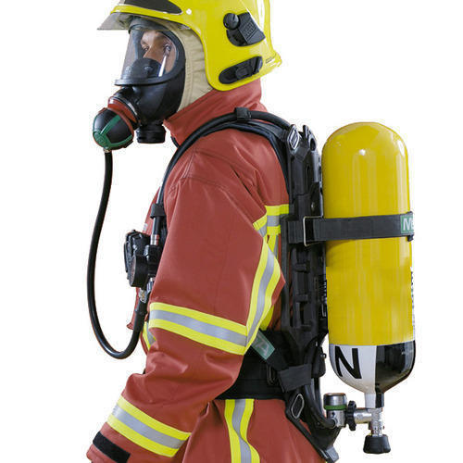

Closed-circuit SCBA
The closed-circuit type filters, supplements, and recirculates exhaled gas: see rebreather for more information. It is used when a longer-duration supply of breathing gas is needed, such as in mine rescue and in long tunnels, and going through passages too narrow for a big open-circuit air cylinder. Before open-circuit SCBA's were developed, most industrial breathing sets were rebreathers, such as the Siebe Gorman Proto, Siebe Gorman Savox, or Siebe Gorman Salvus. An example of modern rebreather SCBAs would be the SEFA. Rebreathers used underwater have the advantage of not releasing tell-tale bubbles, making it more difficult to detect divers involved in covert operations (see frogman).
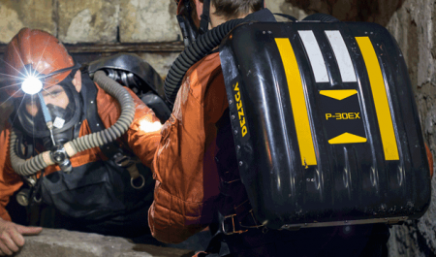

Open-circuit SCBA
Open-circuit industrial breathing sets are filled with filtered, compressed air, rather than pure oxygen. Typical open-circuit systems have two regulators; a first stage to reduce the pressure of air to allow it to be carried to the mask, and a second stage regulator to reduce it even further to a level just above standard atmospheric pressure. This air is then fed to the mask via either a demand valve (activating only on inhalation) or a continuous positive pressure valve (providing constant airflow to the mask).
An open-circuit rescue or firefighter SCBA has a fullface mask, regulator, air cylinder, cylinder pressure gauge, remote pressure gauge (sometimes with an integrated PASS device), and a harness with adjustable shoulder straps and waist belt which lets it be worn on the back. The air cylinder usually comes in one of three standard sizes: 4 liter, 6 liter, or 6.8 liter. The duration of the cylinder can be calculated with this formula: volume (in liters) * pressure (in bars) / 40 - 10 in minutes (the 10 is subtracted to provide a safety margin), so a 6-liter cylinder, of 300bar, is 6 X 300 / 40 - 10 = 35 minutes working duration. The relative fitness, and especially the level of exertion of the wearer, often results in variations of the actual usable time that the SCBA can provide air, often reducing the working time by 25% to 50%.

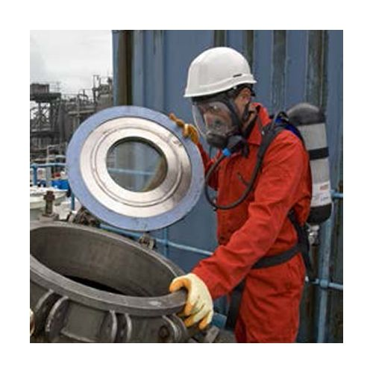

Protective clothing and equipment
Personal protective equipment (PPE) is clothing or equipment designed to be worn by someone to protect them from the risk of injury or illness.
PPE can include:
- Hearing protective devices, such as ear muffs and ear plugs
- Respiratory protective equipment
- Eye and face protection, such as safety glasses and face shields
- Safety helmets
- Fall arrest harnesses for working at heights
- Skin protection, such as gloves, gauntlets and sunscreen
- Clothing, such as high visibility vests, life jackets and coveralls
- Footwear, such as safety boots and rubber boots.

Following are the basic personal protective equipment (PPE) that are always present onboard a ship to ensure safety of the working crew:
- Protective Clothing: Protective clothing is a coverall which protects the body of the crew member from hazardous substance like hot oil, water, welding spark etc. It is popularly known as “dangri “or “boiler suit”.
- Helmet: The most important part of the human body is the head. It needs utmost protection which is provided by a hard plastic helmet on the ship. A chin strap is also provided with the helmet which keeps the helmet on place when there is a trip or fall.
- Safety Shoes: Maximum of the internal space of the ship is utilized by cargo and machinery, which is made of hard metal and which make it clumsy for crew to walk around. Safety shoes ensure that nothing happens to the crew member’s feet while working or walking onboard.
- Safety Hand gloves: Different types of hand gloves are provided onboard ship. All these are used in operations wherein it becomes imperative to protect ones hands. Some of the gloves provided are heat resistant gloves to work on hot surface, cotton gloves for normal operation, welding gloves, chemical gloves etc.
- Goggles: Eyes are the most sensitive part of the human body and in daily operations on ship chances are very high for having an eye injury. Protective glass or goggles are used for eye protection, whereas welding goggles are used for welding operation which protects the eyes from high intensity spark.
- Ear Muff/plug: Engine room of the ship produces 110-120 db of sound which is very high for human ears. Even few minutes of exposure can lead to head ache, irritation and sometimes partial or full hearing loss. An ear muff or ear plug is used on board ship which dampens the noise to a bearable decibel value.
- Safety harness: Routine ship operation includes maintenance and painting of high and elevated surfaces which require crew members to reach areas that are not easily accessible. To avoid a fall from such heightened area, safety harness is used. Safety harness is donned by the operator at one end and tied at a strong point on the other end.
- Face mask: Working on insulation surface, painting or carbon cleaning involves minor hazardous particles which are harmful for human body if inhaled directly. To avoid this, face mask are provided which acts as shield from hazardous particle.
- Chemical suit: Use of chemicals onboard ship is very frequent and some chemicals are very dangerous when they come in direct contact with human skin. A chemical suit is worn to avoid such situations.
- Welding shield: Welding is a very common operation onboard ship for structural repairs. A welder is provided with welding shield or mask which protects the eyes from coming in direct contact with ultraviolet rays of the spark of the weld.

Resuscitators
A resuscitator is a device using positive pressure to inflate the lungs of an unconscious person who is not breathing, in order to keep them oxygenated and alive. There are three basic types: a manual version (also known as a bag valve mask) consisting of a mask and a large hand-squeezed plastic bulb using ambient air, or with supplemental oxygen from a high-pressure tank. The second type is the Expired Air or breath powered resuscitator. The first appearance of the second type was the Brooke Airway introduced in 1957. The third type is an oxygen powered resuscitator. These are driven by pressurized gas delivered by a regulator, and can either be automatic or manually controlled. The most popular type of gas-powered resuscitator is Time Cycled, Volume Constant Ventilators. In the early days of pre-hospital emergency services, pressure cycled devices like the Pulmotor were popular but yielded less than satisfactory results. One of the first modern resuscitation ventilators was the HARV, later called the PneuPac 2R or Yellow Box. Most modern resuscitators are designed to allow the patient to breathe on his own should he recover the ability to do so. All resuscitation devices should be able to deliver >85% oxygen when a gas source is available.

Rescue and escape equipment
It is essential that regular drills and exercises to practice rescue from enclosed spaces are carried out, and that all members of a rescue team know what is expected of them.
When personnel are in need of rescue from an enclosed space, the first action from the person assigned as the attendant should be to raise the alarm. Although speed is often vital in the interest of saving life, rescue operations should not be attempted until assistance has arrived and a planned approach can be made. Over the years, there are many examples of lives having been lost through hasty, ill prepared rescue attempts.

Safety working practices and procedures in accordance with legislation and industry guidelines and personal shipboard safety relevant to oil and chemical tankers

Precautions to be taken when entering enclosed spaces
A ship is a complex structure from inside with several small and enclosed spaces. Many of these enclosed spaces are used for installing some machinery or for storing machine parts or workshop equipment’s. A ship has a matrix of pipelines which runs through each of its parts, including enclosed spaces.
But that is not the point of discussion here. An enclosed place can be used for several reasons; however, the main issue arises when one has to enter these enclosed places in order to do some repairing work or for cleaning purposes.
Because of zero ventilation, these enclosed places generate and store toxic gases which are either produced from chemicals stored in the place or leakage from pipelines. If a person enters such place without taking precaution, he or she may suffer unconsciousness and sometimes even death.
In order to prevent such unfortunate circumstances there is a proper procedure that needs to be followed for safety and wellness of the person entering the enclosed space.

Procedure for Entering an Enclosed Space
The following are the points that need to be followed before entering an enclosed space:
- Risk assessment to be carried out by a competent officer as enclosed or confined space entry is deficient in oxygen, making it a potential life hazard.
- A list of work to be done should be made for the ease of assessment for e.g. if welding to be carried out or some pipe replacement etc. This helps in carrying out the work quickly and easily.
- Risk assessment also needs to be carried out. Risk assessment includes what work to be done, rescue operation etc.
- Potential hazards are to be identified such as presence of toxic gases.
- Opening and securing has to be done and precaution should be taken to check if the opening of enclosed space is pressurized or not.
- All fire hazard possibilities should be minimized if hot work is to be carried out. This can be done by emptying the fuel tank or chemical tank nearby the hot work place.
- The confined space has to be well ventilated before entering.
- The space has to be checked for oxygen content and other gas content with the help of oxygen analyzer and gas detector.
- The oxygen content should read 20% by volume. Percentage less than that is not acceptable and more time for ventilation should be given in such circumstances.
- Enough lighting and illumination should be present in the enclosed space before entering.
- A proper permit to work has to be filled out and checklist to be checked so as to prevent any accident which can endanger life.
- Permit to work is to be valid only for a certain time period. If time period expires then again new permit is to be issued and checklist is to be filled out.
- Permit to work has to be checked and permitted by the Master of the ship in order to work in confined space.
- Proper signs and Men at work sign boards should be provided at required places so that person should not start any equipment, machinery or any operation in the confined space endangering life of the people working.
- Duty officer has to be informed before entering the enclosed space.
- The checklist has to be signed by the person involved in entry and also by a competent officer.
- One person always has to be kept standby to communicate with the person inside the space.
- The person may also carry a life line with him inside.
- The person should carry oxygen analyzer with him inside the enclosed space and it should be on all the time to monitor the oxygen content. As soon as level drops, the analyzer should sound alarm and the space should be evacuated quickly without any delay.
- No source of ignition has to be taken inside unless the Master or competent officer is satisfied.
- The number of persons entering should be constrained to the adequate number of persons who are actually needed inside for work.
- The rescue and resuscitation equipment are to be present outside the confined space. Rescue equipment includes breathing air apparatus and spare charge bottles.
- Means of hoisting an incapacitated person should be available.
- After finishing the work and when the person is out of the enclosed space, the after work checklist has to be filled.
- The permit to work has to be closed after this

The above mentioned procedure is extremely important to entering an enclosed space. These points are imperative to risk any crew member’s life while entering a confined space.

Preventing enclosed space accidents
Enclosed space accidents can be avoided with good planning. In addition, providing all crew members with a suitable safety harness when working within an enclosed space will greatly speed up the rescue effort should an accident occur. Safety lines should be used unless, because of the particular circumstances, their use is considered impractical.

Rescue and recovery organization
Enclosed space rescue procedures should be well planned and regular drills held to improve effectiveness. There are a number of issues that rescue procedures should address.
- Team composition
The rescue team should comprise a dedicated team of personnel drilled and trained as appropriate in all aspects of enclosed space rescue including in the use of resuscitation equipment. All team members should be familiar with the ship's SMS, and its operating and emergency procedures. Although a dedicated team offers major advantages it is essential that back up personnel are also identified in case a member(s) of the dedicated team is unavailable.

- Team roles
The Rescue team should consist of the following personnel:
  - Team leader - this should be a senior officer. The role will be to direct the rescue effort; therefore, the leader should not form part of the team that enters the enclosed space;
  - Entry team - the number of entry team personnel should be kept to a minimum. However, at least two persons should enter the space to carry out the rescue; and
  - Back up personnel - these should be employed to rig the rescue equipment, ensuring that the entry team have the equipment and support necessary to carry out their task and to monitor the enclosed space atmosphere. One crew member should be assigned to assist the rescue team leader with communications and to maintain a record of events.

Depending on the overall crew composition and assessment of the incident some roles can be executed by a single person who may carry out more than one function.

- The rescue operation
The person on watch at the entrance to the enclosed space (attendant) should, as soon as they are aware that a person in the space is in difficulty, immediately raise the alarm. It is therefore essential that a method of raising the alarm is agreed and tested in advance together with a means of communicating the details of the emergency. It is also essential that the rescue team is advised regarding the nature of the accident and how many persons are affected.
Rescue team personnel should proceed immediately to the entrance to the enclosed space together with any additional equipment. No one should enter the space without the team leader's permission.
Unless it has been positively assessed that the atmosphere in the enclosed space is safe to breathe, the entry team should in addition to wearing appropriate protective equipment use breathing apparatus. Only after a full test has confirmed that the enclosed space atmosphere is safe to enter should the entry team proceed without breathing apparatus.

Precautions to be taken before and during “repair and maintenance” work in a gas dangerous area
Maintenance is one thing that keeps any mechanical equipment or machinery going. Weather it is a small machine or a large structure, efficient maintenance can help with prolonged life and favorable outcome. On a ship, maintenance is one thing that keeps machinery up to date and is smooth running condition. In this article we will learn as to how maintenance is being carried out on a ship.

In a ship’s engine room, where the maximum machines are located, engineers and crew carry out the maintenance for safe and efficient operation. Each machine on board a ship requires maintenance which has to be carried out at regular intervals of time.
In the earlier days, the number of crew members and engineers on a ship were large and so the maintenance was carried out fast and easily. However, in the present scenario, the number of crew members and engineers on the ship has reduced drastically.
Many ships carry only 3-4 engineers on board a ship and even the time required to carry out maintenance on the ship has reduced. Maintenance requires manpower and time which may not be available all the time as the number of crew members is less and the amount of machinery is more.
It is for this reason important to plan the maintenance of the machinery in advance so that the machinery can be overhauled and maintained properly. Generally second engineer is required to plan the schedule of maintenance on a ship.
Efficient planning and adequate usage of equipment’s is the key to productive maintenance. In this article we will have a look at the main types of maintenance procedures followed on a ship.

Types of Maintenance Procedures

Preventive or Scheduled Maintenance System
It is famously known as the PMS or Planned Maintenance System. In this type of system the maintenance is carried out as per the running hours like 4000 hrs, 8000 hrs etc., or by the calendar intervals like 6 monthly, yearly etc. of the machinery. The maintenance is carried out irrespective of the condition of the machinery. The parts have to be replaced if it is written in the schedule, even if they can be still used.

Corrective or Breakdown Maintenance
In this system the maintenance is carried out when the machinery breaks down. This is the reason it is known as the breakdown maintenance. This is not a suitable and good method as situations may occur wherein the machinery is required in emergency. The only advantage of this system is that the working of machinery parts is used to its full life or until it breaks. This system might get costly as during breakdown several other parts may also get damaged.

Condition Maintenance system
In this system the machinery parts are checked regularly. With the help of sensors etc. the condition of the machinery is accessed regularly and the maintenance is done accordingly. This system requires experience and knowledge as wrong interpretation may damage the machinery and lead to costly repairs which may not be acceptable by the company.

Safety measures for hot and cold work
Hot work means any work requiring the use of electric arc or gas welding equipment, cutting burner equipment or other forms of naked flame, as well as spark generating tools. It covers all such work, regardless of where it is carried out on board a ship, including open decks, machinery rooms and the engine room.
Performing hot works onboard modern chemical tankers involved numerous hazards .It is anticipated that owners and operators of chemical tankers will issue clear guidance to masters and crews on the control of hot work on board while the ship is in service. The following is intended to assist safety by indicating principal areas that should receive attention.

Hot work requirement
Repair work outside the main engine room which necessitates hot work should only be undertaken when it is essential for the safety or immediate operation of the ship, and when no alternative repair procedure is possible.

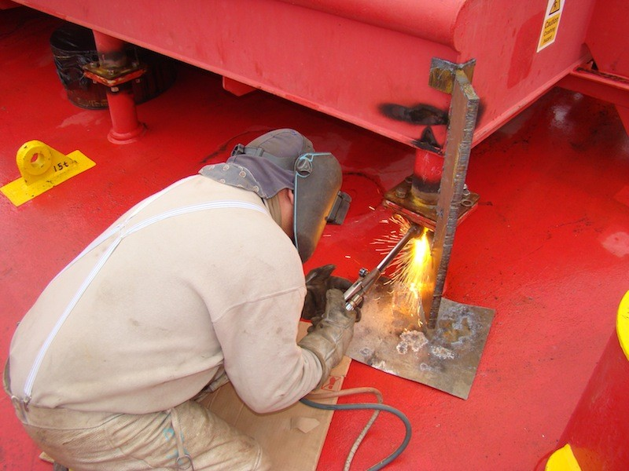

Hot work outside the engine room (and in the engine room when associated with fuel or lubrication systems) must be prohibited until the requirements of national legislation and other applicable regulations have been met, safety considerations taken into account, and a hot work permit has been issued. This may involve the master, owner's superintendent, shore contractor, terminal representative and port authority as appropriate.
Hot work in port at a chemical terminal is normally prohibited. If such work becomes essential for safety or urgent operational needs, then port and terminal regulations must be complied with. Full liaison should be established with port and terminal authorities before any work is started.

Assessment of hot work
- The master is responsible for deciding whether the hot work is justified, and whether it can be conducted safely. Hot work in areas outside the engine room should not be started until a procedure has been discussed and agreed, and the master has informed the ship's owners or operators of details of the work intended.

- Before hot work is started a safety meeting under the chairmanship of the master must be held, at which the planned work and the safety precautions are carefully reviewed.

- The meeting should be attended at least by all those who will have responsibilities in connection with the work. An agreed written plan for the work and the related safety precautions should be made. The plan must clearly and unambiguously designate one officer who is responsible for the supervision of the work, and another officer who is responsible for safety precautions and communications between all parties involved.

- All personnel involved in the preparations and in the hot work operation must be briefed and instructed on their own role. They must clearly understand which officer is responsible for work supervision and which for safety precautions. A written hot work permit should be issued for each intended task. The permit should specify the duration of validity, which should not exceed a working day.

Preparations for hot work
- No hot work must be undertaken inside a compartment until it has been cleaned and ventilated. Tests of the atmosphere in the compartment should indicate 21% oxygen content by volume, flammable vapour as low as possible but not more than 1% LFL, and that the compartment is free from toxic gases. It is important to continue ventilation during hot work.

- No hot work should be undertaken on the open deck unless the area is free from flammable vapour and all compartments (including deck tanks) within a specified radius around the working area have been washed and freed of flammable vapour and/or inerted. Company or national regulations may give guidance on this distance. If no guidance is available, then the advice in ISGOTT should be taken into account.
- All sludge, cargo-impregnated scale, sediment or other material likely to give off flammable or toxic vapour, especially when heated, should be removed from an area of at least 10 meters around all hot work. All combustible material such as insulation should either be removed or protected from heat.

- Adjacent compartments should either be cleaned and gas freed to hot work standard, or freed of cargo vapour to not more than 1% LFL and kept inerted, or completely filled with water. No hot work should be undertaken in a compartment beneath a deck tank in use.

- Care should be taken to ensure that no release of flammable vapour or liquid can occur from non-adjacent compartments that are not gas free.An adjacent fuel oil bunker tank may be considered safe if tests using a combustible gas indicator give a reading of not more than 1% LFL in the ullage space of the bunker tank, and no heat transfer through the bulkhead of the bunker tank will be caused by the hot work. No hot work should be carried out on bulkheads of bunker tanks that are in use.

- All pipelines interconnecting with cargo spaces should be flushed, drained, vented and isolated from the compartment or deck area where hot work will take place.
- Hot work on pipelines and valves should only be permitted when the item needing repair has been isolated from the system by cold work, and the remaining system blanked off. The item to be worked on should be cleaned and gas freed to a standard that is safe for hot work, regardless of whether or not it is removed from the hazardous cargo area.
- All other operations utilizing the cargo or ballast system should be stopped before hot work is undertaken, and throughout the duration of the hot work. If hot work is interrupted for any reason for an extended period, hot work should not be resumed until all precautions have been rechecked and a new hot work permit has been issued.

Checks by officer responsible for safety during hot work
Immediately before hot work is started, the officer responsible for safety precautions should examine the area where it is to)De undertaken, and ensure that tests with a combustible gas indicator show not more than 1% LFL, and, if the work is inside an enclosed space, that the oxygen content is 21% by volume.
Adequate firefighting equipment must be laid out and ready for immediate use. Fire watch procedures must be established for the area of hot work and in adjacent, non-inerted spaces where the transfer of heat may create a hazard. Effective means of containing and extinguishing welding sparks and molten slag must be established.
The work area must be adequately and continuously ventilated. Flammable solvents must not be present, even for use in cleaning tools.
The frequency with which the atmosphere is to be monitored must be established. Atmospheres should be retested at regular intervals and after each break in work periods. Checks should be made for flammable vapours or liquids, toxic gases or inert gas from non-gas free spaces.
Welding apparatus and other equipment to be used should be carefully inspected before each occasion of use to ensure that it is in good condition and, where required, correctly earthed.
Bottles containing Acetylene– A colorless, poisonous gas used with oxygen for oxy-acetylene metal welding or cutting should be checked prior hot work. Flash back arrestor must be fitted and in good working condition.
Special attention must be paid to electric arc equipment to ensure that:
- Electrical supply connections are made in a gas free space.
- Existing supply wiring is adequate to carry the electrical current demanded without overloading and consequent heating.
- Flexible electric cables laid across the deck have sound insulation.
- The cable route to the work site is the safest possible, only passing over gas free or inerted spaces.

After completion of hot work
The work area should be secured, and all special equipment used should be removed. The ship's owner or operator should be informed of the completion of all hot work allowed by the hot work permit.

Electrical safety precautions
Even small voltages can be dangerous and since the environment on board a ship is full of moisture, salt and corrosion, utmost care needs to be taken for the sake of safety of life of the crew as well as to prevent the breakout of electrical fires. Read on to learn a few tips which could be useful.
The electrical equipment on board a ship is subjected to a lot harsher treatment than they would ever see on shore which could lead to their deterioration and hence possible danger for the crew.
Voltage seemingly as low as 110 V can prove fatal; if the associated current is of the order of 0.1 Amps. Since power = voltage current this means that a power of mere 11 watts can prove deadly hence the need to be insulated as we will see below.

Marine Electrical Safety Tips
  - Make sure all electrical cables are physically inspected for any cuts, abrasions or if they are immersed in water due to clogging etc. The same should be notified and appropriate measures should be taken to rectify or report the fault so that it can be repaired in dry-docks.
  - If any sparks are noticed, be sure not to ignore them. They could lead to fire which is one of the deadliest enemies of the ship. It is better to nip this enemy in the bud rather than giving it a chance to spread.
  - Always use intrinsically safe equipment especially in places where the presence of spark can lead to disaster.
  - Never leave the marine wiring having loose connections or joints without proper insulation. This is known as Jury rigging or Jerry rigging (wrong-spelling) in nautical terms and refers to temporary unsatisfactory repairs as these could lead to problems and losses in the long run.
  - When carrying out maintenance or repair on any equipment make sure to switch off power from the main electrical panel and also make sure to put a notice near that switch which says that “work in progress – do not switch on". This would ensure that no over-enthusiastic person would come and switch on the power without bothering to check why it was off in the first place.
  - Wear proper protective gear when working with electrical machineries and follow all instructions, relevant checklists etc. Having understood the equation given in the introduction section, you will realize that since the current flowing also depends on resistance, if you provide an easy path for the current to flow by making your body wet or without much insulation, the current will be sufficiently higher than the minimum required value to harm you.
  - Electrical fires on board (even on land) require special handling and therefore everyone on the ship must be aware of how to react in case of electrical fires in terms of the fire extinguishers to be used and other steps to be followed. This can be drilled into the staff by carrying out regular safety drills which train the crew for such a situation
  - Extension cables should be secured properly without any knots of unnecessary bends. If possible try to roll it up in a nice manner uniformly and store in a dry place.

These few tips will go a long way to ensure that the marine electrical systems do not turn against you to harm you but act as your faithful servants.

First aid with reference to a Material Safety Data Sheet (MSDS)
An MSDS sheet is created by the manufacturer or supplier of a material or chemical product to educate customers about its proper usage. A Material Safety Data Sheet provides summarized information about a material or chemical product’s properties, how to use it carefully, possible hazards, the protocol in case of emergency, and all the probable uses for the material.

Different Sections of a Material Safety Data Sheet
An MSDS is organized into different sections with distinct headings, although the sections and specific information, as well as the order in which the information is delivered, might differ from one supplier to the next.
The major sections on an MSDS are:
- Product and Company Identification

NDA MSDS’ can be found under the MSDA & COA Documents tab of the Product page on the website. The name of the product, sometimes referred to as the product “identifier” is on both the MSDS and the WHMIS label and should match the name on the material label. To find the correct MSDS sheet for the material, it is imperative to search for it based on the actual product name rather than any short form name that might be used for the product. The MSDS and label might have additional identifying information such as a product code.

- Hazards Identification

This section of an MSDS contains information about different ways in which one could be exposed to the material and the potentially harmful effects of the exposure. The effect of the material on animals, if they have been used for experimentation purposes, might be mentioned if they are relevant to human health.

Health effects in this section can be considered general, as the effects will not always be the same for everyone that comes in contact with each potentially hazardous material. The degree of the health effects will be determined by the way in which a material is handled and the purpose for which it is used.
MSDSs from different suppliers will have varying information; some might provide the reasonably anticipated potential effects from the normal use of the product as well as how to handle spills and emergencies, while other MSDSs could provide further details about how to handle worst case scenarios and possible health effects that emerge from exposure to any amount of the substance through any form of contact (absorption, inhalation, etc). One must not assume that a product is more or less hazardous than another based on information outlined in this section.
- Emergency Overview. This section mentions the physical characteristics of the material such as color, odor, physical stage (gas, liquid, or solid), evaporation rate, boiling point, freezing point, and other details. It addresses noteworthy concerns such as flammability, reactivity, and potential health and environmental hazards.
- Regulatory Status. This subsection might include information about the regulatory status of the material under the Controlled Products Regulations (WHMIS) and/or the US Hazard Communication Standard. Simply put, regulations will likely mention the goals of the organizations that are supplying and using this material and their efforts to ensure that the product conforms with all rules, policies, standards, laws, and regulations. References to health, safety, and environmental laws and regulations may be provided here.
- Irritancy of Product. This section will indicate any potential irritation caused by exposure to this material through the skin or eye contact or through the respiratory tract. If experimental animals were used to test irritancy, that will also be mentioned here.
- Sensitization to Product. Sensitization to a product happens when an allergic reaction to a chemical is developed over a period of time. With initial exposure, the sensitivity might be mild and may increase in severity with ensuing instances of exposure. In due course, even brief exposures to small amounts of the substance may cause extreme reactions. The two types of sensitization include skin and respiratory. Symptoms of skin sensitization include swelling, redness, blistering, itching, and pain. Symptoms of respiratory sensitization include coughing, shortness of breath, wheezing, or a tightness in the chest.
- Carcinogenicity. A carcinogen is any cancer-causing substance. Carcinogenic materials will be identified as such by the International Agency for Research on Cancer (IARC) or the American Conference of Governmental Industrial Hygienists (ACGIH). The lists of carcinogens include those that are harmful to both humans and animals. If the evidence for a listed chemical is limited, it may be listed as having the potential to be carcinogenic.
- Reproductive Toxicity. This section will address any potential effects on the reproductive capacity of adult males or females, including consequences such as reduction in fertility and changes to menstrual cycles.
- Teratogenicity and Embryotoxicity. Teratogens are substances that may cause birth defects, and embryo toxins are those that may have toxic effects on an embryo that is evolving. It is important that pregnant women, in particular, minimize their exposure to materials with these properties.
- Mutagenicity. The mutagenicity of a substance refers to its ability to cause mutations in cell DNA, which is what determines the distinguishing qualities and features that parent pass on to their children. It also determines how the body’s cells reproduce. A substance’s possible mutagenic effects may also be linked to its potential carcinogenic, teratogenic or reproductive hazards. Test results of a material’s mutagenicity might not necessarily be reliable or conclusive, due to the fact that the human body is able to eradicate mutagens and repair mutations; however, this information is included to direction attention to a potential health risk.
- Toxicologically Synergistic Products. Synergistic products are those that, when combined with certain other chemicals, may cause greater harm than they would if they were all used individually. The interaction of more than one chemical over the same period of time means the health effects of exposure are added together and made more severe.
- Potential Environmental Effects. This section provides information about the possible effects that the material can have on the environment such as on fish or wildlife as well as its potential to cause bioaccumulation or accumulation in the environment.

- Composition, Information on Ingredients
In this section, the product’s potentially hazardous chemical components, its by-products, and any impurities are mentioned along with the approximate percentages of each. Because chemicals can be referred to by several names, they are also assigned unique numbers by the Canadian and American Chemical Abstracts Services (CAS). These numbers are usually mentioned in this section as well. Sometimes the CAS number is mentioned in the “Product and Company Identification” section. If one or more of the components of the product is an approved trade secret, that information will be included in this section.

- First Aid Measures
This section outlines the safety measures that are to be taken in the event of accidental exposure to the material. These steps are intended to help the user minimize both short-term and long-term injury. In some serious cases, first aid might be necessary for the prevention of death induced by exposure.
It is imperative that this information is understood before beginning to use the product, as there will be no time to read it during an emergency. Product users that are trained to give first aid should review the safety procedures regularly, but all users should be aware of the locations of all the first aid equipment such as kits and the facilities such as eyewash stations and safety showers.

If medical treatment is required and the MSDS is available, it should be taken to the emergency facility along with the victim. If it is not available, the product’s label or the labeled product container itself should be sent in order to inform the medical responders of what the material is made of and the suggested First Aid measures.

- Fire Fighting Measures
Any fire hazards and firefighting protocols are mentioned in this section, mostly for the benefit of firefighters and other emergency responders. This helps them select the best course of action to extinguish the fire, including selecting the appropriate extinguisher. The information in this section along with the sections on Handling and Storage and Stability and Reactivity will help determine the ideal location for the storage of a particular material. For example, flammable materials should be stored away from incompatible materials.

- Accidental Release Measures
The information in this section is also largely beneficial to emergency responders, as it involves recommendations for cleaning up accidental spills or releases, sometimes suggesting materials that would best absorb the spill.

- Handling and Storage
This section covers the general precautions for safely handling the material as well as any required equipment. The information in this section is largely intended for safety professionals and/or those responsible for designing handling and storage and facilities.
When developing these safety procedures, all possible hazards such as fire, reactivity, health and environmental hazards need to be taken into consideration. For example, flammable and combustible liquids can generate static electricity, so MSDS may suggest that the containers of these liquids be bonded and electrically grounded with special wires when dispensing of the contents.
The recommendations for ideal storage locations indicate important factors for materials such as the temperatures at which they should be stored. The sections on Firefighting Measures and Stability and Reactivity would also support these safety protocols.

- Exposure Controls
Information provided in this section is implemented in safety procedures and practices. Because MSDS are developed with all reasonably estimated uses in mind and because they address a wide range of uses, the information might not always apply to each individual situation. The importance and relevance of the information to a particular workplace or specific job can be assessed with the help of a health and safety professional.

- Physical and Chemical Properties
The material’s physical description, which includes its physical state and appearance, should match the description on the MSDS. If the information on both does not match, the MSDS is not the correct one for the product. If the material is old or has disintegrated, the MSDS may not apply to it any longer and further advice should be sought for how to handle the product.
Other information provided in this section is used by technical specialists to help determine the conditions under which the material may be harmful. It is also used to support the development of safety measures that are work site-specific, including procedures for the regulation of exposure, storage, handling, firefighting, and accidental spillage.

- Stability and Reactivity
Any conditions under which the material becomes unstable or under which it can react dangerously will be mentioned in this section. This information will inform the material’s users of safe storage and handling procedures. It will also help them become aware of any incompatible materials that they should avoid storing or mixing together, as violent reactions or even explosions may occur if they are mixed.
Environmental conditions such as exposure to heat, sunlight or the simple aging of a chemical could cause it to disintegrate. When this happens, chemicals can potentially cause fires, explosions, or the creation of new chemicals that pose different threats.

When chemicals undergo polymerization, a chain reaction process during which two or more similar molecules combine to make bigger molecules, they can be hazardous. This is because the reaction may produce heat or enough pressure to become explosive and detonate the chemical container. Chemicals that are prone to decomposition or polymerization often contain stabilizers or inhibitors to reduce or prevent the chances of this hazardous reaction.

- Toxicological Information
Due to the range of health effects caused by chemicals, toxicity tests may be required depending on the ways they will be used. It is difficult to compare the toxicity of one chemical to that of another because of their different toxic effects, so the same toxic potency and intensity must be measured and compared across several different chemicals. This can be done through lethality testing, which measures the amount of the chemical that would cause death. This type of testing is also called “quantal,” as it measures a “quanta” or a particular amount of the chemical and whether or not an effect “occurs.”
This section of an MSDS informs the material user of the toxicity of either the ingredients or the entire product. The language used may be technical and challenging to interpret; however, a well-informed health and safety professional may assist with deciphering.

- Ecological Information
Under WHMIS, it is not mandatory to include this information on an MSDS, but when included it explains the impact of the chemical when it is released into the environment. This includes its toxicity to fish, birds, plants and microorganisms. The relevance of this information mainly pertains to workplace staff and professionals that evaluate the material’s use, disposal, and spill control.

- Disposal Considerations
This section includes information on general waste disposal and is also mostly relevant to environmental professionals. The steps and precautions for proper disposal of hazardous waste and the federal, provincial, local regulations will not be included here, as the appropriate local authorities must be contacted for this information.

- Transport Information
This section pertains to the individuals that ship the material and it provides information about required precautions for shipping. Transportation of Dangerous Goods (TDG) classification may be included along with the Product Identification Number (PIN), if the product meets the TDG criteria.

- Regulatory Information.
Information in this section pertains largely to personnel in charge of regulatory compliance. It may include the product’s regulatory status, beneficial references to pertinent health, safety and environmental laws and regulations, and the product’s WHMIS classification.

Fire safety and fire-fighting operations

Oil and chemical tanker fire response organization and action to be taken
Fire fighting organization on board consists of several teams. The master of the ship bares the overall responsibility for the operation.
Though duties vary from ship to ship, usually the chief officer will be in charge of operations in the accommodations and deck area, and chief engineer is responsible for operations in and around the engine room. The crew is divided into various teams such as fire fighting, engine room, technical and first aid team.
The organization and jurisdictions of shore-based rescue services and the resources available to them will vary from country to country and may involve civilian or military emergency agencies. The way in which the operation is handled will also depend on whether the ship is at sea or in port. Local fire fighting authorities will normally engage fires that occur in port. Fires at sea however will require a great deal more organization, which can include assistance of fire fighting tugs and transportation of fire fighting crew and equipment from sever different stations to the area. Such operations are coordinated at multi- jurisdictional levels.
There are planned courses of action or procedures that are intended to result in the best possible outcome. This involves the placement and coordination of crewmembers or teams in such a way that maximizes their ability to cope with situation. These procedures include:
- Alerting a notifying
- Alarm instructions
- Saving lives
- The emergency escape breathing device
- Limiting the fire
- The use of fire doors
- The use of smoke and fire dampers
- Extinguishing the fire

It is important to alert the bridge, immediately if a fire is detected. This can be done by using automatic or manual alarm systems. The management on board will then have more time to plan and organize the firefighting operation. On board of every vessel you will find an Emergency plan, explaining the meaning of various alarm signals and your specific duties in an emergency situation. Make sure you are familiar with the Emergency Plan on your vessel.
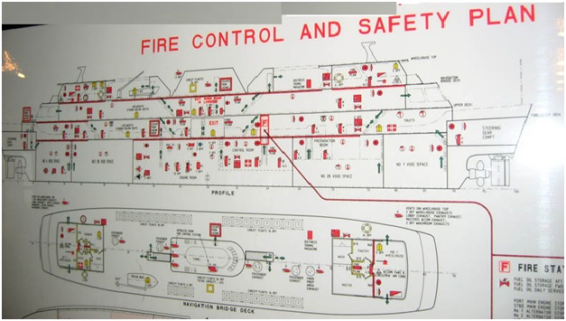

Fire hazards associated with cargo handling and transportations of hazardous and noxious liquids in bulk
Loading of various noxious liquid chemicals involved numerous hazards. It is important to exercise safety during all stages of cargo loading. If, at any stage during or immediately after the loading operation, a non-conformance (which may include cargo quantity, quality, temperature and colour etc.) is believed to exist, all operations should be suspended until such time as the situation is resolved.

Commencement & execution of loading
Immediately prior to commencing the loading the valve setting and the lines on all tanks have to be checked once more. The responsible officer must be satisfied that the cargo system is, in all respects, ready and all the information of the cargo has been received. The following precautions must be observed:
- The quantity and grade of the cargo to be loaded has been agreed to
- The loading rate has been agreed to shore or ship stop has been agreed to
- Ships personnel are ready
- Ship/Shore checklist completed
- High and Hi/Hi level alarms MUST be operational and switched on
- Loading must start at a low rate. In this stage the cargo line, manifold, connections, drain points etc. must be checked for leakages.
- The full loading rate should not commence before both ship and shore are satisfied that there is no leaks in the system and the filling pipe in the tank is covered. When system is satisfactory shore can be informed to increase the loading rate to the agreed level.
- During the loading at least one deck officer must be on duty and available at all times. At least one crewmember must be on deck/manifold throughout the cargo operation. The officer on duty is obliged to carry out the loading in accordance with the instructions received from the Chief-Officer, which should at least encompass the agreements made with the Loading Master as well as the Surveyor.
- Some cargoes loaded in hot climates are chilled and cause bulkheads to sweat on loading. Consideration must therefore be given to sequences of loading. (e.g. Styrene Monomers)
- During the whole loading a detailed cargo log has to be kept.
- Sufficient ullage space should be maintained after loading to allow for heating cargo as required by the Shipper.
- Loading one product in more than one tank simultaneously may increase the risk of an overflow, and the responsible officer must ensure that tanks that are “topped off” are properly isolated from tank(s) still being loaded.
- When nearing completion of loading the shore should be notified and the loading rate reduced

Handling of high vapour pressure cargoes
When handling high vapour pressure cargoes, particularly in high ambient temperatures, high rates of vapour generation may occur during either loading or discharging. As a high vapour pressure petroleum cargo enters an empty tank there is a rapid evolution of gas, as a result it may be necessary to reduce the loading rates. During the loading of high vapour pressure cargoes, a very high concentration of hydrocarbon gas, approaching 100% by volume, may be vented to atmosphere.
Therefore, special precautions regarding handling of high vapour pressure cargoes recommended by ISGOTT are to be followed. When discharging every effort must be made to discharge and completely strip a tank in one operation. Difficulty can be experienced in re-gaining suction from a tank with a low level of cargo.
The main types of cargoes that can cause problems due to high vapour pressure are:
- Crude oils.
- Motor and aviation gasoline’s.
- Natural gasoline’s.
- Light distillate feedstock’s (LDFs) and Naphtha’s.
- Certain chemicals e.g. Acetone, Toluene, Styrene, etc.

Clearing shore pipelines
When, after completion of a product, the shore pipelines are to be cleared by the use of air or inert gas (blow through) or by use of a line scraper (pigging), the responsible officer must ensure that there is sufficient space in the tank or tanks to accommodate the quantity of product in the shore pipeline, otherwise cargo overflow from a tank may occur.
Blowing through or pigging could cause an increase in pressure, and the responsible officer must monitor the operation carefully in order to avoid tank over pressurization. The risk of large volumes of nitrogen or air, that has been under pressure in the shore line, escaping into the cargo tank must be taken into account. The same possibility exists for an abrupt and dramatic increase in the tank filling rate, when pressing a chemical out of shore tanks. During a line clearing operation, it is important that terminal staff react promptly when the scraper is caught in its trap, in order to avoid all the compressed propelling gas entering a loaded cargo tank.

Use of compressed gas
Compressed gas is sometimes used by a terminal to press products out of shore tanks (such as railway wagons) into the ship, and there is an inherent risk of over pressurization of the ship's cargo tank. The gas pressure used for these operations varies, but can range between 2.5 and 5 bar. The point of greatest is when the supply into the ship’s tank changes from liquid to compressed gas, causing an abrupt and dramatic increase in the tank filling rate from liquid at a few hundred cubic meters per hour to gas at several thousand cubic meters per hour.

Over pressurization of a closed tank can occur in seconds, especially when the distance from the manifold to the tank is small or the vapour space in the tank is limited. A crew member stationed at the manifold will be best placed to detect and react to any indication that the flow in the system has changed from liquid to gas.

Topping off
Care must be taken as tanks become full, especially when loading a product into more than one tank simultaneously, due to the increased risk of an overflow while topping off. High level alarms and tank overflow control alarms are safety critical items, and loading should be stopped if it is suspected that either is not working correctly.
The responsible officer must ensure that tanks that have been topped off are properly isolated from tanks still being loaded. Cargo tanks which have been topped off should be checked frequently during the remaining loading operations to detect changes in liquid level, and to avoid an overflow.
When nearing completion of loading the shore should be notified and, if necessary, the loading rate reduced.

Clearing cargo hoses
When clearing the line after loading a static accumulator cargo, it is desirable to minimize the introduction of gas into the tank which will bubble up through the cargo.
If nitrogen is used to clear the cargo hose after loading a cargo treated with an inhibitor that depends on oxygen, care should be taken to minimize the volume of nitrogen entering the cargo tank. Not only may bubbling the nitrogen through the liquid in the tank deplete the dissolved oxygen and affect the inhibitor by requiring it to take oxygen from the atmosphere in the ullage space, but it is also possible that excessive nitrogen will linger in the ullage space.

Blowing lines
The loading line is always blown through with either compressed air, steam or nitrogen, depending on the cargo, to empty it between manifold and terminal. This is necessary to ensure risk-free release of loading arm or hose connection. If possible the vessel’s line system used should also blow empty this way. With heated or solidifying cargoes this is a must.
In case of high viscous cargo it is important to be aware that after line blowing the cargo may contain an air-bubble and therefore the ullage measured immediately after blowing is less than actual (Vegetable oils) giving higher volume of cargo onboard than actual. Pre-blowing and after-blowing ullage measurements should give a good indication of this. The tank in question has to settle before a correct ullage can be taken. If this is not possible or cannot be ascertained, the ullage report to be remarked of entrapped air in the cargo giving higher volume in ship tank.

Pigging
At some installations the landline from tank farm to jetty manifold or part of it are pigged.
It is possible that large amounts of cargo are pressed into a cargo tank at high rate and high pressure. Method and required tank volume necessary for this shoreline emptying must be agreed upon in the pre-loading conference. Especially one must be aware of the high pressure which could be created when pigging and take precautionary measures to prevent over pressurizing the tank or creating an overflow, by venting the tank during this operation and throttling manifold valve to control flow.

Completion of loading & final measurements
When loading is completed the final loading measurements have to be carried out. In order to clear the shore and vessel’s cargo line free from product, the lines are blown from the shore. Cargos sensitive to Oxygen are given a nitrogen blanket following loading. The surveyor together with an officer will take the ullage and cargo temperature of the tank(s) concerned. In the presence of an officer cargo samples are taken sealed and labelled.
Upon completion:
- Loading the manifold valve must be closed
- In cases where the shore line is emptied by either “blowing” or “pigging” the product into the ship tank(s) the responsible officer must ensure that the tank(s) have sufficient space to accommodate the quantity in the shoreline.
- Blowing” or “pigging” can cause a pressure surge and the responsible officer must monitor this operation carefully in order not to over-pressurize or overflow the tank.
- During customary ullaging and sampling the responsible officer must ensure that that this activity is conducted as per local and/or international regulations and that proper personal protective equipment is used.
- Disconnecting of shore hoses or arms must only take place after they have been drained for cargo residues and relieved of any pressure after blowing/pigging.
- Personnel engaged in hose disconnection must wear proper personal protective equipment.
- Cargo heating system should be tested as required.

Disconnection of cargo hoses
After the transfer of a chemical cargo is complete, established procedures should be followed to minimize residues in the line, and especially in the cargo hose or cargo arm between ship and shore. Disconnection must only take place after draining of cargo residues and relief of any pressure, even before emergency disconnection if at all possible.
Disconnection of the hose or cargo arm at the ship's manifold is a time when the cargo containment system is deliberately breached. Although hose disconnection is a routine operation that must be performed, it should be regarded as comparable to opening up any other cargo pipeline on deck. Personnel engaged in hose disconnection should wear protective equipment appropriate to the hazards of the cargo involved which, for a highly toxic cargo, will include a full chemical resistant suit and breathing apparatus.

Preparation for sea voyage
- Cargo samples: are to be stored safely in the designated sample store / locker. Storage elsewhere in cargo office or accommodation is not allowed. Cargo samples should not be brought into accommodation.
- Manifold: blind flanges on the manifold have to be fitted and fully bolted.
- P/V Valves: The valve setting should be in accordance with C.O.F.
- Hoses – If time permits: All loading hoses, jumper hoses, have to be disconnected. If vessel’s hoses have been used, these hoses should be cleaned at sea and thereafter fitted with blind flanges. Thereafter hoses are to be stowed for the sea-voyage. Hoses on the vapour return line, between central vapour return line and specific tank in the towers, when applicable have to be removed. The vapour return line has to be fitted with blind flanges wherever applicable.
- Tank alarms: Tank alarm system to be switched off.
- Tank closures and openings: All tank hatches Butterworth hatches etc. have to be checked that they are closed before commencing the sea voyage.
In general, a round over deck should be made by a responsible officer to check that the cargo area is seaworthy in all respects.

Fire-fighting agents used to extinguish oil and chemical fires
A fire extinguisher is an active fire protection device used to extinguish or control small fires, often in emergency situations. It is not intended for use on an out-of-control fire, such as one which has reached the ceiling, endangers the user (i.e., no escape route, smoke, explosion hazard, etc.), or otherwise requires the expertise of a fire department. Typically, a fire extinguisher consists of a hand-held cylindrical pressure vessel containing an agent which can be discharged to extinguish a fire. Fire extinguishers manufactured with non-cylindrical pressure vessels also exist, but are less common.
There is no official standard in the United States for the color of fire extinguishers, though they are typically red, except for class D extinguishers which are usually yellow, water and Class K wet chemical extinguishers which are usually silver, and water mist extinguishers which are usually white. Extinguishers are marked with pictograms depicting the types of fires that the extinguisher is approved to fight. In the past, extinguishers were marked with colored geometric symbols, and some extinguishers still use both symbols. The types of fires and additional standards are described in NFPA 10: Standard for Portable Fire Extinguishers.
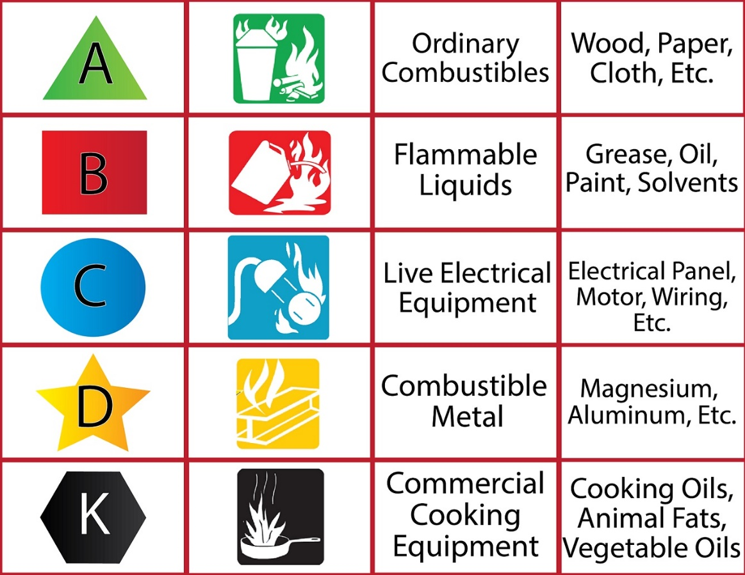

Fire extinguishing capacity is rated in accordance with ANSI/UL 711: Rating and Fire Testing of Fire Extinguishers. The ratings are described using numbers preceding the class letter, such as 1-A:10-B:C. The number preceding the A multiplied by 1.25 gives the equivalent extinguishing capability in gallons of water. The number preceding the B indicates the size of fire in square feet that an ordinary user should be able to extinguish. There is no additional rating for class C, as it only indicates that the extinguishing agent will not conduct electricity, and an extinguisher will never have a rating of just C.

Types of extinguishing agents

Dry Chemical
This is a powder based agent that extinguishes by separating the four parts of the fire tetrahedron. It prevents the chemical reactions involving heat, fuel, and oxygen (combustion), thus extinguishing the fire. During combustion, the fuel breaks down into free radicals, which are highly reactive fragments of molecules that react with oxygen. The substances in dry chemical extinguishers can stop this process.
- Monoammonium phosphate, also known as tri-class, multipurpose, or ABC dry chemical, used on class A, B, and C fires. It receives its class A rating from the agent's ability to melt and flow at 177 °C (351 °F) to smother the fire. More corrosive than other dry chemical agents. Pale yellow in color.
- Sodium bicarbonate, regular or ordinary used on class B and C fires, was the first of the dry chemical agents developed. In the heat of a fire, it releases a cloud of carbon dioxide that smothers the fire. That is, the gas drives oxygen away from the fire, thus stopping the chemical reaction. This agent is not generally effective on class A fires because the agent is expended and the cloud of gas dissipates quickly, and if the fuel is still sufficiently hot, the fire starts up again. While liquid and gas fires do not usually store much heat in their fuel source, solid fires do. Sodium bicarbonate was very common in commercial kitchens before the advent of wet chemical agents, but now is falling out of favor, as it is much less effective than wet chemical agents for class K fires, less effective than Purple-K for class B fires, and is ineffective on class A fires. White or blue in color.
- Potassium bicarbonate (principal constituent of Purple-K), used on class B and C fires. About two times as effective on class B fires as sodium bicarbonate, it is the preferred dry chemical agent of the oil and gas industry. The only dry chemical agent certified for use in ARFF by the NFPA. Colored violet to distinguish it.
- Potassium bicarbonate & Urea Complex (AKA Monnex), used on class B and C fires. More effective than all other powders due to its ability to decrepitate (where the powder breaks up into smaller particles) in the flame zone creating a larger surface area for free radical inhibition. Grey in color.
- Potassium chloride, or Super-K, dry chemical was developed in an effort to create a high efficiency, protein-foam compatible dry chemical. Developed in the 60s, prior to Purple-K, it was never as popular as other agents since, being a salt, it was quite corrosive. For B and C fires, white in color.
- Foam-compatible, which is a sodium bicarbonate (BC) based dry chemical, was developed for use with protein foams for fighting class B fires. Most dry chemicals contain metal stearates to waterproof them, but these will tend to destroy the foam blanket created by protein (animal) based foams. Foam compatible type uses silicone as a waterproofing agent, which does not harm foam. Effectiveness is identical to regular dry chemical, and it is light green in color (some ANSUL brand formulations are blue). This agent is generally no longer used since most modern dry chemicals are considered compatible with synthetic foams such as AFFF.
- MET-L-KYL / PYROKYL is a specialty variation of sodium bicarbonate for fighting pyrophoric (ignites on contact with air) liquid fires. In addition to sodium bicarbonate, it also contains silica gel particles. The sodium bicarbonate interrupts the chain reaction of the fuel and the silica soaks up any unburned fuel, preventing contact with air. It is effective on other class B fuels as well. Blue/red in color.

Foams
Applied to fuel fires as either an aspirated (mixed and expanded with air in a branch pipe) or nonaspirated form to create a frothy blanket or seal over the fuel, preventing oxygen reaching it. Unlike powder, foam can be used to progressively extinguish fires without flashback.
- Aqueous film-forming foam (AFFF), used on A and B fires and for vapor suppression. The most common type in portable foam extinguishers. AFFF was developed in the 1960s under Project Light Water in a joint venture between 3M and the U.S. Navy. AFFF forms a film that floats out before the foam blanket, sealing the surface and smothering the fire by excluding oxygen. AFFF is widely used for ARFF firefighting at airports, often as a twin agent unit (TAU) with purple-K dry chemical.It contains fluoro-tensides which can be accumulated in the human body. The long-term effects of this on the human body and environment are unclear at this time. AFFF can be discharged through an air-aspirating branchpipe nozzle or a spray nozzle, and is now produced only in pre-mix form, where the foam concentrate is stored mixed with water. In the past, as solid charge model was produced, where the AFFF concentrate was housed as a dry compound in an external, disposable cartridge in a specially designed nozzle. The extinguisher body was charged with plain water, and the discharge pressure mixed the foam concentrate with the water upon squeezing the lever. These extinguishers received double the rating of a pre-mix model (40-B instead of 20-B), but are now considered obsolete, as parts and refill cartridges have been discontinued by the manufacturer.
- Alcohol-resistant aqueous film-forming foams (AR-AFFF), used on fuel fires containing alcohol. Forms a membrane between the fuel and the foam preventing the alcohol from breaking down the foam blanket.
- Film-forming fluoroprotein (FFFP) contains naturally occurring proteins from animal by-products and synthetic film-forming agents to create a foam blanket that is more heat resistant than the strictly synthetic AFFF foams. FFFP works well on alcohol-based liquids and is used widely in motorsports. As of 2016, Amerex has discontinued production of FFFP, instead using AR-AFFF made by Solberg. Existing model 252 FFFP units can maintain their UL listing by using the new charge, but only the model 250 will be produced in the future.
- Compressed air foam system (CAFS): The CAFS extinguisher (example: TRI-MAX Mini-CAF) differs from a standard stored-pressure premix foam extinguisher in that it operates at a higher pressure of 140 psi, aerates the foam with an attached compressed gas cylinder instead of an air-aspirating nozzle, and uses a drier foam solution with a higher concentrate to water ratio. Generally used to extend a water supply in wildland operations. Used on class A fires and with very dry foam on class B for vapor suppression. These are very expensive, special purpose extinguishers typically used by fire departments or other safety professionals.
- Arctic Fire is a liquid fire extinguishing agent that emulsifies and cools heated materials more quickly than water or ordinary foam. It is used extensively in the steel industry. Effective on classes A, B, and D.
- FireAde, a foaming agent that emulsifies burning liquids and renders them non-flammable. It is able to cool heated material and surfaces similar to CAFS. Used on A and B (said to be effective on some class D hazards, although not recommended due to the fact that fireade still contains amounts of water which will react with some metal fires).
- Cold Fire, is an organic, eco-friendly wetting agent that works by cooling, and by encapsulating the hydrocarbon fuel, which prevents it from entering into the combustion reaction. Bulk Cold Fire is used in booster tanks and is acceptable for use in CAFS systems. Cold Fire is UL listed for A and B fires only, though the manufacturer claims it is effective on class D and "grease" fires, which implies class K capability. End users should be cautious about agents use on fires outside of their UL listing, despite sales claims. Aerosol versions are preferred by users for cars, boats, RVs, and kitchens. Used primarily by law enforcement, fire departments, EMS, and the racing industry across North America. Cold Fire offers Amerex equipment (converted 252 and 254 models), as well as imported equipment in smaller sizes.

Water
Cools burning material. Very effective against fires in furniture, fabrics, etc. (including deep seated fires), but can be safely used only in the absence of electricity.
- Pump-Type water consists of a ​2 ¹⁄₂- or 5-gallon non-pressurized metal or plastic container with a pump mounted to it, and a discharge hose and nozzle. Pump type water extinguishers are often used where freezing conditions may occur, as they can be economically freeze-protected with calcium chloride (except stainless steel models), such as barns, out buildings and unheated warehouses. They are also useful where many, frequent spot fires may occur, such as during fire watch for hot work operations. They are dependent on the user's strength to produce a decent discharge stream for firefighting. Water and antifreeze are the most common, but loaded stream and foam designs were made in the past. Backback models exist for wildland firefighting, and may be solid material such as metal or fiberglass, or collapsible vinyl or rubber bags for ease of storage.
- Air-pressurized water (APW) cools burning material by absorbing heat from burning material. Effective on class A fires, it has the advantage of being inexpensive, harmless, and relatively easy to clean up. In the United States, APW units contain 2.5 US gal (9.5 l) of water in a tall, stainless steel cylinder. In Europe, they are typically mild steel, lined with polyethylene, painted red, containing 6–9 l (1.6–2.4 US gal) of water.
- Water mist (WM) uses a fine misting nozzle to break up a stream of de-ionized (distilled) water to the point of not conducting electricity back to the operator. Class A and C rated. It is used widely in hospitals and MRI facilities because it is both completely non-toxic and does not cause cardiac sensitization like some gaseous clean agents. These extinguishers come in 1-3/4 and 2-1/2 gallon sizes, painted white in the United States. Models used in MRI facilities are non-magnetic and are safe for use inside the room that the MRI machine is operating. Models available in Europe come in smaller sizes as well, and some even carry a Class F rating for commercial kitchens, essentially using steam to smother the fire and the water content to cool the oil.

Wet chemical and water additives
Wet chemical (potassium acetate, potassium carbonate, or potassium citrate) extinguishes the fire by forming an air-excluding soapy foam blanket over the burning oil through the chemical process of saponification (an alkali reacting with a fat to form a soap) and by the water content cooling the oil below its ignition temperature. Generally class A and K (F in Europe) only, although older models also achieved class B and C fire-fighting capability in the past, current models are rated A:K (Amerex, Ansul, Buckeye and Strike First) or K only (Badger/Kidde).
- Wetting agents: Detergent based additives used to break the surface tension of water and improve penetration of class A fires.
- Antifreeze chemicals added to water to lower its freezing point to about −40 °F (−40 °C). Has no appreciable effect on extinguishing performance. Can be glycol based or loaded stream, see below.
- Loaded Stream An alkali metal salt solution added to water to lower its freezing point to about −40 °F (−40 °C). Loaded stream is basically concentrated wet chemical, discharged through a straight stream nozzle, intended for class A fires. In addition to lowering the freezing point of the water, loaded stream also increases penetration into dense class A materials, and will give a slight class B rating (rated 1-B in the past), though current loaded stream extinguishers are rated only 2-A. Loaded Stream is very corrosive, and extinguishers containing this agent must be recharged annually to check for corrosion.

Halons, Halon-replacement clean agents and carbon dioxide
Clean agents extinguish fire by displacing oxygen (CO₂ or inert gases), removing heat from the combustion zone (Halotron-1, FE-36, Novec 1230) or inhibiting the chemical chain reaction (Halons). They are referred to as clean agents because they do not leave any residue after discharge which is ideal for protecting sensitive electronics, aircraft, armored vehicles and archival storage, museums, and valuable documents.
- Halon (including Halon 1211 and Halon 1301), are gaseous agents that inhibit the chemical reaction of the fire. Classes B:C for 1301 and smaller 1211 fire extinguishers (2.3 kg; under 9 lbs) and A:B:C for larger units (9–17 lb or 4.1–7.7 kg). Halon gases are banned from new production under the Montreal Protocol, as of January 1, 1994 as its properties contribute to ozone depletion and long atmospheric lifetime, usually 400 years. Halon may be recycled and used to fill newly manufactured cylinders, however, only Amerex continues to do this. The rest of the industry has moved to halon alternatives, nevertheless, halon 1211 is still vital to certain military and industrial users, so there is a need for it.

Halon was completely banned in Europe and Australia except for critical users like law enforcement and aviation, resulting in stockpiles either being destroyed via high heat incineration or being sent to the United States for reuse. Halon 1301 and 1211 are being replaced with new halocarbon agents which have no ozone depletion properties and low atmospheric lifetimes, but are less effective. Halon 2402 is a liquid agent (dibromotetrafluoroethane) which has had limited use in the West due to its higher toxicity than 1211 or 1301. It is widely used in Russia and parts of Asia, and it was used by Kidde's Italian branch, marketed under the name "Fluobrene".
- Halocarbon replacements, HCFC Blend B (Halotron I, American Pacific Corporation), HFC-227ea (FM-200, Great Lakes Chemicals Corporation), and HFC-236fa (FE-36, DuPont), have been approved by the FAA for use in aircraft cabins in 2010. Considerations for halon replacement include human toxicity when used in confined spaces, ozone depleting potential, and greenhouse warming potential. The three recommended agents meet minimum performance standards, but uptake has been slow because of disadvantages. Specifically, they require two to three times the concentration to extinguish a fire compared with Halon 1211. They are heavier than halon, require a larger bottle because they are less effective, and have greenhouse gas potential. Research continues to find better alternatives.
- CO₂, a clean gaseous agent which displaces oxygen. Highest rating for 20 lb (9.1 kg) portable CO₂ extinguishers is 10B:C. Not intended for class A fires, as the high-pressure cloud of gas can scatter burning materials. CO₂ is not suitable for use on fires containing their own oxygen source, metals or cooking media. Although it can be rather successful on a person on fire, its use should be avoided where possible as it can cause frostbite and suffocation.
- Novec 1230 fluid (AKA dry water, or Saffire fluid), a fluorinated ketone that works by removing massive amounts of heat. Available in fixed systems and wheeled units in the US and in portables in Australia. Unlike other clean agents, this one has the advantage of being a liquid at atmospheric pressure, and can be discharged as a stream or a rapidly vaporizing mist, depending on application.
- Potassium aerosol particle-generator, contains a form of solid potassium salts and other chemicals referred to as aerosol-forming compounds (AFC). The AFC is activated by an electric current or other thermodynamic exchange which causes the AFC to ignite. The majority of installed currently are fixed units due to the possibility of harm to the user from the heat generated by the AFC generator.
- E-36 Cryotec, a type of high concentration, high pressure wet chemical (potassium acetate and water), it is being used by the U.S. Military in applications like the Abrams tank to replace the aging halon 1301 units previously installed.

Class D dry powder and other agents for metal fires
There are several class D fire extinguisher agents available; some will handle multiple types of metals, others will not.
- Sodium chloride (Super-D, Met-L-X, M28, Pyrene Pyromet*) contains sodium chloride salt, which melts to form an oxygen-excluding crust over the metal. A thermoplastic additive such as nylon is added to allow the salt to more readily form a cohesive crust over the burning metal. Useful on most alkali metals including sodium and potassium, and other metals including magnesium, titanium, aluminum, and zirconium.
- Copper-based (Copper Powder Navy 125S) developed by the U.S. Navy in the 1970s for hard-to-control lithium and lithium-alloy fires. The powder smothers and acts as a heat sink to dissipate heat, but also forms a copper-lithium alloy on the surface which is non-combustible and cuts off the oxygen supply. Will cling to a vertical surface. Lithium only.
- Graphite-based (G-Plus, G-1, Lith-X, Chubb Pyromet) contains dry graphite that smothers burning metals. The first type developed, designed for magnesium, works on other metals as well. Unlike sodium chloride powder extinguishers, the graphite powder fire extinguishers can be used on very hot burning metal fires such as lithium, but unlike copper powder extinguishers will not stick to and extinguish flowing or vertical lithium fires. Like copper extinguishers, the graphite powder acts as a heat sink as well as smothering the metal fire.
- Sodium carbonate-based (Na-X) is used where stainless steel piping and equipment could be damaged by sodium chloride-based agents to control sodium, potassium, and sodium-potassium alloy fires. Limited use on other metals. Smothers and forms a crust.
- Ternary eutectic chloride (T.E.C.) dry powder is a dry powder invented in 1959 by Lawrence H Cope, a research metallurgist working for the UK Atomic Energy Authority, and licensed to John Kerr Co. of England. It consists of a mixture of three powdered salts: sodium, potassium and barium chloride. T.E.C. forms an oxygen-excluding layer of molten salt on the metal's surface. Along with Met-L-X (sodium chloride), T.E.C has been reported to be one of the most effective agents (along with Met-L-X {sodium chloride}) for use on sodium, potassium, and NaK fires, and is used specifically on atomic metals like uranium and plutonium as it will not contaminate the valuable metal unlike other agents. T.E.C. is quite toxic, due to the barium chloride content, and for this reason is no longer used in the UK, and was never used in the US aside from radioactive material handling glove boxes, where its toxicity was not an issue due their confined nature. T.E.C. is still widely used in India, despite toxicity, while the West uses chiefly sodium chloride, graphite, and copper types of powder and considers T.E.C. obsolete.
- Trimethoxyboroxine (TMB) liquid is a boron compound dissolved in methanol to give it proper fluidity and allow it to be discharged from a portable fire extinguisher. It was developed in the late 1950s by the U.S. Navy for use on magnesium fires, especially crashed aircraft and aircraft wheel fires from hard landings. It is unique as an extinguishing agent in that the agent itself is a flammable liquid. When TMB contacts the fire, the methanol ignites and burns with a greenish flame due to the boron. As the methanol burns off, a glassy coating of boric oxide is left on the surface of the metal, creating an air-excluding crust. These extinguishers were made by the Ansul Chemical Co. utilizing TMB agent manufactured by the Callery Chemical Company, and were modified 2.5-gallon water extinguishers (Ansul used re-branded Elkhart extinguishers at the time), with a variable-stream nozzle that could deliver a straight stream or spray at the squeeze of a lever. A 6-inch fluorescent orange band with the letters "TMB" stenciled in black identified TMB from other extinguishers. This agent was problematic in that it had a shelf life of only six months to a year once the extinguisher was filled, since the methanol is extremely hygroscopic (absorbs moisture from the air), which causes corrosion to the extinguisher and renders its use on fire dangerous. These extinguishers were used from the 1950s–70s in various applications, such as the MB-1 and MB-5 crash trucks. The current SOP is to use water fog and cool/burn out the burning metal.

TMB was used experimentally by the US Air Force, specifically with regard to B-52 engine assemblies, and was tested in modified 10-gallon wheeled CBM extinguishers. Other agents were added to suppress the methanol flare up, such as chlorobromomethane (CBM), Halon 2402, and Halon 1211, with varied success. Halon 1211 was the most successful, and the combined TMB pressurized with halon 1211 and nitrogen was called Boralon was used experimentally by the Los Alamos National Laboratory for use on atomic metals, using sealed cylinder extinguishers made by Metalcraft and Graviner which eliminated the moisture contamination problem. TMB/Boralon was abandoned in favor of more versatile agents, though it is still mentioned in most US firefighting literature.
- Buffalo M-X liquid was a short-lived oil-based extinguishing agent for magnesium fires, made by Buffalo in the 1950s. It was discovered by the Germans in WWII that a heavy oil could be applied to burning magnesium chips to cool and smother them, and was easy to apply from a pressurized extinguisher, which was made by the German firm Total. After the war, the technology grab was all-encompassing, and fire extinguishers were no exception.

Buffalo marketed a 2.5-gallon and 1-quart extinguisher using M-X liquid discharged through a low-velocity shower head type nozzle, but it was met with limited success, as it was going up against Ansul's Met-L-X, which could be used on more types of metals and was non-combustible. M-X had the advantage of being easy to recharge and non-corrosive, since it was oil-based, but production did not last long due to its limited applications.
- Some water-based suppressants may be used on certain class D fires, such as burning titanium and magnesium. Examples include the Fire Blockade and FireAde brands of suppressant. Some metals, such as elemental lithium, will react explosively with water, therefore water-based chemicals should never be used on such fires due to the possibility of a violent reaction.

Most class D extinguishers will have a special low-velocity nozzle or discharge wand to gently apply the agent in large volumes to avoid disrupting any finely divided burning materials. Agents are also available in bulk and can be applied with a scoop or shovel.
- Note. "Pyromet" is a trade name that refers to two separate agents. Invented by Pyrene Co. Ltd. (UK) in the 1960s, it was originally a sodium chloride formulation with monoammonium phosphate, protein, clay and waterproofing agents. Modern Pyromet made by Chubb Fire is a graphite formulation.

Fire extinguishing ball
Several modern ball or grenade-style extinguishers are on the market. They are manually operated by rolling or throwing into a fire. The modern version of the ball will self-destruct once in contact with flame, dispersing a cloud of ABC dry chemical powder over the fire which extinguishes the flame. The coverage area is about 5 m² (54 sq ft). One benefit of this type is that it may be used for passive suppression. The ball can be placed in a fire prone area and will deploy automatically if a fire develops, being triggered by heat. Most modern extinguishers of this type are designed to make a loud noise upon deployment.
This technology is not new, however. In the 1800s, glass fire grenades filled with suppressant liquids were popular. These glass fire grenade bottles are sought by collectors. Some later brands, such as Red Comet, were designed for passive operation, and included a special holder with a spring-loaded trigger that would break the glass ball when a fusible link melted. As was typical of this era, some glass extinguishers contained the toxic carbon tetrachloride.

Condensed aerosol fire suppression
Condensed aerosol fire suppression is a particle-based form of fire extinction similar to gaseous fire suppression or dry chemical fire extinction. As with gaseous fire suppressants, condensed aerosol suppressants use clean agents to suppress the fire. The agent can be delivered by means of mechanical operation, electric operation, or combined electro-mechanical operation. To the difference of gaseous suppressants, which emit only gas, and dry chemical extinguishers, which release powder-like particles of a large size (25–150 µm) condensed aerosols are defined by the National Fire Protection Association as releasing finely divided solid particles (generally <10 µm), usually in addition to gas.
Whereas dry chemical systems must be directly aimed at the flame, condensed aerosols are flooding agents and therefore effective regardless of the location and height of the fire. Wet chemical systems, such as the kind generally found in foam extinguishers, must, similarly to dry chemical systems, be sprayed directionally, onto the fire. Additionally, wet chemicals (such as potassium carbonate) are dissolved in water, whereas the agents used in condensed aerosols are microscopic solids.

Low-frequency sound
In 2015, researchers announced that high volume sound in the 30 to 60 hertz range drives oxygen away from the combustion surface, extinguishing the fire. One proposed application is to extinguish fires in outer space, with none of the clean-up required for mass-based systems.

Fixed fire-fighting foam system operations
Using fixed fire fighting systems is the last resort on board ships to fight a major fire. Majority of the seafarers during their entire career tenure do not get a chance to use the fixed fire fighting system, and in fact secretly wish that they do not ever have to face such situation.

However, an emergency can occur any time and therefore it is important that the ship’s crew is aware of the design and operation of the fixed firefighting system installed on board.

Fixed foam firefighting system non-lethal in nature and can be used even when there are human present inside the fire affected room/room. This makes the initial time duration for application of fire fighting system shorter as compared to the CO2 system which requires evacuation of personnel before operation.

Once the fire is extinguished, the ship’s crew has to make a re-entry in the affected place to assess the damage to the ship’s equipment.
Following common precautions and procedures need to be considered for all fixed fire fighting systems installed on ship:
- Never enter a place soon after extinguishing of fire, especially pump room, engine room etc. due to high temperature. Allow time to cool down.
- Ensure breathing apparatus, explosion proof lights and gas analyzers are present for making an entry.
- Once it is confirmed that the fire was extinguished, remove all chances of re-ignition and ensure the room is cool enough. Exchange air inside the room by using forced air blowers.
- Keep checking the level of oxygen and other gases when working/ assessing inside the room.
- The oxygen analyzer and gas detectors should be of explosion proof type
- When entering the room, enter as a team (of 2 people). A stand by team needs to be ready for evacuation with breathing apparatus (BA) and other safety equipment if something goes wrong.
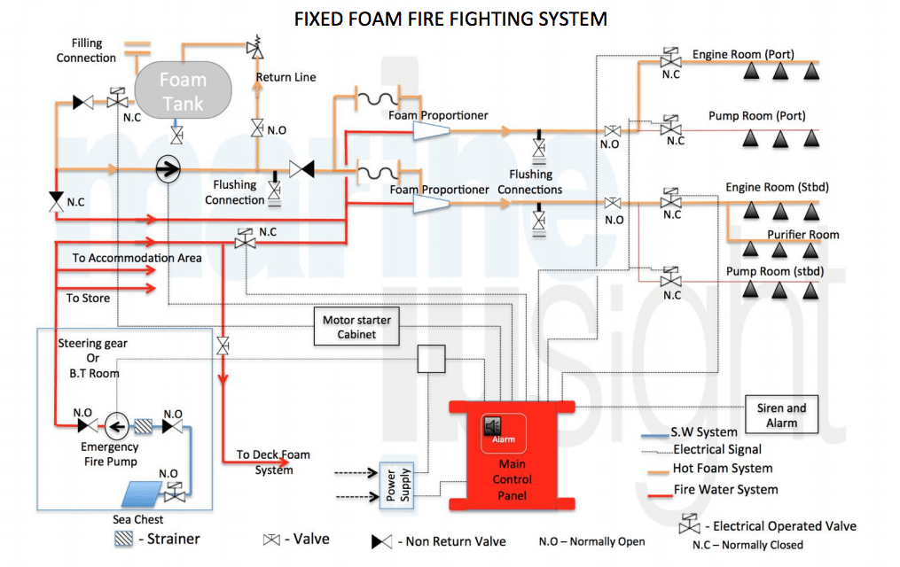
Following precautions and checks need to carried out once the foam fixed fire fighting system is used for fire extinguishing purpose:
- The place will be acquired with plenty of drainage which is a mixture of water and foam. Use pumps to remove the drain mixture.
- Ensure there are no gases present in the room and pumps are in good working condition before using as it may lead to secondary accidents such as explosion or electrical shocks.
- Use fresh water mist while cleaning the foam from the room.
- Keep checking the gas content in the room as during cleaning, foam may contain poisonous gases which was produced during the fire.
- The electric machinery and systems covered with foam should be wiped out using cloth.
- All the machinery to be inspected prior cleaning is finished. If internal electric parts or panels are still moist, use hot air blow to clean the same.
- After complete use of foam system, drain out foam solution lines and liquid lines by air blow.
- Check the level of the foam liquid tank and refill it to the required level.
- Check the foam discharge nozzle in the fire area and foam generator for any fire damages.
- Check all the valves involved in the discharging of foam are set to normal ready-to-use position. If the foam discharged is done manually, set the manual button to normal ready-to-use position.

The above points are required to ensure the affected space is checked and cleaned, and the machinery in that space is ready for further usage. The foam system needs to be made normal as soon as possible to ensure it is ready for any other emergency situation in near future.

Portable fire-fighting foam operations
The use of foam is, traditionally, not an everyday occurrence. However, when it is needed, the operation must be flawless and efficient. Today, many fire apparatus are equipped with pre-plumbed foam systems; these are great, but again, they are only effective if we know how to properly execute their function.
Foam is an effective firefighting agent because of its ability to cool, smother, separate, and suppress vapors. Since foam is a water-based extinguishing agent it has the ability to absorb heat energy as well as cool adjacent fuels. In addition, foam creates a blanket, which separates the burning vapors from the fuel; such is the case for Class B fires. This foam blanket also inhibits oxygen availability, which again aids in the full extinguishment process.
There are many types of foam on the market. They vary depending on their intended class of fire and concentration. It is key to match the class of foam with the class of fire it is intended to extinguish.
Many foams can extinguish a variety of fires. For example, aqueous film-forming foam is able to extinguish class A and B fires. Traditionally, compressed air foam systems have dual tanks with separate class A and class B foams, allowing the apparatus officer to determine the needed foam for the incident. No matter what systems you have, make sure you are proficient in its use.
When applying foam, there are three generally accepted methods: bank-down, roll-on, and rain-down. Banking down is a great method when the fire or area to cover is near a wall or near an object. During this technique, the nozzle firefighter deflects the foam stream against the wall and allows the foam to “bank” onto the fire or spill, creating an extinguishing blanket.
The roll on method is a similar deflection method where the firefighter deflects or “rolls” the foam onto the product via the ground. The nozzle is pointed toward the ground near the fire or spill, and the foam is gently rolled onto the fire.

The rain down method uses the reach of the stream to affect extinguishment. The firefighter simply points the stream up and allows the foam product to “rain” onto the fire or spill. Use caution here to ensure to the foam is hitting the target.
Foam should not be intimidating; it can be an excellent additive to aid in extinguishment and is a necessary tool for certain fires. Take the time on your next tour to practice with your foam system and ensure your operational proficiency.

Fixed dry chemical powder operations
Dry Chemical Powder Fire Extinguishing Systems extinguish flames almost instantly. These systems are often found on board vessels carrying bulk chemical agents and liquefied gases.
It is important to ensure maintenance on these systems is carried out to a high standard OCON work to strict procedures and guidelines in servicing this equipment to ensure correct and safe operation at all times.
Dry Chemical is a powder composed of very small particles usually of sodium bicarbonate, potassium bicarbonate, urea-based potassium bicarbonate, or monoammonium phosphate with added particulate material supplemented by special treatment to provide resistance to packing, resistance to moisture absorption (caking) and the proper flow capabilities
- Interruption of the chain reaction sequence.
- Heat absorption effects
Multipurpose Dry Chemical is usually monoammonium phosphate-based and is effective on fires in ordinary combustibles, such as wood or paper, as well as on fires in flammable liquids, etc
A total flooding system means a supply of dry chemical permanently connected to fixed piping, with fixed nozzles arranged to discharge dry chemical into an enclosed space or enclosure about the hazard.
This type of system shall be used only where there is a permanent enclosure about the hazard that is adequate to enable the required concentration to be built up.
The leakage of dry chemical from the protected space shall be minimized since the effectiveness of the flooding system depends upon obtaining an extinguishing concentration of dry chemical.

In total flooding system, the rate of application shall be such that the design concentration in all parts of the enclosure shall be obtained within 30 seconds.

Spill containment in relation to fire-fighting operations
Like fire, chemicals are very useful for a broad variety of functions. But just like fire, many chemicals are inherently hazardous or even deadly when they’re not used in a properly controlled manner, or when accidents occur.
That’s an important fact to remember, because chemicals are used to some degree at nearly every workplace from industrial plants, to laboratories, to agriculture, to maintenance functions, and even in office environments. Whether chemicals are added as part of a production process, used to clean or lubricate equipment, or exist as the byproduct of some other action, they can pose a hazard to workers. Some are highly corrosive or toxic.

Others are flammable, may oxidize quickly, or may react with other substances to create a deadly situation. When chemicals are stored or handled properly, the inherent risk is minimized. But if something goes wrong and a chemical is spilled, appropriate action must be taken immediately to prevent injury to workers and others, and to minimize the potential damage to other materials and facilities. In this article, we’ll review basic reactions to and planning for chemical spills.

Prevention: the best solution
It may seem obvious, but the best way to deal with a chemical spill is to avoid having one in the first place. The key is to follow proper procedures for storing, transferring, handling, using, and disposing of chemicals. All workers on a jobsite should be trained to recognize the hazards and proper procedures associated with every chemical they may encounter, including the actions they need to take when a spill occurs. They should also have access to the MSDS (material safety data sheet) for each chemical.
Chemicals should be stored and transported properly, as noted in the MSDS. For example, some chemicals should not be exposed to excessive heat. Others must be stored in fireproof containers. Still others cannot be jostled while they are being moved. In addition, workers using the chemicals must wear the proper personal protective equipment (PPE) to minimize the chance of injury, because even a small splash in the eyes can create a traumatic injury.
If appropriate, the worksite should have materials for dealing with spills of the specific chemicals that are being used. That could be anything from a bag of absorbent material and paper towels to an elaborate kit with special cleaning equipment and PPE. Instructions for dealing with a spill should be easily accessible and highly visible.

How dangerous is a spill?
There is no simple answer to that question, because the hazard level depends on a variety of factors. Beyond the properties of the actual material itself, the degree of hazard may also depend on just how much material was spilled, where the spill occurred and what surface received the spill, the amount of ventilation in the area, and the temperature of the surface, immediate area, and the chemical itself. Depending on the specific hazards involved, it may be necessary to evacuate the area or to take steps to prevent against environmental damage.
Generally speaking, though, regardless of the level of hazard involved, there are four basic steps involved with dealing with spills. While the specific actions related to each step may vary, as may the people responsible for handling each step, they form the basis of a spill response.

Steps involved with dealing with spills

Communicate the hazard.
Immediately notify others working in the area and any supervisory personnel of the hazard, and if the situation warrants it, evacuate the area. Be sure to tell the dispatcher which material that was spilled and the quantity, so that first responders will be ready to address the situation. It’s an excellent idea to have someone who is familiar with the incident and the layout of the worksite remain on the scene to assist the first responders, assuming that it is safe to do so.
Make sure that anyone who is injured or has been contaminated is removed from the immediate area and taken to a safe place. If appropriate, flush contaminated areas with water while waiting for medical personnel to arrive. This underscores the importance of workers knowing the proper steps to take for each chemical they work with.

Control the spill
This step focuses on ensuring that the spill does not become any worse. If there is a way to stop the spill or minimize the chances of it becoming worse, take those actions (such as closing a valve or righting a container that has tipped over). Workers should immediately don appropriate PPE for the chemical and the nature of the hazard. In some cases, that will include proper respiratory protection.
If possible (and appropriate), shut down any potential sources of heat or ignition. Increase ventilation to the area if that will safely disperse any fumes. If the fumes present a hazard of their own, it’s usually better to isolate the area by closing doors and windows after the workplace has been evacuated.

Contain the hazard
Once the immediate situation has been addressed, take steps to keep the spill from spreading to other areas or contaminating adjacent surfaces. Depending on the material and situation, this usually involves confining the spilled material to a small area by using some type of absorbent material or neutralizer. Start spreading those materials around the perimeter of the spill to prevent it from expanding, and work your way to center.
You’ll want to prevent the spill from spreading to floor drains or other places that may allow the material to flow into environmentally sensitive areas. You may need to build a dike to block or direct the material, or use a special product such as a spill sock.
If you have to leave the area during this process, be sure to block access to the spilled material with caution tape or some other method that will prevent others from coming in contact with it.

Clean up the spill and any damage
Collect the material used to contain or neutralize the spill, and dispose of it in the specified manner. If the spill is small, that may be a plastic bag, while larger spills may require plastic pails or drums. In some cases, you’ll also need to dispose of any equipment such as brooms or dustpans that you used to clean up the material. If what you’ve gathered qualifies as a hazardous material, be sure to label it accordingly and dispose of it as specified by local laws and environmental regulations.
Clean the surfaces that were affected by the spill with the correct material, whether that’s bleach, a mild detergent, water, or some other material appropriate for the material that was spilled. Instead of rinsing the area after cleaning, you may need to use another method such as more absorbent material.
Be sure to wash your hands and any other areas that may have come in contact with the materials thoroughly. If your clothing can be safely decontaminated and cleaned, follow the appropriate steps. Otherwise, dispose of the clothing following proper safety procedures.

Cargo Operations

For oil and chemical tankers
When approaching a port to load or discharge cargo, the following important checks should be made by the ship in time to allow any necessary work to be done:
- On tanks in which cargo is to be transferred, in-tank instrumentation such as level gauges, level alarms and thermometers should be tested for operation and accuracy, and remote system controls tested where appropriate. High level alarms and tank overflow control alarms are safety critical components of the cargo transfer system, and loading should not commence if pre-transfer checks find them at fault.
- Hatches, lids and openings to cargo tanks that are not required to be open for a specific reason should be firmly closed.
- Cargo pipelines and crossover valves should be checked, and all drains closed and secured.
- All ship's cargo and bunker pipelines not in use should be securely blanked and fully bolted at the manifold. Unless it is to be used, the stern cargo pipeline should be isolated from the tanker's main pipeline system at a point forward of the aft accommodation, by blanking or the removal of a spool piece.
- Where loading or discharging is to be via a cargo pump-room, the pump-room ventilation system should be checked to ensure readiness for operation throughout the cargo operations.
- Cargo area deck lighting should be checked and confirmed as being in full working order, with special attention given to the area of the ship to shore cargo connection and hose handling equipment.

Ship checks after arrival but prior to cargo operations
Before any cargo transfer starts, the responsible officer should be satisfied that the applicable precautions are being observed. The use of safety checklists, appropriately adapted for the specific ship, is strongly recommended. The following important checks should be made by the ship at this stage:
- Information should be sought on any forecast of adverse weather conditions which may require operations to be stopped or transfer rates reduced.
- Certain cargoes require the vapour that is displaced by incoming cargo to be returned to the shore facility. The responsible officer should ensure that the ship and the shore vapour system are compatible, and that the system will operate in compliance with local and terminal regulations.
- The characteristics of the product must be known, usually in the form of a cargo information form or data sheet indicating, among other things, health hazards, specific gravity, temperature, vapour pressure, reactivity with other materials or cargoes, heat sensitivity, risk of exothermic self-reaction, toxicity and general safe handling practices. It is desirable that initial response to emergencies is clearly shown. An example data sheet is in Appendix M.
- If a cargo liable to self-reaction is to be loaded, correct arrangements should be made for conditions and limitations in the inhibitor certificate to be met for the duration of the voyage.
- Normally tanks to be loaded are pre-inspected for cleanliness by an independent surveyor. This can vary from a superficial visual inspection from the deck, to a very detailed inspection inside the cargo tank in which bulkheads are wall-washed and thoroughly checked. The responsible officer should satisfy himself that the tanks to be so inspected are well ventilated and safe to enter, and are marked as being safe to enter. Tank entry procedures should be complied with. When a tank is entered for inspection the surveyor should be accompanied by the responsible officer or a person delegated by him.
- Tanks passed for loading should be tightly secured with all cargo openings closed.
- All sighting ports and ullage plugs should be closed and secured, unless expected to be used during handling of the cargo about to be loaded. If openings are required to be open for venting purposes, each opening should be protected by a flame screen designed for that opening and kept clean.
- When not in use, sea suction and overboard discharge valves connected to cargo and ballast systems must be securely closed and lashed, and may be sealed by shore authorities. In-line blanks should be inserted where these are provided. When lashing is not practicable, valves should be suitably marked to indicate clearly that they are to remain closed.
- Before cargo handling is started, all deck scuppers and any open drains onto the jetty must be effectively plugged to prevent spilled cargo escaping into the water around the tanker or onto the terminal. Accumulations of rainwater should be drained periodically and scupper plugs replaced immediately afterwards. Contaminated water should be transferred to a slop tank or other suitable receptacle.
- Cargo manifolds should be ready for connection to shore hoses, but with blank flanges removed only on those lines to be used, and only on the connecting side of the ship.
- Where loading is via a cargo pump-room, the pump-room ventilation system should be working throughout the operation, and all drains and non-essential valves in the pump-room must be closed and secured.
- Accommodation doors and portholes overlooking the cargo area should be shut. If stern loading is to be undertaken, it may be necessary to provide special advice to the crew.
- The cargo venting system should be appropriate for the cargo operation.
- Intakes for central air conditioning and mechanical ventilation systems should be checked for correct setting.
- Means should be provided for the prompt removal of any spillage on deck.
- Firefighting equipment should be inspected, and ready for immediate use.
- Correct personal protective clothing and breathing apparatus, appropriate to the cargo, should be immediately available, and should be worn as necessary.
- Just prior to commencing cargo transfer, the responsible officer should check that the cargo pipeline system is set correctly, that correct valves are open and that pipeline valves not being used (including drop valves) are closed.

Joint ship anti shore liaison, and checks prior to cargo operations
A liaison meeting should be held with the responsible terminal staff, at which the operational plan for the order of cargo handling can be agreed. The following joint ship and shore checks in co-operation with a terminal representative are recommended:
- That the Ship/Shore Safety Checklist has been completed satisfactorily.
- That local and terminal regulations have been ascertained and are being observed.
- That agreement has been reached with the responsible terminal representative about signals to indicate stand-by, start operation, slow down and stop operation.
- That when shore-supplied nitrogen is to be used for inerting cargo tanks, the procedure for handling it has been agreed.
- That the sequence of cargoes and pumping rates has been agreed.
- Whether ship or shore will order pumps to be stopped on completion.
- That emergency shutdown procedures, and action to be taken in case of fire or other emergency, have been agreed.
- That if an insulating flange is used in the hose connection, its insulation has not been impaired.

For oil tankers

Cargo information
Pre-arrival Meeting Before arrival into port, whenever possible, the Master shall hold meeting with the Chief Officer and Chief Engineer. The meeting should cover items related to loading or discharging, such as loading/discharging plan, information on cargo characteristics and safety measures, surveys and inspections expected, local regulations, required manning for anticipated work, etc. The meeting shall be recorded in the Deck Logbook, if necessary.
The Chief Officer and Chief Engineer shall inform their departmental personnel of the important topics of the meeting. The Chief Officer shall record all-important details on cargo, safety precautions and duties of the individual crewmembers and display it in the Officers and Crew messrooms.
The Master shall study contract clauses and Marketing Division instructions and explain any special requirements for dealing with:
- Particular cargo,
- Any additional entries required in the Deck Logbook, and
- Other records to be kept.
The Chief Officer shall present loading/discharging plan and unusual characteristics of the cargo. Ballast procedure shall be also planned.

Inerting
Inert gas (IG) piping Fitted on all tankers over 20,000 dwt and on all tankers fitted with crude oil washing (COW) systems. IG piping is usually large diameter low-pressure mild steel, with smaller diameter branch lines. The internal surface of inert gas piping does not usually corrode. The external surface is painted but will corrode if the paint coating deteriorates.
Using inert gas system on board tankers required some careful consideration. Below guideline should be followed when operating the inert gas system.

During Operation of Inert Gas System (IGS)
The oxygen content of the Inert Gas (hereinafter called IG) supplied to cargo tanks should be 5% or less. However, it is to be noted that too less content of oxygen in the IG would introduce other impurities into the cargo tanks.
During operation of the Inert Gas system (IGS) the automatic Recorder for Oxygen (O2) and IG Pressure on main line must be operational. The details of the start of operation (such as discharge at XXX port, date and time of mark, etc. should be noted on the recording).
Prior to start of the IGS, ensure safety confirmation as per the Operational Record of the GS. Inspection of the deck seal and PV breaker must be confirmed in good condition. Also, the status of alarm, indication and proper operation and sequence of related equipment must be observed.
Prior arrival discharge port, Follow Company’s designated Tanker Discharging Checklist for IGS preparation and checks / tests. * For operation of the IGS and precautions, refer to IGS operation maker’s manual which is provided to each vessel.
Starting of Inert Gas System before entering discharge ports of environmentally sensitive nature, where the air pollution and scrubber discharge flushing could interfere with the ecosystem, the Inert Gas System shall be run before embarking the harbor pilot at time of entering the port. This is done so that the IGS plant can settle down & avoid dark funnel smoke emissions on start-up.

Loading
Many tankers now load from oilfields at sea. To do this they moor up (usually by the bow) to a gantry, buoy or turret (toranj). Tankers on the North Sea run (often called shuttle tankers) have been specially designed to load at the bow from a single point mooring at sea.
Crude oil can be loaded into a tanker from a variety of offshore facilities or from a conventional oil terminal through the midship manifold. Modern oil tankers may be equipped with the most advanced loading systems, combining a Bow Loading (BL) system and the ship's part of the Submerged Turret Loading (STL) system.
The basis of the Submerged Turret Loading system is the buoy moored to the seabed. The buoy is pulled into and secured in a mating cone in the bottom of the vessel and thus connecting the mooring system. Internal in the buoy is the turret connection (toranj) to the mooring and riser systems. The outer buoy hull can rotate freely with the vessel around the turret by means of internal turret bearings.

Oil is transferred through an in-line swivel via the loading manifold to the piping system of the vessel. Disconnected, the buoy will float in an equilibrium position ready for new connection.
The Floating turret system enables the vessel to be easily moored at the bow and oil transferred conventionally to the midship manifold.
Floating production, storage and offloading systems (FPSO) can offer significant advantages over fixed production platforms particularly in remote offshore locations where deep water, strong ocean currents and harsh weather conditions may occur, or where export pipelines are difficult to install or uneconomic to run.

Liquid cargo is nowadays usually transferred using an articulated arm loading/discharge system, and groups of arms are often found on a shore refinery or on offshore loading facilities. It connects to the tanker’s manifold usually located near the center of the ship.

Loading oil cargo in a tanker ship requires utmost diligence in planning and most careful consideration will need to be made for safe operation. Following are the basic procedures at various stages of loading oil cargo.

Unloading
The Chief Officer shall prepare a detailed cargo oil discharge plan prior to arrival discharge port. The discharge plan shall be posted in the CCR at a conspicuous location, and distributed to all personnel directly involved in the discharge operation.
The discharge plan should be signed to confirm that personnel have read and fully understood the plan. The Chief Officer shall also prepare a watch schedule and Person in-Charge list for oil transfer operations for the discharge operation.
Prior to commencement of discharge operation the Chief Officer shall conduct a “Pre transfer cargo safety meeting” with all the concerned crew and shall have a duty officer read aloud such discharge plan to all the attending officers and crew.

Special details, port requirements and special precautions or procedures should be discussed with all personnel involved in the discharge operation.

Tank cleaning
The process of removing hydrocarbon vapours, liquids or residues. Tank cleaning may be required for one or more of the following reasons:
- To carry clean ballast.
- To gas free tanks for internal inspections, repairs or prior to entering dry dock.
- To remove sediments from tank top plating. This may be required if the vessel is engaged in the repetitive carriage of fuel oil or similar sediment settling cargoes. Although washing may not be necessary in between consecutive voyages, assuming the cargoes are compatible, many Ship Owners have found it prudent to water wash a small group of tanks on a rotation basis between voyages, thus preventing any large accumulation of sediments.
- To load a different and not compatible grade of cargo. Washing in between carrying different grades of cargo is the most common reason for tank cleaning. In most cargo sequences on product tankers, the cleaning may consist of no more than a simple hot or cold seawater wash.
A simple water wash will disperse many types of chemicals and has been found effective between clean petroleum products such as gasoil and kerosene. However, it should be noted that there is a number of grade sequences, particularly in the petroleum product trade, where no washing at all needs to be carried out. Thus the decision for necessary tank cleaning required in such trades is often made only when knowledge of the next grade to be loaded is obtained.

The Chief Officer is in charge of and shall supervise as the person in charge of the Tank Cleaning, Hydrocarbon Gas (HC) Purging, and Gas Freeing & Re-Inerting operations. He shall ensure that all activities carried out during such operations are in compliance with the latest edition ICS/OCIMF International Safety Guide for Oil Tankers and Terminals (ISGOTT).

Purging and gas freeing

Gas-Freeing for Cargo Tank entry
Cargo Tank entry shall not be permitted unless the Oxygen Content is 21% and the hydrocarbon vapor content is less than 1% of the Lower Flammable Level (LFL).

Follow company’s “Procedure for Entry into Enclosed Spaces” with related permits.
If the previous cargo contains Hydrogen Sulfide (H2S) or other toxic contaminants which could evolve toxic gases (eg benzene, toluene, Mercaptans, etc), the tank should be checked for such gases.

Refer to “Guidelines for Toxic Gases Hazards” Carrying out “Hot Work” inside Tanks within the ‘Dangerous Area’ need special caution as per “Procedures for Hot Work” and carry out preparation accordingly.

Gas-Freeing or Purging for the Reception of Cargo
If the intention of Gas-Freeing or Purging operations is to prevent the next cargo to be loaded from contamination due to the previous cargo oil hydrocarbon gas, use the gas content indicated by the Charterer as standard, but go on with the operations mentioned in (2) of Article 1 until the LFL decreases down to 40% or under.

For chemical tankers

Cargo information
Pre-arrival Meeting Before arrival into port, whenever possible, the Master shall hold meeting with the Chief Officer and Chief Engineer. The meeting should cover items related to loading or discharging, such as loading/discharging plan, information on cargo characteristics and safety measures, surveys and inspections expected, local regulations, required manning for anticipated work, etc. The meeting shall be recorded in the Deck Logbook, if necessary.
The Chief Officer and Chief Engineer shall inform their departmental personnel of the important topics of the meeting. The Chief Officer shall record all-important details on cargo, safety precautions and duties of the individual crewmembers and display it in the Officers and Crew messrooms.

The Master shall study contract clauses and Marketing Division instructions and explain any special requirements for dealing with:
- Particular cargo,
- Any additional entries required in the Deck Logbook, and
- Other records to be kept.
The Chief Officer shall present loading/discharging plan and unusual characteristics of the cargo. Ballast procedure shall be also planned.

Loading
Chemical data sheet means a document, in accordance with the IMO Codes and usually from the manufacturer of the cargo, (Cargo Information Form) that contains necessary information about the properties of the chemical for its safe carriage as cargo. Careful study of such data sheets is essential in cargo planning of various chemical cargo, safe stowage and any segregation requirement etc.
Every chemical tanker must have a Procedure and Arrangements Manual that gives Procedures for compliance with Marpol Annex II when noxious liquid substance cargoes are handled on board. The following sequence outlines a general cycle of operations, and supplementary comments are made where relevant.
- Preparation for cargo loading.
- Inerting / purging.
- Loading.
- Transport.
- Preparation for discharge.
- Discharge.
- Ballasting.
- Tank-cleaning/gas-freeing.
Should be considered as general guidance only, as there is considerable variation in the design of cargo containment and cargo handling systems. Specific instructions in the form of Critical Operations Checklists should be prepared for individual vessels.
The cargo containment and handling systems have been designed and constructed in accordance with the requirements of the IBC/BCH codes, the SOLAS convention and the MARPOL 73/78 convention to safely transport and handle the chemicals the ship is certified to carry.
However, the required levels of safety in cargo-operations can only be achieved if all parts of systems and equipment are maintained in good working order. Similarly, the personnel involved in cargo operations must be fully aware of these instructions, their duties and be thoroughly trained in the correct procedures and handling of the equipment.
Before and during all operations involving the cargo, ballast and bunkering systems, the Master must ensure that the precautions required by the company safety management system and relevant checklists are fully observed.
Reference is to be made to the publications listed bottom of this page as well as equipment operating and instruction manuals.
Each vessel, which is certified for the carriage of noxious liquid substances (NLS) in bulk, is provided with a Procedure and Arrangements Manual (P & A Manual). All substances permissible for carriage onboard are listed in this manual and are approved for and on behalf of the flag state government that the vessel is registered under, usually by a Classification Society acting on its behalf.

Unloading
A chemical carrier's cargo containment and handling systems are carefully designed, and constructed under strict supervision, to comply with the requirements of the IMO Codes and the SOLAS and MARPOL Conventions, in order to transport and handle safely the chemicals that the ship is certified to carry. There are large variations in the design of cargo containment and cargo handling systems, and specific instructions should always be prepared for inclusion in the ship's cargo handling manual.
The following measures have to be taken prior to discharging operations commencing, with particular attention being paid when the cargo is highly toxic, flammable or both:
- Ensure Cargo Temperature(s) correct (High Viscosity and solidifying substances) Continue/reduce/close tank heating on relevant tanks
- Switch on High – Level alarms and test
- Prepare the Level gauging system
- Check if P/V valves are working and PV line clear.
- Prepare the vapour return line-if required.
- Prepare manifold, drip tray and cargo line system.
- Manifold - reducer-ASA/Din
- Prepare ballasting system
- Prepare / check jumper hoses or fixed connections.
- A chemical carrier's cargo containment and handling systems are carefully designed, and constructed under strict supervision, to comply with the requirements of the IMO Codes and the SOLAS and MARPOL Conventions, in order to transport and handle safely the chemicals that the ship is certified to carry. There are large variations in the design of cargo containment and cargo handling systems, and specific instructions should always be prepared for inclusion in the ship's cargo handling manual.
- The following measures have to be taken prior to discharging operations commencing, with particular attention being paid when the cargo is highly toxic, flammable or both:
- Ensure Cargo Temperature(s) correct (High Viscosity and solidifying substances) Continue/reduce/close tank heating on relevant tanks
- Switch on High – Level alarms and test
- Prepare the Level gauging system
- Check if P/V valves are working and PV line clear.
- Prepare the vapour return line-if required.
- Prepare manifold, drip tray and cargo line system.
- Manifold - reducer-ASA/Din
- Prepare ballasting system
- Prepare / check jumper hoses or fixed connections.

Tank cleaning and gas freeing
Gas freeing onboard chemical tankers is required for entry into cargo tanks, for hot works or washing for clean ballast tanks. Gas Freeing is one of the most hazardous operations routinely undertaken onboard a Chemical Tanker and the additional risk created by cargo gases expelled from the tanks, which may be toxic, flammable and corrosive, cannot be over-emphasized.
It is therefore extremely important that all care is exercised during gas freeing operations as the consequences of an inadvertent error can be serious and have far reaching consequences for personnel and the environment.
A space is considered as “gas free” when the concentration of flammable gases in its atmosphere is less than 0% LEL, the concentration of toxic gases (including IG components) is less than the TLV and the Oxygen concentration is not less than 20.8%.
Hazards may encounter at various stages. The following recommendations apply to cargo tank gas freeing in general. The IBC Code contains advice about cargo tank gas freeing.
It is essential to know what type of vapours can be expected: they may be flammable and/or toxic and/or corrosive:
- Venting of toxic and flammable gas during gas freeing should be through the vessel's approved gas freeing outlets, and therefore the exit velocity should be sufficient to carry the vapours clear of the deck. No escape of cargo vapours should occur at deck level before the concentration within the tank has fallen below 30% LFL and the relevant TLV. Thereafter, final clearance of the vapour mixture may continue at tank deck level through other larger deck openings.
- If portable ventilation equipment is to be used to blow air into a tank, tank openings should be kept closed until work on that tank is about to commence.
- Where cargo tanks are gas freed by means of permanently installed fans, air is introduced into the cargo tank through the cargo lines. The entire line system should be thoroughly drained before venting to avoid any obstruction of the air flow or tendency for water or cargo residues to be blown into a cargo tank. Valves on the systems, other than those required for ventilation, should be closed and secured. The fans should normally be blanked or disconnected from the cargo tank system when not in use.
- Fixed gas freeing equipment should not be used for gas freeing of a tank while simultaneously being used to ventilate another tank in which washing is in progress, regardless of the capacity of the equipment.
- Portable fans should only be used if they are water driven, or hydraulically or pneumatically driven. Their construction materials should be such that no hazard of incendiary sparking arises if, for any reason, the impeller touches the inside of the casing. The manufacturer's recommendations for maintenance should be followed. Guards should be in place to prevent accidental contact with fan blades.
- Portable fans, where used, should be placed in such positions and the ventilation openings so arranged that all parts of the tank being ventilated are effectively and equally gas freed. Fans should generally be as remote as possible from the ventilation outlets.
- Portable fans should be so connected to the deck that an effective electrical bond exists between the fan and the deck.
- The wind direction may cause cargo vapours to pass near to air intakes for accommodation spaces or engine room ventilation, and necessitate additional precautions. Central air conditioning or mechanical ventilation system intakes should be adjusted to prevent the entry of gas, if possible by using recirculation of air within the spaces.
- If at any time it is suspected that gas is being drawn into the accommodation block, the central air conditioning and any mechanical ventilating systems should be stopped and the intakes covered or closed. It is unlikely that any ship now uses window-type air conditioning units which draw in air from outside the superstructure, but any which are still in use, or other plants which are not certified as safe for use in the presence of flammable gas, should be electrically disconnected and any external vents or intakes closed.
- If the tanks are connected by a common venting system, each tank should be isolated to prevent the transfer of gas to or from other tanks.
- When a tank appears to have been gas freed and all mechanical ventilation has been stopped, a period of about ten minutes should elapse before taking final gas measurements. This allows relatively stable conditions to develop within the tank space. Tests should then be made at several levels and, where the tank is sub-divided by a wash bulkhead, in each compartment of the tank. In large compartments such tests should be made at widely separate positions. If satisfactory gas readings are not obtained, the tank should be checked for cargo residues and then ventilation resumed.
- On completion of all gas freeing and tank washing, the gas venting system should be carefully checked, particular attention being paid to the efficient working of the P/V valves and any high velocity vent valves. If the valves or vent risers are fitted with devices designed to prevent the passage of flame, these should also be checked, and cleaned if found necessary. Gas vent risers and their drains should be checked to ensure that they are free of any blockage.
- On completion of gas freeing, attention should be given to all equipment that has been used, and to enclosed or partially enclosed spaces that can retain or contain cargo residues or vapours, so that no unsuspected dangerous pockets can remain. Places where such cargo traces may exist include cargo lines, cargo valves, cargo pumps, stripping lines and valves, venting lines and P/V valves, vapour return lines, ullaging or sounding arrangements, heating coils, cargo handling equipment store rooms, protective clothing store rooms and cargo sample store rooms.

Emergencies for oil and chemical tankers

Emergency procedures, including emergency shutdown
The Emergency Shut Down (ESD) system is a requirement of the IMO Code for the carriage of oil and chemicals in bulk and is a recommendation of SIGTTO.
All members of the ship’s company must be aware of locations and the methods of activating and testing the Emergency Shut Down System specific to their vessel. The Emergency Shut Down System is a quick closing system, which may be activated automatically or manually. It will close all deck valves and shut down all cargo machinery.

ESD will be initiated by one of the following:
- Manual activation by personnel using the ESD pushbuttons
- Blackout of the ship
- Shore activation of their ESD system
- Fusible links around each tank domes, manifold and compressor house in case of fire
- Cargo tank Very High level alarm
- Low tank pressure
- Hold/cargo tank differential pressure
- Low cargo valves hydraulic pressure
- Low control air pressure
- Fire extinguisher system released

The initiation of ESD will lead to the following:
- All ESD manifold loading valves will close
- The gas compressors will trip
- The main discharge and spray pumps will trip
- All shore pumps will trip
- Master gas valve to engine room will close
- Inert gas generator will trip

The requirement of the cargo Emergency Shutdown (ESD) system are to stop cargo liquid and vapour flow in the event of an emergency and to bring the cargo handling system to a safe, static condition. The earlier method of cargo shut down comprise of manual trip points and automatic fire sensors that can initiate remote closure of emergency shutdown valves "for shutting down liquid and vapour cargo transfer between ship and shore"
This emergency trip, when activated, must also stop cargo pumps and compressors. However, these provisions do not necessarily provide adequate protection, particularly against overflow, during other operations involving the transfer of liquid and vapour on board. It must be recognised that operations such as reliquefaction or cargo tank spraying may be routine operations at sea. These deficiencies eliminated by intruducing cargo emergency shutdown (ESD).
The ESD system minimises potential risks during the transfer of liquefied gases between ship and shore loading and unloading installations. It provides a quick and safe means of stopping the transfer of cargo and isolating ship and shore cargo systems in a controlled manner, either manually or automatically, in the event of fault conditions that affect the ability of the operator to control safely the transfer of cargo. Most export terminals, and an increasing number of import terminals, now have a second level of protection providing for the rapid disconnection of the loading arms from the ship. These two levels of cover are known as `ESD-1' and `ESD-2'.
The emergency shutdown (ESD) system is a requirement of the IMO code for the carriage of liquefied gases in bulk and is a recommendation of SIGTTO. It is fitted to protect both the ship and terminal in the event of power loss, cryogenic or fire risks, on either the ship or in the terminal.
The system will stop the flow of LNG liquid and vapour by shutting down the pumps and gas compressors as well as manifold and shipside valves, by the activation of a single control. Shut down of the cargo system can be initiated either manually or automatically if certain off-limit conditions occur.
The ship's ESD system is active at all times, whether at sea or in port. When at sea all manifold and tank filling valves are held in the shut position and the cargo and spray pumps are held in the off position. The cargo compressors may be operated as normal, but will stop if an ESD is initiated. The shore ESD input is blocked in the At Sea DCS condition.
Manual emergency shut down push buttons are situated strategically around the ship, at locations that include the wheelhouse, cargo control room, fire control station, manifold platforms and tank liquid domes. In addition, manual activation of the shore ESD system will, through the ship/ shore link, set off the ship’s ESD.
Automatic shut down for fire is initiated by fusible plugs which are generally located at each tank dome, manifold platform, and in the cargo compressor and electric motor rooms. ESD1 may also be initiated automatically under conditions such as the following:
- Blackout of the ship.
- Vapour header pressure falls below pre-set limit.
- Individual tank pressure falls below pre-set limit.
- Extreme liquid level in any cargo tank.
- Low cargo valve hydraulic pressure.

ESD2 is normally initiated by the terminal and will result in all the actions as for ESD1, plus the initiation of a dry break of the shore arm from the ship. ESD2 may be initiated manually, for example, in the event of a terminal emergency, or automatically, for example, if the ship moves outside the movement envelope of the chicksans.
The automatic disconnection of shore arms can be a violent and potentially dangerous operation and it is important that personnel at the manifold are warned to leave the area before ESD2 activation.
Each ship must have procedures for testing the function of ESD systems which must be tested prior to arrival in port and also immediately before commencing cargo operations.

Organizational structure
Whenever some incident of a serious or harmful nature happens all of a sudden, we classify it as an emergency. One of the most important factors in dealing with an emergency situation is the presence of a solid action plan apart from a sharp mind and lack of fear. This is a general rule which is applicable to all situations whether on board a ship in the middle of the ocean, or in a crowded city admist a sea of people.
Nevertheless, the situation on a ship is more critical since normally ships are isolated floating objects moving in the vast and deep seas. It is therefore necessary to know about the emergency essentials since there are so many types of emergencies which might arise when a ship is sailing or even at port.
We have been dealing with various types of situations in separate articles, but here we will take a look at the general procedure and plans to be followed in case of emergency situation on board a ship.

Types of Emergencies
This emergency organization will perforce consist of ship board personnel who will have the advice and possibly even the assistance of the company personnel response team/shore personnel. For effective usage of the limited emergency equipment available on board all personnel must be aware of the location of firefighting gear and lifesaving appliances and trained in their use. They must also be aware of the alarm’s signals, recognize them and muster at the muster point in case of any type of emergency.
The basic structure of the emergency organization will consist of four teams
- The COMMAND CENTER
- The EMERGENCY TEAM
- The BACK-UP SQUAD
- The ENGINEERS/TECHNICAL TEAM

Alarms
The appropriate signal to indicate different emergency situations are:
- General Emergency Alarm. Is recognized by 7 short followed by 1 long blasts of ship`s horn or rings of ship`s bell. It is sounded to make aware the crew onboard that emergency has occurred.
- Fire Alarm. Is sounded as continuous ringing of ship`s bell or blast of ship`s horn.
- Man Overboard Alarm. When a man falls overboard, the ship alarm bell sounds 3 long rings and ship whistle will blow 3 long blasts to notify the crew onboard and the other ships in nearby vicinity.
- Abandon Ship Alarm. When the emergency is out of control is no longer safe for crew onboard the ship. The Master can give a verbal Abandon ship order, but this alarm is never given by ship`s bell or whistle. The general alarm is sounded and everybody goes to emergency muster station where the Master or his substitute (Chief Officer) gives the verbal order to abandon the ship.
- Ship Security Alarm System. Is a silent alarm system sounded in a pirate attack emergency? This signal is connected with different coastal authorities all over the world via a global satellite system to inform about the piracy.

The General alarm will be sounded in the event of:
- Fire.
- Collision.
- Grounding.
- Man overboard.
- cargo hose burst.
- Major leakage or spillage of oil cargo.
- Any other emergency which calls for emergency action.

Other Alarms could include:
- Engineer alarm for unmanned machinery spaces.
- CO2 release alarm.
- FIRE detector alarms.
- I G system alarms.
- Cargo tank level alarms.
- Refrigerated store alarm etc.

Emergency procedures
- Fire
- Inform Officer On Watch.
- Check if it is a false or true alarm.
- Report back of findings.
- In case of fire, raise the Fire alarm as soon as possible.
- Try to stop fire and if it is not possible, muster crew members to be ready for abandon the ship.

- Collision
- Inform the Master and Engine Room
- Immediately send distress signal
- Record important data
- Sound the alarms
- Assess the damages
- Take the soundings
- Take immediate action in case of damage
- Check for oil spill
- Reach the nearest port it is possible
- Abandon the ship only if everything else fails
- Grounding
- Stop Engines
- Sound General Alarm
- Close water tight doors
- Send distress signal
- Check position on the chart
- Take note of any valuable information
- Take soundings
- Evaluate risk of pollution

- Person Overboard
- Shout ‘Man Overboard on Starboard/Port side’
- Change over to hand steering from auto and put the wheel hard over to the respective side (port or starboard)
- Release MOB marker from the side of the bridge wing to which MOB has occurred. This marker is buoyant and has a self-igniting light as well as a self-activating smoke signal
- Press the MOB button on the GPS to mark the position of the casualty for future reference
- Sound ‘O’ on the whistle (one prolonged blast). This is to let the Master and the crew know about the emergency situation. Supplement this with the appropriate ‘O’ flag
- Post extra lookout as soon as possible
- Sound the General Alarm on the ship’s whistle to alert everybody to proceed to stations. This is to ensure that if the crew has not understood the one prolonged blast for MOB, they are alerted regardless and proceed to muster stations to assist in the recovery of the person
- Thereafter, announce the MOB situation on the ship’s PA system
- Inform the engine room of the situation and let them know that maneuvering will be required
- Execute the Williamsons turn (explained later)
- Keep a keen eye on the RADAR/ARPA and put the VHF on Channel 16
- Maintain a record of all the events in the Bell book
- Carry out Master’s orders
- The Chief Mate should take-over all decisions based on deck with regard to lowering survival craft etc.
- The Third Mate ought to assist the Master on Bridge
- The officer in charge at the moment must send out an “Urgency signal” on all the communications systems to let ships in the vicinity know about the situation
- Keep the lifebuoy (MOB marker) in sight
- The rescue boat should be manned adequately with enough personnel to carry out the rescue operation
- A portable handheld VHF must be carried by the officer in the rescue boat
- Once the person is rescued, the rescue boat must be picked up upon arrival close to the ship along with the lifebuoy and hoisted back
- Immediate first aid should be administered if required
- An ‘Urgency Signal’ must be sent out to cancel the last transmitted MOB alert
- Appropriate entries must be made in the Ship’s Logbook
- The Master must carry out an enquiry with respect to the MOB incident and all entries made in the Ship’s Logbook

- Flooding (ingress water into the ship)
- Engine Room Flooding
- In case of engine room flooding, Chief Engineer should be called immediately and general alarm should be raised.
- Immediate action should be taken in preventing more sea water to enter the engine room and Emergency bilging from the Engine Room should be established in accordance with the Chief Engineer.

- Cargo Hold Flooding
- In case of cargo hold flooding, Master must be informed immediately.
- All precaution must be taken to contain the flooding to that hold.
- General alarm must be raised.

Pollution prevention for oil and chemical tankers

Basic knowledge of the effects of oil and chemical pollution on human and marine life
Some boat operators, deliberately or accidentally, discharge oil and chemicals into our waterways. Most of the oil and chemicals in our waterways come from refuelling, boat maintenance and bilge discharges. Oil and chemicals can be toxic to marine and human life.
It is in everyone's interest to protect our waterways from pollution. All boat operators need to use and dispose of onboard oil and chemicals correctly and safely.

Oil and chemicals on board your vessel
Products that are pollutants that will harm the environment:
- Petrol.
- Gear box oil.
- Motor oil.
- Two-stroke oil.
- Diesel.
- Hydraulic oil.
- Cooling system additives.
- Cleaning agents.
- Degreasers.
- Acid and paints.

Once these toxins enter our waterways they have the potential to retard or prevent the reproductive development of many marine animals, which can have a flow-on effect through the whole ecosystem. Contaminated fish stocks and filter feeders such as oysters and mussels can also pass on harmful chemicals to humans, if consumed.

Clean bilges help reduce pollution. Use absorbents to mop up excess oil or fuel, wash your bilge with biodegradable degreasers or detergents and dispose of any cleaning residue ashore.
If oil does spill into the water, use absorbents to mop it up and let the regional harbour master, marina manager or port authority know so that it can be cleaned up as soon as possible. Do not use dispersants or other cleaning chemicals because they can increase the toxic effects of oil spills.

How to handle oil and chemicals
All boat operators need to help reduce oil and chemicals entering our waterways. Here are some tips to help:
- When refuelling insert the nozzle into the filler before starting the pump. Likewise always turn the pump off and ensure that the flow of fuel has stopped before removing the nozzle.
- Always check the capacity of fuel tanks before refuelling.
- Watch the breathers for signs of 'blow-back' or overflow.
- Do not overfill your fuel tank.
- Ensure your bilges are clean before discharging.
- Always supervise the operation of bilge pumps to ensure only water is being pumped into waterways.
- Revise the installation of your bilge pump's float switch to stop oil accidentally discharging with bilge water.
- If you use degreasers or detergents, including biodegradable products to clean your bilge, make sure the residue is not discharged into the waterways.
- Use absorbents to clean waste oil from your bilge.
- Repair oil and fuel leaks when first noticed.
- For everyday deck scrubbing use clean water and only use chemicals for severe staining.
- Read the product information before you decide on any chemical cleaner. If it is toxic to humans, it is not good for marine life either.
- Use phosphate free biodegradable detergents.
- Carry absorbent material onboard to clean up any accidental spills.

If you accidentally discharge oil or chemicals into the water, let the regional harbour master, marina operator or port authority know, so that it may be cleaned up.

Basic knowledge of shipboard procedures to prevent pollution
The matrix of conventions described earlier provide for the construction, operation and state monitoring of ships and tankers with respect to the prevention of pollution.

In general terms MARPOL provides for the following pollution prevention measures:

- Construction
Ships are constructed to maximize safety and environmental protection using double hulls and protective segregated ballast tanks.

Each ship must carry certificates which certify that the ship is properly constructed and has adequate safety measures in place. The exact requirements of the certificates, which are reviewed annually, can be found in the Annexes, Protocols and Codes aligned to the MARPOL Convention.
The ships must carry certificates relating to their operations as follows:
- International Oil Pollution Prevention Certificate (Ship Construction Certificate or IOPP Certificate)
- International Pollution Prevention Certificate for the Carriage of Noxious Liquid Substances in Bulk (Chemical Tanker Construction Certificates or IPP Certificate)
- International Sewage Pollution Prevention Certificates (SPP Certificate)
- Shipboard Waste Management Plans (Garbage Management Plan)
- International Air Pollution Prevention Certificate (APP Certificate)

- Port Facilities
To encourage operators of vessels to meet their obligations under MARPOL all ports must have reasonably priced reception facilities for the discharge of oil, chemicals, harmful substances, sewage, garbage and ballast water.

- Safe Operation and Safety Management Systems
All ships must have ISM Code Safety Management Certificates (International Safety Management Code for the Safe Operation of Ships and Pollution Prevention) issued as part of the SOLAS Convention.

Safety management certificates include emergency pollution control plans detailing how the ship will manage a pollution event. An example is a Shipboard Oil Pollution Emergency Plan (SOPEP) which is mandatory for all ships.

Emergency plans must detail the shipboard organisation to deal with pollution, including deployment of equipment, structure of the response team, official reports, duties of the officers and crew and shipboard drills.

- Ships Standing Orders for Pollution
Every ship should have standing orders and detailed plans to deal with operational and emergency discharges of pollution. These include:
- Oil and chemical discharges
- Garbage Management Plans
- Sewage treatment and discharges
- Packaging, labelling and storage of hazardous goods
- Air pollution measures.

Most of these measures will be supervised by the engineering or catering departments.

If you see an oil leak, disposal of garbage or discharge of sewage that does not seem to be right (especially any discharges in harbours or coastal waters) you should report the incident to your supervisor.

- Port State Control
Under the international conventions ships may be detained until these requirements are met.
Inspections may include;
- Watchkeeping arrangements and competency
- Communications
- Certification and documentation
- Life Saving Equipment
- Accommodation
- Pollution prevention
- Seaworthiness and overloading
- Safety Management

- Record Books
Ships must carry the following records, which must be retained for 3 years;
- Oil Record Books
- Cargo Record Books
- Garbage Record BooksReporting spills
All ships must report accidental discharges of pollutants, or discharges in excess of the allowable amount, to the nearest coastal state by the fastest available means. The use of the code words “POLREP” meaning “Pollution Report” will alert the authorities that action will be required to minimize the environmental effects of the discharge.

POLREPs are aimed mainly at Oil, Noxious Liquid substances and Harmful substances in Packed Form and contain the following minimum information in a standard format:
- Identity of the ships involved
- Time, type and location of incident
- Quantity and type of harmful substance
- Assistance and salvage measures required.
Reports must be made by the quickest available means, as the timeliness of the report is critical for the marshalling of resources needed to contain a spill (It is a lot easier to recover oil trapped inside an oil control boom rather than scrape it off rocks and beaches).
The way you report a spill will depend on where you are. In Australia the report is to be made to the Rescue Coordination Centre (RCC) Canberra by POLREP (a Harmful Substances Report) by satellite communications. Vessels in a large port or harbour with a Port Authority should first report any spill on the on the Port Operations Channel on the VHF radio, as this is the quickest way to alert the authorities.
Vessels in remote harbours or at sea should send a POLREP form by satellite communications, radio, fax or email to the national Rescue Coordination Centre in Canberra. The alternative is to contact NSW Maritime or RCC by phone.

All vessels should carry a copy of a State or Federal POLREP Form in their Safety Management System.
- AMSA POLREPs can be found at the AMSA website, in Marine Orders Parts 91 and 93.
- NSW POLREPs can be found at Schedule 1 of the Marine Pollution Regulations (NSW) 2006.
- On receipt of the POLREP the RCC will activate the National Plan to Combat Oil Pollution at Sea.

SOPEP and SMPEP. Measures to be taken in the event of spillage, including the need to:

- Shipboard Oil Pollution Emergency Plan (SOPEP)
Regulation 37 of MARPOL Annex I, as amended by Resolution MEPC 117(52) adopted on 15 October 2004, requires every oil tanker of 150 gt and above and every ship other than an oil tanker of 400 gt and above to carry an oil pollution emergency plan approved by the Administration.
The shipboard oil pollution emergency plan is prepared with the above requirement in mind. The purpose of such a plan is to give the master guidance on the action to be taken if an oil spill occurs or is threatened, whether from routine operations or after a major incident such as a collision, fire or explosion. The model plan is based on the guidelines issued by IMO in resolution MEPC 54(32) and amended by MEPC 86(44).

- Shipboard Marine Pollution Emergency Plan (SMPEP)
Regulation 37 of the MARPOL Annex I, as amended by Resolution MEPC 117(52) adopted on 15 October 2004, requires every oil tanker of 150 gt and above and every ship other than an oil tanker of 400 gt and above to carry a shipboard oil pollution emergency plan (SOPEP) approved by the Administration. Regulation 17 of Annex II of MARPOL requires every ship of 150gt and above that is certified to carry noxious liquid substances in bulk to carry on board a pollution emergency plan for noxious liquid substances not later than 1st January 2003. Ships to which both regulations apply may have a combined plan called a Shipboard Marine Pollution Emergency Plan, or SMPEP.
This model shipboard marine pollution emergency plan is prepared with the above requirements in mind. The purpose of a ship having such a plan is to give the master guidance on the action to be taken if a spill of oil or a noxious liquid substance occurs or is threatened, whether from an error during routine operations or after a major incident such as a collision, fire or explosion. The model plan is based on the SMPEP guidelines in resolution MEPC.85(44) dated 13th April 2000. A plan prepared according to this model will also satisfy the requirements for oil pollution emergency plans and relevant oil pollution reporting procedures that are contained in Articles 3 and 4, respectively, of the International Convention on Oil Pollution Preparedness, Response and Co-operation (OPRC), 1990.

Report relevant information to the responsible persons
In most cases, concerns about pollution should be referred to the source or person causing the problem. The contact telephone numbers on this page should be used when an approach to the person causing the problem has not been or is unlikely to be successful.

Report to the responsible organization
Non-emergency incidents should be reported to the organization responsible for regulating pollution from that activity. To find out which organization is responsible for the incident, please follow the relevant link below:
- Water
- Air
- Noise
- Waste & litter
- Chemical & radiation
- Motor vehicle
- Other pollution

Why notify?
Leaks, spills and other pollution incidents can harm the environment. Each of the following response agencies needs to be informed of pollution incidents quickly, so action can be coordinated to prevent or limit harm to the environment and human health generally
- appropriate regulatory authority (ARA)
- Environment Protection Authority (EPA) if they are not the ARA
- Ministry of Health
- SafeWork NSW (formerly WorkCover)
- local authority, if they are not the ARA
- Fire and Rescue NSW

Pollution incidents causing or threatening material harm to the environment must be notified.
A 'pollution incident' includes a leak, spill or escape of a substance, or circumstances in which this is likely to occur. 'Pollution incident' is defined in the Dictionary to the Act and is reproduced at the end of this document.

Under the POEO Act, the following people have a duty to notify a pollution incident occurring in the course of an activity that causes or threatens material harm to the environment
- the person carrying on the activity
- an employee or agent carrying on the activity
- an employer carrying on the activity
- the occupier of the premises where the incident occurs

Notification must be given immediately, i.e. promptly and without delay, after the person becomes aware of the incident.

Only persons engaged in the activity resulting in the pollution incident, and occupiers of the land where the incident occurs, have a duty to report the incident.

If you are concerned about pollution, and an approach to the person causing the problem is not possible or is unlikely to be successful, please raise the concern with the relevant authority.

In general terms, sufficient detail of the incident must be reported to enable appropriate follow-up action. Any required information that is not known when the incident is notified must be notified immediately once it becomes known.

Assist in implementing shipboard spill-containment procedures
Keeping in mind the recent oil spills at sea, spilling of oil on ship has become the most dreaded accident without doubts. It is always better to take precautionary measures to prevent such accidents. However, sometimes accidents happen without any warning, leaving very less time to act. In this article we will learn what to do in case of oil spill on a ship.
There are two types of oil spill accidents on board a ship. One in which there is no danger of the oil going over board; whereas the one wherein the chances of oil going overboard are maximum is the most dangerous one.

Oil Spill on Ship
There can be two situations where in the oil spills over the deck and goes overboard causing marine pollution:
- Overflow of oil from internal transfer of oil through vent or sounding pipe of the tank.
- Oil spill during bunker operation or sludge discharge operation. With proper SOPEP equipment and training, oil spill over the deck can be contained and marine pollution can be avoided.

Steps to Take in Case of an Oil Spill
- If anybody sees oil on deck immediately close the ship side scuppers and alarm the ship staff by shouting and contacting duty officer on bridge and engine room.
- Stop all the transfer immediately and locate the effected tank and its sounding pipe and vent position.
- Emergency muster to be called up by the master and everybody must carry out their duty as listed in the muster list for oil spill.
- Use of SOPEP equipment and other means to be done to contain the spill within the ship.
- Lower the quantity of spilled tank to a safer level in any other permissible tank.
- Putting saw dust over the scupper plug will give an additional barrier for oil to go overboard.
- Collect the spread oil in a 200 liter SOPEP drum and clear the affected area.
- Master to enter the whole scenario in the ship’s incident report form and call up for meeting to discuss the accident so such accidents can be avoided in near future.

Oil Spill during Bunkering Operation or Sludge Discharge Operation
The following points are to be noted in case of oil spill during bunkering:
- One stand by officer is always present in the bunkering manifold. If he sees any oil or leakage near that area immediately shout “stop” to the bunker supplying vessel loudly or in the VHF. If remote switch is supplied, immediately press the switch.
- For sludge disposal operation, if any spill occurs immediately stop the ship’s sludge transfer pump from remote panel, normally situated near the bunker manifold.
- Inform the Chief engineer, duty officer about the emergency situation.
- Scupper must be plugged before starting any of these operations, if oil spill occur on the deck recheck the plug and put saw dust over it.
- Master will call for emergency muster and crew will carry out their duties as per the muster list for oil spill emergency.
- Drip tray in bunker manifold must be check for over filling and should be emptied in 200 liter drum if required.
- A foam type portable fire extinguisher must be readily available to avoid the worsening of the situation by fire.

Actions to be taken in Case Oil Goes Overboard
- If the oil spill goes overboard, the Master will immediately inform the coastal authority like port state control and owner or office management.
- Measures to be taken to limit the area of spill in the water with use of oil booms and other effective SOPEP items and all efforts to be made not to allow further oil to go overboard.
- Use of Oil spill dispersant chemical can be done to contain the spill but with prior permission from port state authorities.
- Contact with 24 hr Oil Spill Response Organization to be done by master for further cleaning up operation by shore team.
- Entry to be made in Bridge log book, Engine room log book and Oil Record Book about the spill.

Case studies on oil and NLS ship emergencies

Fire and explosion during unloading operations on an oil tanker
A recent case study onboard a chemical tanker revealed fatality During Tank Cleaning Operations. What has happened? A parcel size chemical tanker was in ballast voyage and was in the final stage of tank cleaning. The next cargo parcels to be loaded, included a grade requiring a high standard of Tank Cleanliness.
The Wall Wash Test taken by the ship crew upon completion of tank cleaning revealed unsatisfactory results. The ship’s crew decided to conduct a spray in the tank with methanol to achieve the required standard of WWT. This was conducted utilizing a portable air driven pump placed on top of the methanol drum on the catwalk in vicinity of the tank. The pump was connected to a PVC hose serving as the discharge hose.

Contributing to the above operation, there was hot work on the fire line involving cutting with a grinder and welding of a pre-fabricated piece of about 1m section. No hot work permit had been issued nor any approval taken from company as required by the SMS. The senior officers of the ship and the crew working on deck were aware of both the operations involving the hot work and the tank cleaning operation.
The discharge hose connection to the pump was leaking resulting in a liquid/vapour trail reaching the source of ignition (Hot work on the fire line 29 meters abaft). Upon ignition, the fire flashed back to the area where the drum of methanol was positioned in vicinity of the cargo tank being sprayed with methanol resulting in a subsequent explosion inside the cargo tank.
As a result of the explosion, three (3) crew members involved in the methanol spray operations were directly affected. The first crew member inside the cargo tank and a second crew member positioned on the main deck and in vicinity of the methanol drum, sustained severe burn injuries. The third crew member stationed outside the cargo tank in vicinity of the tank entrance was reported as missing and assumed fallen overboard due to the force of the explosion. The cargo tank, adjacent pair of cargo tank, the double bottom ballast tank and main deck was damaged structurally.
The search and rescue operations for the missing crew member was carried out by the Ship with sea support vessels of the regional rescue center for the next two and half days without any success. The two (2) crew members with severe burn injuries were medically evacuated by a helicopter to the nearest hospital and subsequently to another hospital well equipped to treat burn patients. Unfortunately, the crew members succumbed to their injuries after a few days of the treatment due to the extensive nature of the burns sustained.

Collapsing of seamen during squeegeeing operations
Following personnel entered 3S COT for squeegeeing the remaining cargo of Tallow. The Tank’s atmosphere had been checked. Enclosed space entry permit issued. Gases were measured as O2: 20.9%, HC: 0% LEL, CO: 0 ppm, H2S: 0 ppm.
- AB
- AB
- AB
- Pump Man
- OS
- DTSM

What happened?
While squeegeeing the cargo of Tallow (US packer Inedible Tallow) in ·S COT. DTSM & AB collapsed and became unconscious.

Incident
Both of the above mentioned crew members were among the 6 persons who went down to squeeze the cargo. While halfway through the squeezing, these men felt uneasy and decided to come up.
At 0305LT DTSM came up and within 5minutes AB also came up.
After coming up on deck both collapsed and became unconscious.
By the time vessel had already informed terminal and agents has called for medical help from shore.
At 0325 both the men were transferred to the hospital by two ambulances. Before they were taken to the hospital, they were administered First Aid in the form of Oxygen and I.V. fluids by the medical staff inside the ambulance.
Both returned to the vessel and bot signed off being unfit for duty for 3 weeks.

